s3 SNS COLLEGE OF TECHNOLOGY
(An Autonomous Institution)
Approved by AICTE, New Delhi, Affiliated to Anna University, Chennai
Fg Accredited by NAAC-UGC with ‘A++’ Grade (Cycle III) &
Accredited by NBA (B.E - CSE, EEE, ECE, Mech& B.Tech.IT)
COIMBATORE-641 035, TAMIL NADU
23EET103 – Electric Circuits and Electron Devices

IA -1 Question Bank

PART – A

1. State the significance of Ohm’s Law.

Ohm’s Law states that current is directly proportional to voltage and inversely

proportional to resistance.

It forms the fundamental relationship between voltage, current and resistance.

It helps in designing and analysing electrical circuits.

It is applicable to linear, metallic conductors at constant temperature.

2 Write down the expression of equivalent resistance for ‘n’ number of resistors in series connection.,.,
For n resistors in series:4
Req=R1+R2+R3+...+Rn
In series:
Same current flow through all resistance
Total resistance is the sum of individual resistances.

Ideal Voltage Source | Practical Voltage Source
Internal resistance is zero (0 Ω) | Internal resistance is small but non-zero
Terminal voltage remains constant for any load current | Terminal voltage decreases as load current increases
No internal voltage drop | Internal voltage drop = IrI rIr
No internal power loss | Internal power loss occurs
Short-circuit current is infinite (theoretical) | Short-circuit current is limited
Efficiency is 100% | Efficiency is less than 100%
Cannot be physically realized | All real sources (battery, generator) are practical
3 Differentiate Ideal from Practical voltage sources
4 What is the power factor and why is it important in AC circuits?

Power factor is defined as the cosine of the phase angle between voltage and current in an AC circuit.
Power Factor = cosφ.
It indicates how effectively electrical power is being converted into useful work.

A high power factor improves efficiency and reduces transmission losses.
5 Why the form factor value is taken as 1.1 in AC circuits?

Form factor is the ratio of RMS value to average value of an alternating waveform.
For a sinusoidal waveform, Form Factor = 0.707Vm / 0.637Vm ≈ 1.11.
Hence, it is approximately taken as 1.1 for sine waves.
6 Outline the limitations of Ohm's law.
- It is valid only for linear metallic conductors.
- It is not applicable to non-linear devices like diodes and transistors.
- It is valid only when temperature remains constant.
- It does not apply to electrolytes and semiconductor materials.

7 State KCL and K
Kirchhoff’s Current Law (KCL)
At any electrical node (junction), the algebraic sum of currents is zero.
That is, sum of incoming currents = sum of outgoing currents.

Kirchhoff’s Voltage Law (KVL)
In any closed loop of a circuit, the algebraic sum of all voltages is zero.
That is, sum of voltage rises = sum of voltage drops.
8 Why is electric charge important in circuit analysis?
- Electric charge is the fundamental quantity responsible for the flow of current in a circuit.
- Current is defined as the rate of flow of charge.
- Circuit laws like KCL are based on conservation of charge.
- Voltage, current, and electric fields are all related to the behavior of electric charge.

9. Point out the importance of impedance and state its unit.
- Impedance is the total opposition offered to alternating current (AC) in a circuit.
- It combines both resistance (R) and reactance (X) (inductive and capacitive effects).
- It determines the magnitude and phase angle of current in AC circuits.
- It plays a key role in power factor and AC power calculations.
The SI unit of impedance is Ohm (Ω).

10 Define Peak factor.
Peak Factor is the ratio of the maximum (peak) value of an alternating quantity to its RMS (root mean square) value.
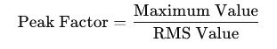
PART – B
  - Using Kirchhoff’s First Law, determine the value of the unknown current of the circuit as shown below(KCL):
At any node, the sum of currents entering the node equals the sum of currents leaving the node.
Identify the Node
At the top central node:
- Current entering from left I = 18 A
- Current leaving through right branch (given) = I₂ = 4 A
- Current leaving through middle branch = I₁ (unknown)0

Apply KCL
Incoming Current=Outgoing Currents
18=I₁+4

I₁ = 18 - 4 =14
I₁ = 14A
  - Using Kirchhoff’s Voltage Law (KVL), determine the electric current flowing in the circuit shown below. If $R_{1}=2 Ω$, $R_{2}=4 Ω$, $R_{3}=6 Ω$. All elements are connected in a single closed loop. Find the value of current I.
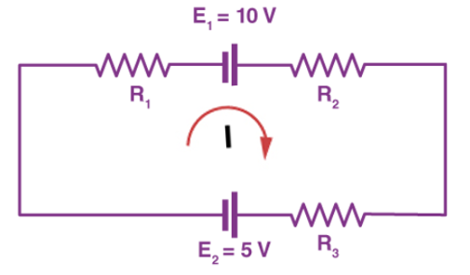
  - 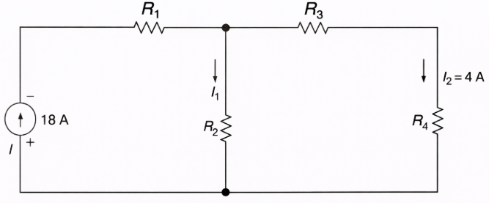Kirchhoff’s Current Law

Given:
E1=10 V
E2=5 V
R1=2Ω
R2=4Ω
R3=6Ω
All elements are connected in a single closed loop → Series circuit.

Find Total Resistance
Since all resistors are in series:
Req=R1+R2+R3
Req = 2+4+6 = 12 Ω

Apply Kirchhoff’s Voltage Law (KVL)
KVL states:
Sum of voltages in a closed loop=0
+E1−IR1−IR2−IR3−E2=0
E1-I(R1+R2+R3)-E2 = 0
Substitute values:
10 -I(12) -5 = 0
5-12I=0
I = 5 / 12
I=0.417 A
  - Explain comprehensively the concepts of (i) Voltage, (ii) Current, (iii) Power, (iv) Energy and (v) Resistance, including their SI units and mathematical expressions.

Quantity | Definition | Mathematical Expression | SI Unit | Explanation / Key Points
Voltage (V) | Voltage is the electrical potential difference between two points in a circuit. It represents the work done to move a unit charge from one point to another. | V = W / Q | Volt (V) | 1 Volt = 1 Joule/Coulomb. It is the driving force that pushes charges through a conductor. Also called EMF when supplied by a source.
Current (I) | Current is the rate of flow of electric charge through a conductor. | I = Q /t | Ampere (A) | 1 Ampere = 1 Coulomb/second. It flows from higher potential to lower potential (conventional direction).
Power (P) | Power is the rate at which electrical energy is consumed or converted into other forms of energy. | P=VI | Watt (W) | 1 Watt = 1 Joule/second. Indicates how fast electrical work is done. Used in rating electrical devices.
Energy (E) | Electrical energy is the total work done or total power consumed over time. | E=Pt | Joule (J)  Commercial Unit: kWh | 1 kWh = 3.6 × 10⁶ J. Energy determines electricity consumption in homes and industries.
Resistance (R) | Resistance is the opposition offered by a material to the flow of electric current. | R=V/I | Ohm (Ω) | 1 Ohm = 1 Volt/Ampere. Depends on material, length, cross-sectional area and temperature. Given by

  - Analyze the following electrical power terms in AC circuits, explaining their definitions, relationships, and associated units:
i) Power
ii) Real Power
iii) Reactive Power
iv) Apparent Power

Power (Instantaneous Power)
Definition:
Instantaneous power is the product of instantaneous voltage and instantaneous current at any given time.
p(t)=v(t) i(t)
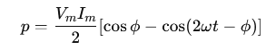
For sinusoidal signals:
- Voltage: v=V_{m}sinωt
- Current: i=I_{m}sin(ωt−ϕ)
Power varies continuously with time.
Unit: Watt (W)

Real Power (Active Power) – P
Definition:
Real power is the actual useful power consumed by the load and converted into work, heat, or light.
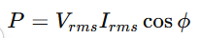
Where:
ϕ = Phase angle between voltage and current
Unit: Watt (W)
Key Points:
- Exists in resistive components.
- Responsible for useful energy conversion.
- Also called Active Power or True Power.

(iii) Reactive Power – Q
Definition:
Reactive power is the power that oscillates between the source and reactive elements (inductor and capacitor).
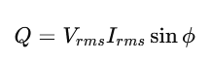
Unit: Volt-Ampere Reactive (VAR)
Key Points:
- Exists in inductors and capacitors.
- Does not perform useful work.
- Responsible for energy storage in magnetic or electric fields.

(iv) Apparent Power – S
Definition:
Apparent power is the total power supplied by the source in an AC circuit.
S=V_{rms}I_{rms}​
Unit: Volt-Ampere (VA)
Key Points:
- It is the vector sum of real and reactive power.
- Represents total power handling capacity of the system.
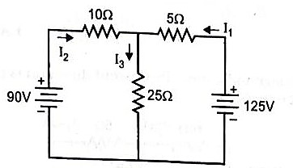
  - Calculate the currents supplied by the batteries in the network shown in the figure

Given Circuit
- Left battery = 90 V
- Right battery = 125 V
- Resistors:
  - 10 Ω (left top)
  - 5 Ω (right top)
  - 25 Ω (vertical)
Let the top junction voltage be V (with bottom node as reference 0V).
Apply KCL at the Top Node
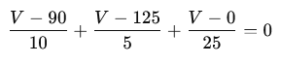
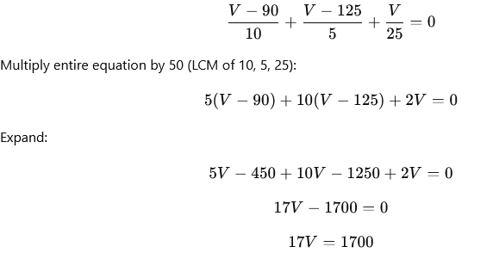
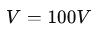
Calculate Currents
Current from 90V battery (I₂)

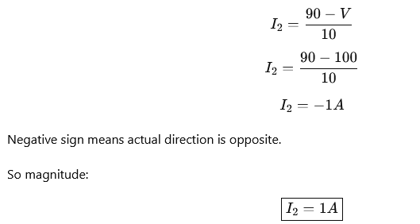
Current from 125V battery (I₁)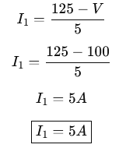
  - Determine the equivalent resistance between terminals A & B shown in figure
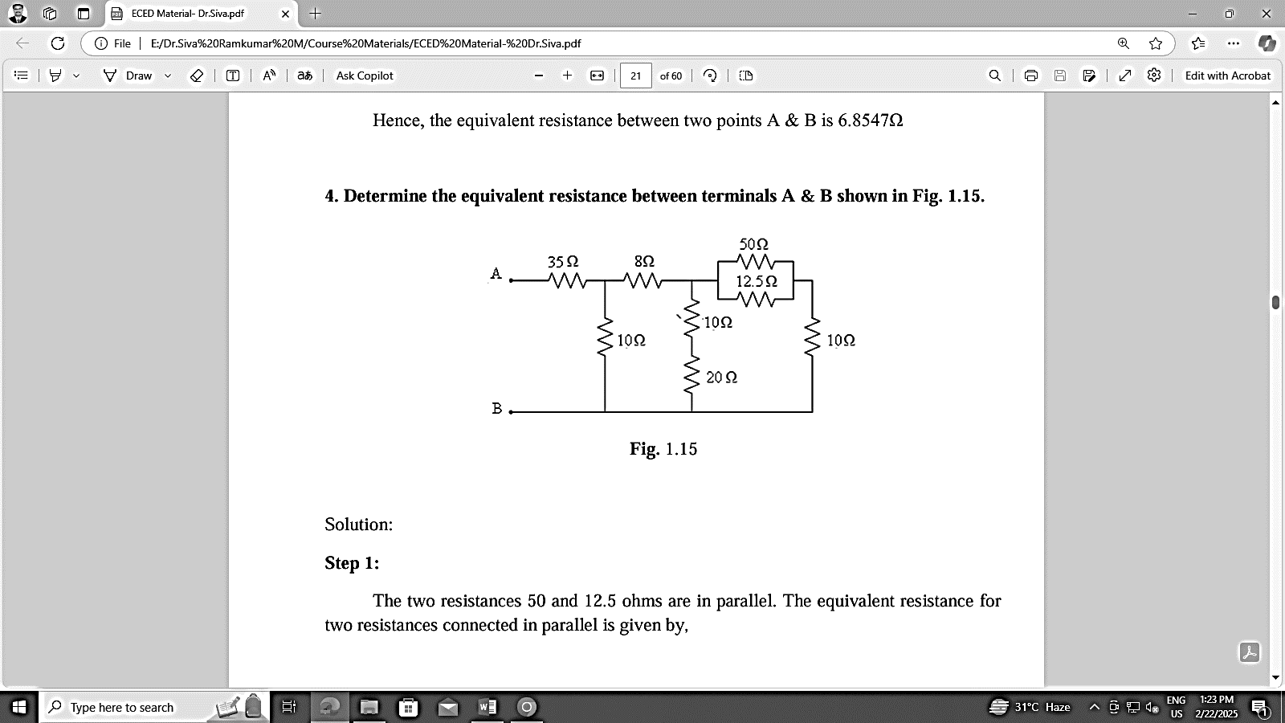

Identify Right-Side Parallel Network
The top right box shows:
- 50 Ω
- 12.5 Ω
These are in parallel.
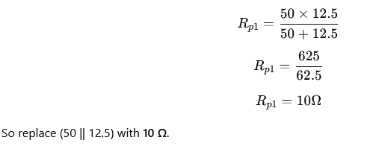

Combine with Vertical 10Ω (Rightmost)
Now this 10Ω (from parallel) is in series with the rightmost vertical 10Ω.
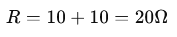

Combine with 20Ω (Middle Vertical Branch)
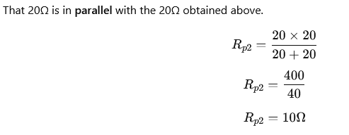

Combine with 8Ω (Series)
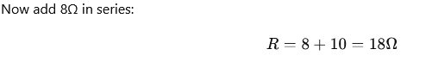

Combine with Left Vertical 10Ω
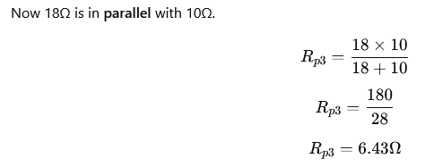

Add 35Ω (Series)
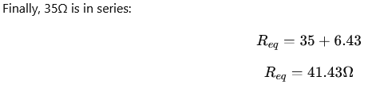
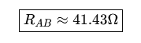
  - A 12V DC source is connected to two resistors of 4Ω and 8Ω in series. Analyze and determine: (i) Total resistance, (ii) Circuit current, (iii) Voltage drop across each resistor and (iv) Total power consumed in the circuit.

Given Data
- Supply Voltage, V=12V
- R1=4Ω
- R2=8Ω
- Connection: Series Circuit

- Total Resistance
R_{eq} = R₁ + R₂
R_{eq} = 4 + 8 = 12 Ω
- Circuit Current
By ohm’s law ,
I = V / R
=12 / 12
I = 1 A
- Voltage Drop Across Each Resistor

Across 4Ω:
V₁ = I * R
= 1 * 4
V₁ = 4 V
Across 8Ω:
V₂ = I * R
= 1 * 8
V₂ = 8 V

- Total Power Consumed

Power formula:

P = V * I
= 12 * 1
P = 12 W

  - Illustrate and analyze Kirchhoff’s Current Law (KCL) and Kirchhoff’s Voltage Law (KVL) using suitable circuit examples.

Kirchhoff’s Current Law (KCL)

Kirchhoff’s Current Law states that for a parallel path the total current entering a circuit junction is exactly equal to the total current leaving the same junction.

In other words the algebraic sum of ALL the currents entering and leaving a junction must be equal to zero as: Σ I_{IN} = Σ I_{OUT}.
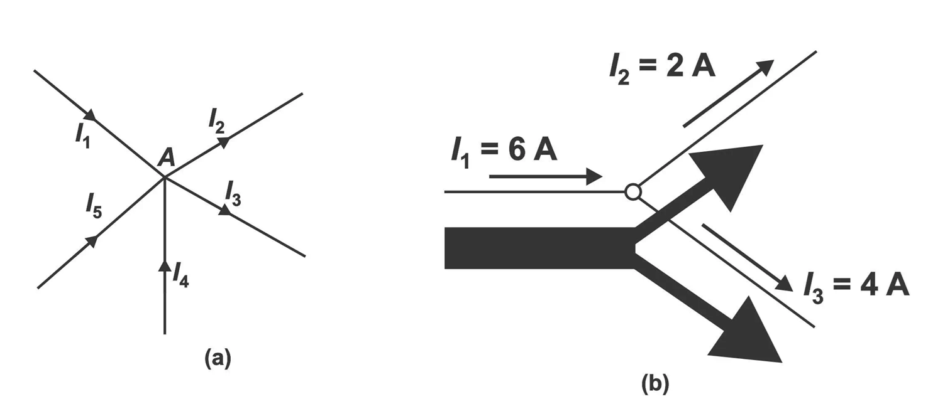

I₁ + (-1₂) + (-I₃) + (+I₄) + (-I₅) = 0
(Or) I₁ + I₄ – I₂ -I₃ – I5 = 0
(Or) I₁ + I₄ = I₂ + I₃ + I5
Incoming currents = outgoing currents
This law can also be mentioned according to the following algebraic method;
Σ1 _{Entering} = Σ1_{Leaving}
Σ1 = 0
For example, 6A current is coming towards a point, and 2A and 4A currents are leaving outward. Thus,
Σ1 _{Entering} = Σ1_{Leaving}
6A = 2A + 4A
6A = 6A

Kirchhoff’s Voltage Law (KVL)
Voltage law states that in any closed circuit or mesh, the algebraic sum of all the EMF’s plus the algebraic sum of voltage drops is zero. This is because a circuit loop is a closed conducting path so no energy is lost.

In other words the algebraic sum of ALL the potential differences around the loop must be equal to zero as: ΣV = 0.

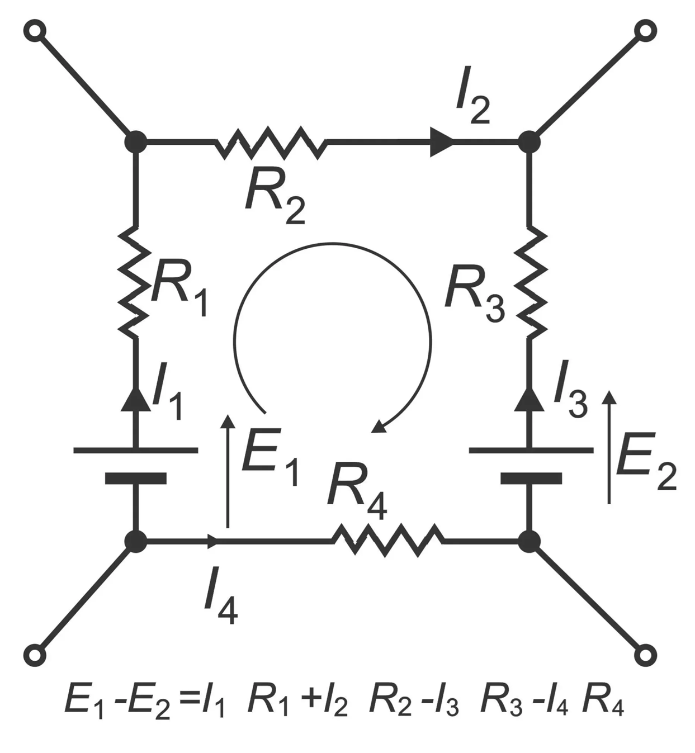

Example
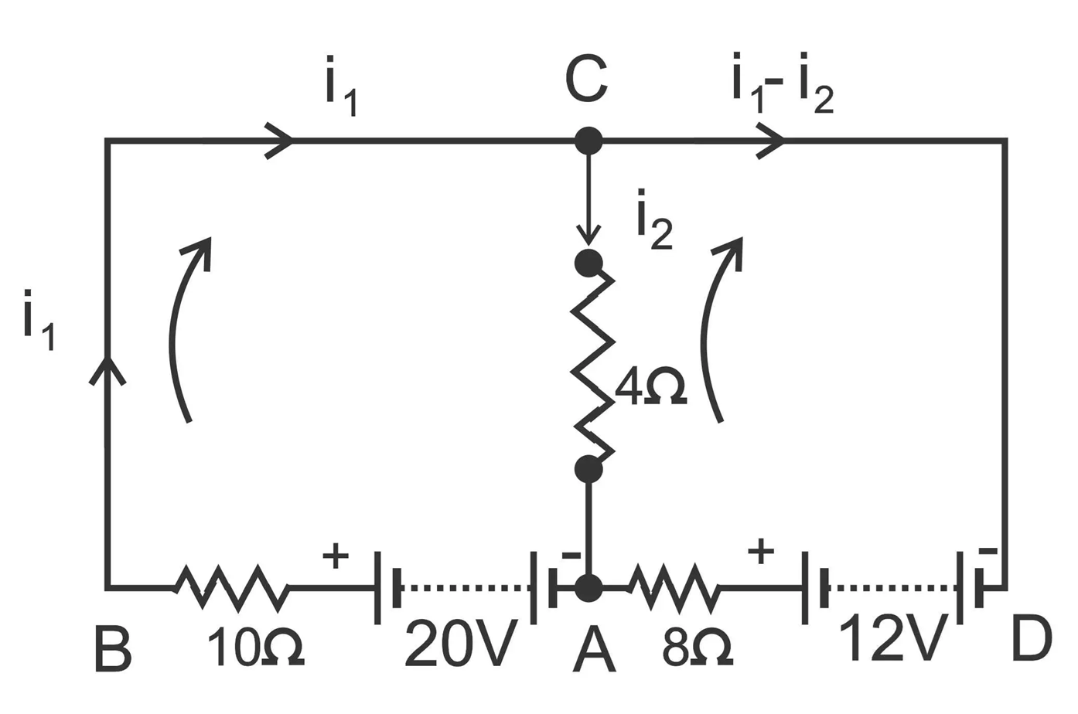
If current in mesh
A B C = i₁ and in C A = i₂, then current in mesh C D A = i₁ – i₂
In mesh A B C, 20 volts are acting in a clockwise direction. Equating the sum of the I R products, we get;
10 i₁ + 4 i₂ = 20 … (1)
In mesh A C D, 12 volts are acting in clockwise direction; then,
8 (i₁ – i₂) 0 4i₂ = 1₂
8i₁ – 12i₂ = 12 … (2)
Multiply (1) by 3
30i₁ + 12i₂ = 60
38i₁ = 72
i₁ = 72/ 38 = 36 / 19 = 1.895 amperes = current in 10 ohms resistor
Substituting this value in (1), we get;
10 [36/19] + 4i₂ = 20 or 360/ 19 + 4i₂ = 20
4i₂ = 380 – 360 / 19 = 20 /19
i₂ = 5 / 19 = 0.263 amperes

  - Analyze the fundamental characteristics of a single-phase AC waveform with suitable diagrams
A single-phase AC waveform is an alternating quantity whose magnitude and direction vary sinusoidally with time.
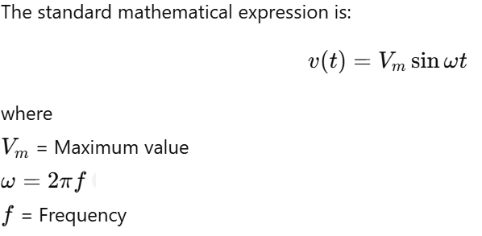
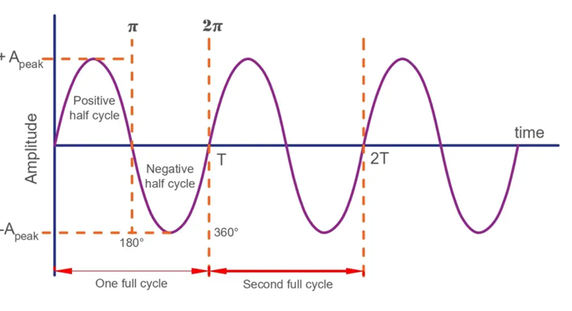
Waveform:
A Waveform is a graph in which the instantaneous value of any quantity is plotted against time.
Amplitude:
The Maximum positive and negative value of alternating quantity is called amplitude.
V_{m} = Peak value
Frequency:
The number of cycles per second of an alternating quantity is known as frequency.
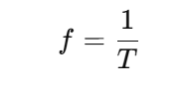
Time Period:
Time period of an alternating quantity is the time taken to complete one cycle.

RMS Value (Effective Value):
The RMS value of an alternating current(AC) is equal to the value of a steady current (DC Current) that produces the same amount of heat as the alternating current when passed through circuit for the same amount of time.

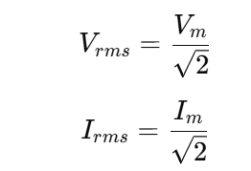

Average Value:
The average value of AC is given by that steady current which transfers across same charge as would transferred by ac across same circuit at same time.
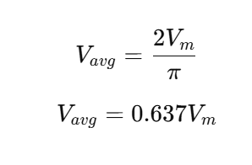
Form Factor:
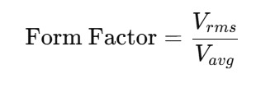
Peak Factor:
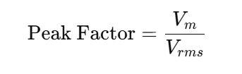

  - Analyze the concept of power factor in a single-phase AC circuit and examine the causes and effects of a low power factor on system performance.
Power Factor:
The power factor (PF) is defined as the cosine of the phase angle between voltage and current.
$Power Factor=cos⁡ϕ$
Where:
- $ϕ$= Phase angle between voltage and current

Types of Power in AC Circuit
$Real Power (P)=VIcos⁡ϕ(Watts)Reactive Power (Q)=VIsin⁡ϕ(VAR)Apparent Power (S)=VI(VA)$
Relationship:
$cos⁡ϕ=\frac{P}{S}$
Nature of Power Factor
Circuit Type | Phase Relation | Power Factor
Pure Resistive | V and I in phase | PF = 1 (Unity)
Inductive | Current lags | Lagging PF
Capacitive | Current leads | Leading PF
Causes of Low Power Factor:
Low power factor mainly occurs in AC systems due to the presence of inductive and reactive components that cause the current to lag behind the voltage.
Most industrial and commercial loads are inductive in nature.
Examples:
- Induction motors
- Transformers
- Reactors
- Chokes
Inductive loads require magnetizing current to create magnetic fields. This current does not perform useful work but increases reactive power.
Effects of Low Power Factor
- Increase in line current.
- Increase in copper losses (I²R losses).
- Overheating of cables and electrical equipment.
- Larger conductor size required.
- Poor voltage regulation (greater voltage drop).
- Reduced efficiency of the power system.
- Reduced capacity of generators and transformers (higher kVA demand).
- Higher electricity charges and penalty by utilities.
12. Three Resistances of values 2Ω, 3Ω and 5Ω are connected in series across a 20V DC Supply . Calculate
  - Equivalent resistance of the circuit
  - The total Current of the circuit
  - The voltage drop across each resistor
  - The power dissipated in each resistor

Given Data
- $R_{1}=2Ω$
- $R_{2}=3Ω$
- $R_{3}=5Ω$
- Supply Voltage $V=20V$
- Connection: Series Circuit
(i)Equivalent resistance of the circuit
R_{eq} = R₁ + R₂ +R₃
R_{eq} = 2 + 3 + 5
R_{eq} = 10 Ω
(ii)Total Current of the Circuit
I = V / R
I = 20 / 10
I = 2 A
(iii)Voltage drop across each resistor
Across 2Ω
V₁ = I * R
V₁=2 * 2
V₁ = 4V
Across 3Ω
V₂ = I * R
V₂=2 * 3
V₂ = 6V
Across 5Ω
V₃ = I * R
V₃=2 * 5
V₃ = 10V
(iv) The power dissipated in each resistor
Power in 2Ω:
P₁ = I² * R
P₁ = 2 * 2 * 2
P₁ = 8 W
Power in 3Ω:
P₂ = I² * R
P₂ = 2 * 2 * 3
P₂= 12 W
Power in 5Ω:
P₃ = I² * R
P₃ = 2 * 2 * 5
P₃= 20 W

    - Calculate the voltage drop in each resistor in the below circuit
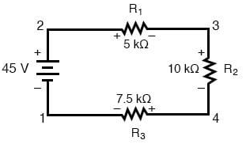
Given
- Supply Voltage $V=45V$
- $R_{1}=5 kΩ$
- $R_{2}=10 kΩ$
- $R_{3}=7.5 kΩ$
All resistors are connected in series.
- Total Resistance
Req = R1 + R2 +R3
Req = 5 +10 + 7.5
Req = 22.5 kΩ
- Circuit Current
I = V / R
I = 45 / 22.5
I = 0.002 A
I = 2mA

V₁ = I * R
V₁=2mA * 5kΩ
V₁ = 10V
Across 10kΩ
V₂ = I * R
V₂=2mA * 10kΩ
V₂ = 20V
Across 7.5Ω
V₃ = I * R
V₃=2mA * 7.5kΩ
V₃ = 15V

