Monthly Test – June 2019
Computer Science
Class: XII Marks :50
Date: -06-‘19 Time : 1$\frac{1}{2}$hrs
Section - A
I. Fill in the blanks. 5X1=5
1. ___________ the technology that enables voice communications.
2. The term ______ refers to the computers that are attached to the computers and seeking to share the resource.
3. _________ is a wireless digital communication system.
4. The ________ is the medium used to carry information or data from one point to another.
5. _____ is useful to transfer files from one network in an organization to another.
Section - B
I. Answer the following
1. What is ARPANET? (2)
2. Differentiate between Bus Topology and Star Topology of Networks.
What are the advantages and disadvantages of Star over Bus Topology ? (3)

3. Write in detail about Modem. (4)

4. Write about RJ - 45. (2)

5. What are the different types of Unguided Media? Explain in detail. (6)

6. Give the comparison between the Guided media. (3)

7. Explain the types of network. (4)

8. Explain Star, Bus and Ring topology in detail. (6)

9. Define the following (6)
(i) Data Channel (ii) Baud (iii)Bandwidth
(iv)Router (v)Gateway (vi)WiFi Card

10. Define the following
(i)HTTP (ii)FTP (iii)TCP/IP (iv)SLIP (v)PPP (5)

Monthly Test – June 2019
Computer Science
Class: XI Marks :50
Date: -06-‘19 Time : 1$\frac{1}{2}$hrs
Section - A
I. Fill in the blanks. 5X1=5
1. ___________ the technology that enables voice communications.
2. The term ______ refers to the computers that are attached to the computers and seeking to share the resource.
3. _________ is a wireless digital communication system.
4. The ________ is the medium used to carry information or data from one point to another.
5. _____ is useful to transfer files from one network in an organization to another.
Section - B
I. Answer the following
1. What is ARPANET? (2)
2. Differentiate between Bus Topology and Star Topology of Networks.
What are the advantages and disadvantages of Star over Bus Topology ? (3)

3. Write in detail about Modem. (4)

4. Write about RJ - 45. (2)

5. What are the different types of Unguided Media? Explain in detail. (6)

6. Give the comparison between the Guided media. (3)

7. Explain the types of network. (4)

8. Explain Star, Bus and Ring topology in detail. (6)

9. Define the following (6)
(i) Data Channel (ii) Baud (iii)Bandwidth
(iv)Router (v)Gateway (vi)WiFi Card

10. Define the following
(i)HTTP (ii)FTP (iii)TCP/IP (iv)SLIP (v)PPP (5)
11. CASE STUDY BASED QUESTION :
Ayurveda Training Educational Institute is setting up its centre in Hyderabad with four specialized departments for Orthopedics, Neurology and Pediatrics along with an administrative office in separate buildings. The physical distances between these department buildings and the number of computers to be installed in these departments and administrative office are given as follows. You, as a network expert, have to answer the queries as raised by them in (i) to (iv). (4)
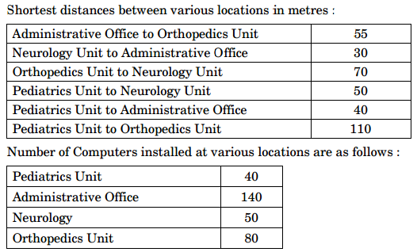
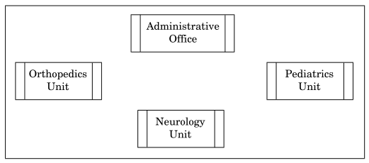

(i) Suggest the most suitable location to install the main server of this institution to get efficient connectivity.
(ii) Suggest the best cable layout for effective network connectivity of the building having server with all the other buildings.
(iii) Suggest the devices to be installed in each of these buildings for connecting computers installed within the building out of the following :
- Gateway
- Modem
- Switch
(iv) Suggest the topology of the network and network cable for efficiently connecting each computer installed in each of the buildings out of the following :
Topologies : Bus Topology, Star Topology Network Cable : Single Pair Telephone Cable, Coaxial Cable, Ethernet Cable.
11. CASE STUDY BASED QUESTION :
Ayurveda Training Educational Institute is setting up its centre in Hyderabad with four specialized departments for Orthopedics, Neurology and Pediatrics along with an administrative office in separate buildings. The physical distances between these department buildings and the number of computers to be installed in these departments and administrative office are given as follows. You, as a network expert, have to answer the queries as raised by them in (i) to (iv). (4)

(i) Suggest the most suitable location to install the main server of this institution to get efficient connectivity.
(ii) Suggest the best cable layout for effective network connectivity of the building having server with all the other buildings.
(iii) Suggest the devices to be installed in each of these buildings for connecting computers installed within the building out of the following :
- Gateway
- Modem
- Switch
(iv) Suggest the topology of the network and network cable for efficiently connecting each computer installed in each of the buildings out of the following :
Topologies : Bus Topology, Star Topology Network Cable : Single Pair Telephone Cable, Coaxial Cable, Ethernet Cable.

