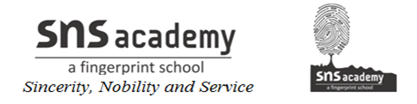
Monthly Test – June 2019
Computer Science
Class: XII Marks :50
Date: 26-06-‘19 Time : 1$\frac{1}{2}$hrs
Section - A
I. Fill in the blanks. 5X1=5
1. ___________ is the client / server software program.
2. The term ______ refers to the computers that are attached to the computers and seeking to share the resource.
3. _________ helps a group of networks users to use a modem to transmit long distance messages.
4. The ________ is the medium used to carry information or data from one point to another.
5. _____ is the unit of measurement for the information carrying capacity of a communication channel.
Section - B
I. Answer the following
1. What is computer network. (2)
2. Differentiate between Bus Topology and Star Topology of Networks.
What are the advantages and disadvantages of Star over Bus Topology ? (3)

3. Define the following (4)
(i) Hacker (ii) Cracker (iii) Operator (iv) Network Admin

4. Differentiate between Radio Link and Microwave in context of wireless communication technologies.
(2)
5. What are the different types of transmission media? Explain in detail. (6)

6. Give the comparison between the Guided media. (3)

7. Explain the types of network. (4)

8. What is Network Topology? Explain the types of topologies. (6)

9. Define the following (6)
(i) Modem (ii) RJ-45 (iii)Hub (iv)Switch (v)Repeater (vi)Bridge
Monthly Test – June 2019
Computer Science
Class: XI Marks :50
Date: 24-06-‘19 Time : 1$\frac{1}{2}$hrs
Section - A
I. Fill in the blanks. 5X1=5
1. ___________ is the client / server software program.
2. The term ______ refers to the computers that are attached to the computers and seeking to share the resource.
3. _________ helps a group of networks users to use a modem to transmit long distance messages.
4. The ________ is the medium used to carry information or data from one point to another.
5. _____ is the unit of measurement for the information carrying capacity of a communication channel.
Section - B
I. Answer the following
1. What is computer network. (2)
2. Differentiate between Bus Topology and Star Topology of Networks.
What are the advantages and disadvantages of Star over Bus Topology ? (3)

3. Define the following (4)
(i) Hacker (ii) Cracker (iii) Operator (iv) Network Admin

4. Differentiate between Radio Link and Microwave in context of wireless communication technologies.
(2)
5. What are the different types of transmission media? Explain in detail. (6)

6. Give the comparison between the Guided media. (3)

7. Explain the types of network. (4)

8. What is Network Topology? Explain the types of topologies. (6)

9. Define the following (6)
(i) Modem (ii) RJ-45 (iii)Hub (iv)Switch (v)Repeater (vi)Bridge
10. Define the following
(i)HTTP (ii)FTP (iii)TCP/IP (iv)SLIP (v)PPP (5)

11. Hi Speed Technologies Ltd. is a Delhi based organization which is expanding its office setup to Chandigarh. At Chandigarh office campus, they are planning to have 3 different blocks for HR, Accounts and Logistics related work. Each block has number of computers, which are required to be connected in a network for communication, data and resource sharing. As a network consultant, you have to suggest the best network related solutions for them for issues/problems raised in (i) to (iv), keeping in mind the distances between various blocks / locations and other given parameters. (4)
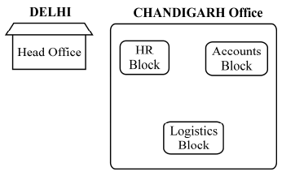
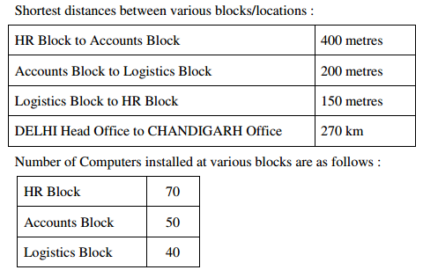
(i) Suggest the most appropriate block/location to house the SERVER in the CHANDIGARH Office (out of the 3 blocks) to get the best and effective connectivity. Justify your answer. 1
(ii) Suggest the best wired medium and draw the cable layout (Block to Block) to efficiently connect various Blocks within the CHANDIGARH office compound. 1 (iii) Suggest a device / software and its placement that would provide data security for the entire network of CHANDIGARH office. 1
(iv) Which of the following kind of network, would it be ? 1 (a) PAN (b) WAN (c) MAN (d) LAN

10. Define the following
(i)HTTP (ii)FTP (iii)TCP/IP (iv)SLIP (v)PPP (5)

11. Hi Speed Technologies Ltd. is a Delhi based organization which is expanding its office setup to Chandigarh. At Chandigarh office campus, they are planning to have 3 different blocks for HR, Accounts and Logistics related work. Each block has number of computers, which are required to be connected in a network for communication, data and resource sharing. As a network consultant, you have to suggest the best network related solutions for them for issues/problems raised in (i) to (iv), keeping in mind the distances between various blocks / locations and other given parameters. (4)
(i) Suggest the most appropriate block/location to house the SERVER in the CHANDIGARH Office (out of the 3 blocks) to get the best and effective connectivity. Justify your answer. 1
(ii) Suggest the best wired medium and draw the cable layout (Block to Block) to efficiently connect various Blocks within the CHANDIGARH office compound. 1 (iii) Suggest a device / software and its placement that would provide data security for the entire network of CHANDIGARH office. 1
(iv) Which of the following kind of network, would it be ? 1 (a) PAN (b) WAN (c) MAN (d) LAN

