Computer Science - Monthly Test
Class: XII Marks :70
Date: -04-19 Time : 3hrs

Section - A
I. Answer the following
- What is the importance of a primary key in a table? Explain with a suitable example. (2)
- What are views? How are they useful? (2)
- What do you understand by data independence? (2)
- What are the two types of data independence? How they different? (3)
- What do you understand by the terms Primary Key and Degree of a relation in relational database? (2)
- What are the similarities and differences between network and hierarchical data models? (2)
- What do you mean by relational database? (2)
- What is the function of select and project operation? (3)

Section – B
II. Answer the following
- What are the major advantage of a database system (4)
- What is relation? Define the properties of a relation. (4)
- Explain deference between physical and logical data independence. (4)
12. Define the following terms (6)
(i)Integrated database (ii) Shared database (iii) View
13. Define the following terms (6)
(i)Database system (ii) Data security (iii) Data integrity
14. What are the set difference and set intersection operations? How are they
different? (4)
15. Illustrate the difference between the three levels of data abstraction. (4)

Computer Science - Monthly Test
Class: XII Marks :70
Date: -04-19 Time : 3hrs

Section - A
I. Answer the following
- What is the importance of a primary key in a table? Explain with a suitable example. (2)
- What are views? How are they useful? (2)
- What do you understand by data independence? (2)
- What are the two types of data independence? How they different? (3)
- What do you understand by the terms Primary Key and Degree of a relation in relational database? (2)
- What are the similarities and differences between network and hierarchical data models? (2)
- What do you mean by relational database? (2)
- What is the function of select and project operation? (3)

Section – B
II. Answer the following
- What are the major advantage of a database system (4)
- What is relation? Define the properties of a relation. (4)
- Explain deference between physical and logical data independence. (4)
12. Define the following terms (6)
(i)Integrated database (ii) Shared database (iii) View
13. Define the following terms (6)
(i)Database system (ii) Data security (iii) Data integrity
14. What are the set difference and set intersection operations? How are they
different? (4)
15. Illustrate the difference between the three levels of data abstraction. (4)

16. Explain the concept of UNION between two tables, give appropriate example. (5)
17. Explain the concept of INTERSECTION between two tables, give appropriate example. (5)

18. (10)
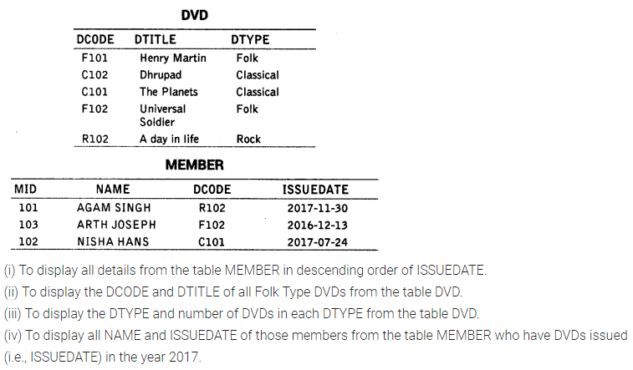

16. Explain the concept of UNION between two tables, give appropriate example. (5)
17. Explain the concept of INTERSECTION between two tables, give appropriate example. (5)

18. (10)

