- The order of reactivity of following alcohols with halogen acids is ___________.
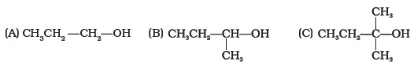
- Which of the following alcohols will yield the corresponding alkyl chloride on reaction with concentrated HCl at room temperature?
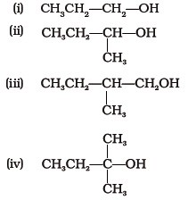
- Identify the compound Y in the following reaction.
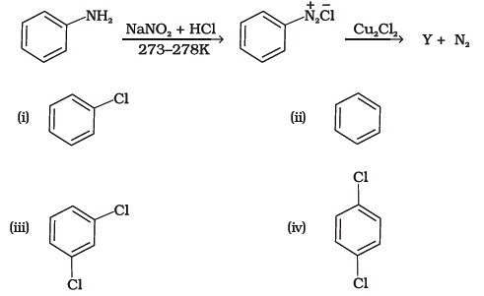
- Toluene reacts with a halogen in the presence of iron (III) chloride giving ortho and para halo compounds. The reaction is
  - (i) Electrophilic elimination reaction
  - (ii) Electrophilic substitution reaction
  - (iii) Free radical addition reaction
  - (iv) Nucleophilic substitution reaction
- Which of the following is halogen exchange reaction?
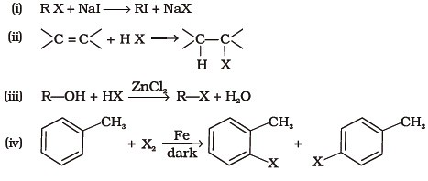
- Which reagent will you use for the following reaction ?
  - (i) Cl₂/UV light
  - (ii) NaCl + H₂SO₄
  - (iii) Cl₂ gas in dark
  - (iv) Cl₂ gas in the presence of iron in dark
- Arrange the following compounds in the increasing order of their densities.
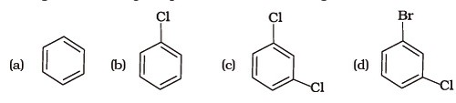
- Arrange the following compounds in increasing order of their boiling points
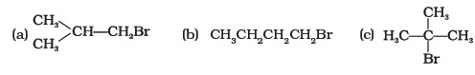
- In which of the following molecules carbon atom marked with asterisk (*) is asymmetric?
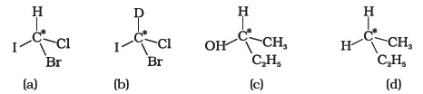
  - (i) (a), (b), (c), (d)
  - (ii) (a), (b), (c)
  - (iii) (b), (c), (d)
  - (iv) (a), (c), (d)
- Which of the following structures is enantiomeric with the molecule (A) given below :
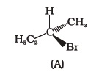
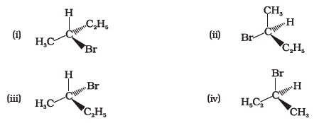
- Which of the following is an example of vic-dihalide?
  - (i) Dichloromethane
  - (ii) 1,2-dichloroethane
  - (iii) Ethylidene chloride
  - (iv) Allyl chloride
- The position of –Br in the compound in CH₃CH == CHC (Br)(CH₃)₂ can be classified as ____________.
  - (i) Allyl
  - (ii) Aryl
  - (iii) Vinyl
  - (iv) Secondary
- Chlorobenzene is formed by reaction of chlorine with benzene in the presence of AlCl₃. Which of the following species attacks the benzene ring in this reaction ?
  - (i) Cl–
  - (ii) Cl⁺
  - (iii) AlCl₃
  - (iv) [AlCl₄]–
- Ethylidene chloride is a/an ______________.
  - (i) vic-dihalide
  - (ii) gem-dihalide
  - (iii) allylic halide
  - (iv) vinylic halide
- What is ‘A’ in the following reaction?
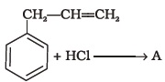
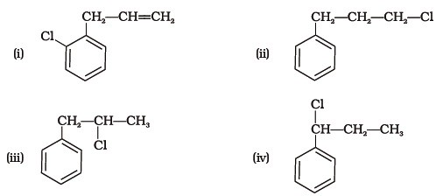
- A primary alkyl halide would prefer to undergo _____________.
  - (i) S_{N}1 reaction
  - (ii) S_{N}2 reaction
  - (iii) α–Elimination
  - (iv) Racemisation
- Which of the following alkyl halides will undergo S_{N}1 reaction most readily?
  - (i) (CH₃)3C—F
  - (ii) (CH₃)3C—Cl
  - (iii) (CH₃)3C—Br
  - (iv) (CH₃)3C—I
- 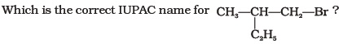
  - (i) 1-Bromo-2-ethylpropane
  - (ii) 1-Bromo-2-ethyl-2-methyl ethane
  - (iii) 1-Bromo-2-methylbutane
  - (iv) 2-Methyl-1-bromobutane
- What should be the correct IUPAC name for diethyl bromomethane?
  - (i) 1-Bromo-1,1-diethoxyethane
  - (ii) 3-Bromopentane
  - (iii) 1-Bromo-1-ethyl propane
  - (iv) 1-Bromopentane
- The reaction of toluene with chlorine in the presence of iron and in the absence of light yields ____________.
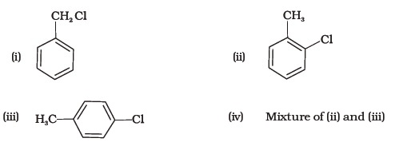
- Chloromethane on treatment with excess of ammonia yields mainly
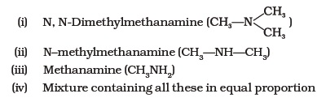
- Molecules whose mirror image is non superimposable over them are known as chiral. Which of the following molecules is chiral in nature?
  - (i) 2-Bromobutane
  - (ii) 1-Bromobutane
  - (iii) 2-Bromopropane
  - (iv) 2-Bromopropan-2-ol
- Reaction of C₆H₅CH₂Br with aqueous sodium hydroxide follows ____________.
  - (i) S_{N}1 mechanism
  - (ii) S_{N}2 mechanism
  - (iii) Any of the above two depending upon the temperature of reaction
  - (iv) Saytzeff rule
- Which of the carbon atoms present in the molecule given below are asymmetric
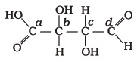
  - (i) a, b, c, d
  - (ii) b, c
  - (iii) a, d
  - (iv) a, b, c
- Which of the following compounds will give racemic mixture on nucleophilic substitution by OH– ion?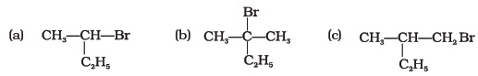
  - (i) (a)
  - (ii) (a), (b), (c)
  - (iii) (b), (c)
  - (iv) (a), (c)
Note : In the questions 26 to 29 arrange the compounds in increasing order of rate of reaction towards nucleophilic substitution
- 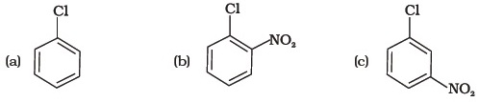
  - (i) (a) < (b) < (c)
  - (ii) (c) < (b) < (a)
  - (iii) (a) < (c) < (b)
  - (iv) (c) < (a) < (b)
  - (i) (a) < (b) < (c)
  - (ii) (c) < (b) < (a)
  - (iii) (a) < (c) < (b)
  - (iv) (c) < (a) < (b)
- 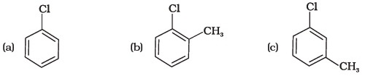
  - (i) (a) < (b) < (c)
  - (ii) (a) < (c) < (b)
  - (iii) (c) < (b) < (a)
  - (iv) (b) < (c) < (a)
- 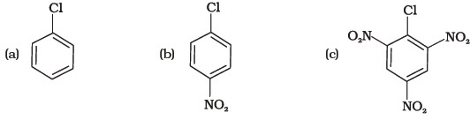
  - (i) (c) < (b) < (a)
  - (ii) (b) < (c) < (a)
  - (iii) (a) < (c) < (b)
  - (iv) (a) < (b) < (c)
- 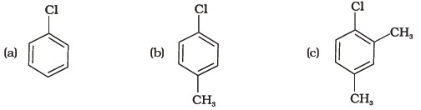
  - (i) (a) < (b) < (c)
  - (ii) (b) < (a) < (c)
  - (iii) (c) < (b) < (a)
  - (iv) (a) < (c) < (b)
- Which is the correct increasing order of boiling points of the following compounds?
1-Iodobutane, 1-Bromobutane, 1-Chlorobutane, Butane
  - (i) Butane < 1-Chlorobutane < 1-Bromobutane < 1-Iodobutane
  - (ii) 1-Iodobutane < 1-Bromobutane < 1-Chlorobutane < Butane
  - (iii) Butane < 1-Iodobutane < 1-Bromobutane < 1-Chlorobutane
  - (iv) Butane < 1-Chlorobutane < 1-Iodobutane < 1-Bromobutane
- Which is the correct increasing order of boiling points of the following compounds?
1-Bromoethane, 1-Bromopropane, 1-Bromobutane, Bromobenzene
  - (i) Bromobenzene < 1-Bromobutane < 1-Bromopropane < 1-Bromoethane
  - (ii) Bromobenzene < 1-Bromoethane < 1-Bromopropane < 1-Bromobutane
  - (iii) 1-Bromopropane < 1-Bromobutane < 1-Bromoethane < Bromobenzene
  - (iv) 1-Bromoethane < 1-Bromopropane < 1-Bromobutane < Bromobenzene

33. The correct order of increasing the reactivity of C—X bond towards nucleophile in following compounds
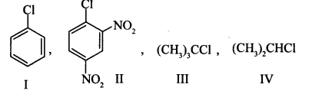
(a) IV < III < I < II
(c) I < II < IV < III
(b) III < II < I < IV
(d) II < III < I < IV

