WORKSHEET
GRADE: XII CHEMISTRY
DATE: 21.09.19 TOPIC: AMINES
- What is the role of HNO₃ in the nitrating mixture used for nitration of benzene?
- Why is NH₂ group of aniline acetylated before carrying out nitration?
- What is the product when C₆H₅CH₂NH₂ reacts with HNO₂?
- What is the best reagent to convert nitrile to primary amine?
- Give the structure of ‘A’ in the following reaction.
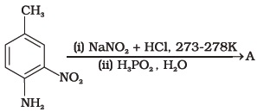
6. What is Hinsberg reagent?
7. Why benzene diazonium chloride is not stored and is used immediately after its preparation?
8. Why does acetylation of —NH₂ group of aniline reduce its activating effect?
9. Explain why MeNH₂ is stronger base than MeOH?
10. What is the role of pyridine in the acylation reaction of amines?
11. Under what reaction conditions (acidic/basic), the coupling reaction of aryldiazonium chloride with aniline is carried out?
12. Predict the product of reaction of aniline with bromine in non-polar solvent such as CS₂.
13. Arrange the following compounds in increasing order of dipole moment.
CH₃CH₂CH₂, CH₃CH₂NH₂, CH₃CH₂OH
14. What is the structure and IUPAC name of the compound, allyl amine?
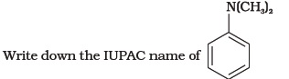
15. A compound Z with molecular formula C₃H₉N reacts with C₆H₅SO₂Cl to give a solid, insoluble in alkali. Identify Z.
16. A primary amine, RNH₂ can be reacted with CH₃—X to get secondary amine, R—NHCH₃ but the only disadvantage is that 3° amine and quaternary ammonium salts are also obtained as side products. Can you suggest a method where RNH₂ forms only 2° amine?
17. Complete the following reaction.
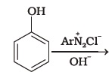
18. Why is aniline soluble in aqueous HCl?
19. Suggest a route by which the following
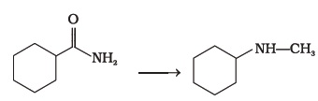
20. Identify A and B in the following reaction.
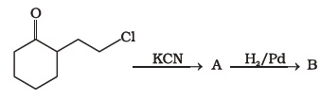
21. How will you carry out the following conversions?
(i) toluene ⎯⎯⎯→ p-toluidine
(ii) p-toluidine diazonium chloride ⎯⎯⎯→ p-toluic acid
22. Write following conversions:
(i) nitrobenzene ⎯→ acetanilide
(ii) acetanilide ⎯→ p-nitro aniline
23. A solution contains 1 g mol. each of p-toluene diazonium chloride and p- nitro phenyl diazonium chloride. To this 1 g mol. of alkaline solution of phenol is added. Predict the major product. Explain your answer.
24. How will you bring out the following conversion?
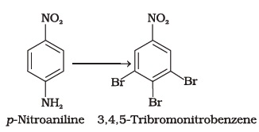

25. How will you carry out the following conversion?
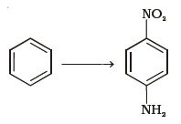
26. How will you carry out the following conversion?
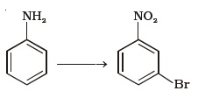
27. How will you carry out the following conversions?
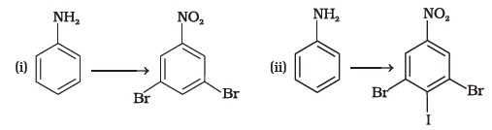

Matching Type Questions
Note: Match the items of Column I and Column II in the following questions.
- Match the reactions given in Column I with the statements given in Column II.
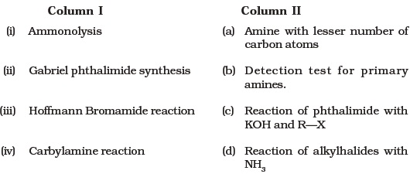

- Match the compounds given in Column I with the items given in Column II.
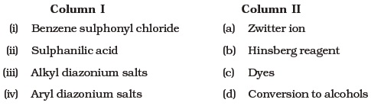

Assertion and Reason Type Questions
Note: In the following questions a statement of assertion followed by a statement of reason is given. Choose the correct answer out of the following choices.
(i) Both assertion and reason are wrong.
(ii) Both assertion and reason are correct statements but reason is not correct explanation of assertion.
(iii) Assertion is correct statement but reason is wrong statement.
(iv) Both assertion and reason are correct statements and reason is correct explanation of assertion.
(v) Assertion is wrong statement but reason is correct statement.
- Assertion: Acylation of amines gives a monosubstituted product whereas alkylation of amines gives polysubstituted product.
Reason: Acyl group sterically hinders the approach of further acyl groups.
- Assertion: Hoffmann’s bromamide reaction is given by primary amines.
Reason: Primary amines are more basic than secondary amines.
- Assertion: N-Ethylbenzene sulphonamide is soluble in alkali.
Reason: Hydrogen attached to nitrogen in sulphonamide is strongly acidic.
- Assertion: N, N-Diethyl benzene sulphonamide is insoluble in alkali.
Reason: Sulphonyl group attached to nitrogen atom is strong electron withdrawing group.
- Assertion: Only a small amount of HCl is required in the reduction of nitro compounds with iron scrap and HCl in the presence of steam.
Reason: FeCl₂ formed gets hydrolysed to release HCl during the reaction.
- Assertion: Aromatic 1° amines can be prepared by Gabriel Phthalimide Synthesis.
Reason: Aryl halides undergo nucleophilic substitution with anion formed by phthalimide.
- Assertion: Acetanilide is less basic than aniline.
Reason: Acetylation of aniline results in decrease of electron density on nitrogen.

Long Answer Type Questions
- A hydrocarbon ‘A’, (C₄H₈) on reaction with HCl gives a compound ‘B’, (C₄H₉Cl), which on reaction with 1 mol of NH₃ gives compound ‘C’, (C₄H₁₁N). On reacting with NaNO₂ and HCl followed by treatment with water, compound ‘C’ yields an optically active alcohol, ‘D’. Ozonolysis of ‘A’ gives 2 moles of acetaldehyde. Identify compounds ‘A’ to ‘D’. Explain the reactions involved.
- A colourless substance ‘A’ (C₆H₇N) is sparingly soluble in water and gives a water soluble compound ‘B’ on treating with mineral acid. On reacting with CHCl₃ and alcoholic potash ‘A’ produces an obnoxious smell due to the formation of compound ‘C’. Reaction of ‘A’ with benzenesulphonyl chloride gives compound ‘D’ which is soluble in alkali. With NaNO₂ and HCl, ‘A’ forms compound ‘E’ which reacts with phenol in alkaline medium to give an orange dye ‘F’. Identify compounds ‘A’ to ‘F’.
- Predict the reagent or the product in the following reaction sequence.
