- Can absolute electrode potential of an electrode be measured?
- 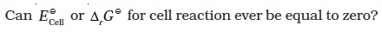
- Under what condition is E_{Cell} = 0 or Δ_{r} G = 0?
- Aqueous copper sulphate solution and aqueous silver nitrate solution are electrolysed by 1 ampere current for 10 minutes in separate electrolytic cells. Will the mass of copper and silver deposited on the cathode be same or different? Explain your answer.
- Depict the galvanic cell in which the cell reaction is Cu + 2Ag⁺ → 2Ag + Cu²⁺
- Value of standard electrode potential for the oxidation of Cl– ions is more positive than that of water, even then in the electrolysis of aqueous sodium chloride, why is Cl– oxidised at anode instead of water?
- What is electrode potential?
- Consider the following diagram in which an electrochemical cell is coupled to an electrolytic cell. What will be the polarity of electrodes ‘A’ and ‘B’ in the electrolytic cell?
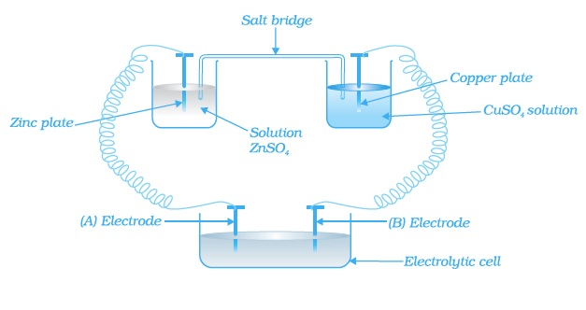
- Why is alternating current used for measuring resistance of an electrolytic solution?
- A galvanic cell has electrical potential of 1.1V. If an opposing potential of 1.1V is applied to this cell, what will happen to the cell reaction and current flowing through the cell?
- How will the pH of brine (aq. NaCl solution) be affected when it is electrolysed?
- Unlike dry cell, the mercury cell has a constant cell potential throughout its useful life. Why?
- Solutions of two electrolytes ‘A’ and ‘B’ are diluted. The Λ_{m} of ‘B’ increases 1.5 times while that of A increases 25 times. Which of the two is a strong electrolyte? Justify your answer.
- When acidulated water (dil.H₂SO₂ solution) is electrolysed, will the pH of thesolution be affected? Justify your answer.
- In an aqueous solution how does specific conductivity of electrolytes change with addition of water?
- Which reference electrode is used to measure the electrode potential of other electrodes?
- Consider a cell given below Cu|Cu²⁺|| Cl²⁺|Cl₂,Pt
Write the reactions that occur at anode and cathode
- Write the Nernst equation for the cell reaction in the Daniel cell. How will the E_{Cell} be affected when concentration of Zn²⁺ ions is increased?
- What advantage do the fuel cells have over primary and secondary batteries?
- Write the cell reaction of a lead storage battery when it is discharged. How does the density of the electrolyte change when the battery is discharged?
- Why on dilution the Λ_{m} of CH₃COOH increases drastically, while that of CH₃COONa increases gradually?
- How much electricity in terms of Coulomb is required to reduce 1 mol of Cr2O72- to Cr3+.
- Write the Nernst equation and emf of the following cells at 298K:
Sn/Sn2+(0.050M)//H+(0.020M)/H2(g)/Pt(s) EoSn2+/Sn= - 0.13V.
- Give the application of salt bridge other than the application given in the passage.
- Two meatals A and B have electrode potential values of -0.25V and 0.80V respectively. Which of these liberare hydrogen gas from sulphuric acid?
- Under what condition an elecrochemical cell behaves as an electrolytic cell?
- What is the structure and IUPAC name of glycerol?
- Write the IUPAC name of the following compounds.
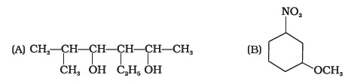
- Write the IUPAC name of the compound given below.
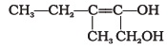
- Name the factors responsible for the solubility of alcohols in water.
- What is denatured alcohol?
- Suggest a reagent for the following conversion.
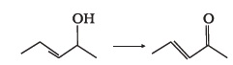
- Out of 2-chloroethanol and ethanol which is more acidic and why?
- Suggest a reagent for conversion of ethanol to ethanal.
- Suggest a reagent for conversion of ethanol to ethanoic acid.
- Out of o-nitrophenol and p-nitrophenol, which is more volatile? Explain.
- Out of o-nitrophenol and o-cresol which is more acidic?
- When phenol is treated with bromine water, white precipitate is obtained. Give the structure and the name of the compound formed.
- Arrange the following compounds in increasing order of acidity and give a suitable explanation. Phenol, o-nitrophenol, o-cresol
- Alcohols react with active metals e.g. Na, K etc. to give corresponding alkoxides. Write down the decreasing order of reactivity of sodium metal towards primary, secondary and tertiary alcohols.
- What happens when benzene diazonium chloride is heated with water?
- Arrange the following compounds in decreasing order of acidity. H₂O, ROH, HC ≡ CH
- Name the enzymes and write the reactions involved in the preparation of ethanol from sucrose by fermentation.
- How can propan-2-one be converted into tert- butyl alcohol?
- Write the structures of the isomers of alcohols with molecular formula C₄H₁₀O. Which of these exhibits optical activity?
- Explain why is OH group in phenols more strongly held as compared to OH group in alcohols.
- Explain why nucleophilic substitution reactions are not very common in phenols.
- Preparation of alcohols from alkenes involves the electrophilic attack on alkene carbon atom. Explain its mechanism.
- Explain why is O==C==O nonpolar while R—O—R is polar.
- Why is the reactivity of all the three classes of alcohols with conc. HCl and ZnCl₂ (Lucas reagent) different?
- Write steps to carry out the conversion of phenol to aspirin.
- Nitration is an example of aromatic electrophilic substitution and its rate depends upon the group already present in the benzene ring. Out of benzene and phenol, which one is more easily nitrated and why?
- In Kolbe’s reaction, instead of phenol, phenoxide ion is treated with carbon dioxide. Why?
- Dipole moment of phenol is smaller than that of methanol. Why?
- Ethers can be prepared by Williamson synthesis in which an alkyl halide is reacted with sodium alkoxide. Di-tert-butyl ether can’t be prepared by this method. Explain.
- Why is the C—O—H bond angle in alcohols slightly less than the tetrahedral angle whereas the C—O—C bond angle in ether is slightly greater?
- Explain why low molecular mass alcohols are soluble in water.
- Explain why p-nitrophenol is more acidic than phenol.
- Explain why alcohols and ethers of comparable molecular mass have different boiling points?
- The carbon-oxygen bond in phenol is slightly stronger than that in methanol. Why?
- Arrange water, ethanol and phenol in increasing order of acidity and give reason for your answer.

63. Give the IUPAC name of the following compound:
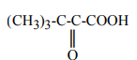
64. Write the reaction when glucose is heated with excess of HI.
65. What is the denticity of co-ordination compound used for the treatment of lead Poisoning?
66. Convert 1° alcohol to 2⁰ alcohols.
67. What happens when n-butyl chloride is treated with alcoholic KOH?
- Why is there a large difference in the boiling points of butanal and butan-1-ol?
- Write a test to differentiate between pentan-2-one and pentan-3-one.
- Give the IUPAC names of the following compounds
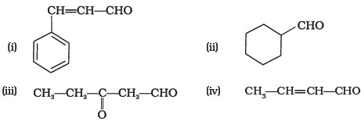
- Give the structure of the following compounds.
  - (i) 4-Nitro Propiophenone
  - (ii) 2-Hydroxy Cyclopentanecarbaldehyde
  - (iii) Phenyl acetaldehyde
- Write IUPAC names of the following structures.
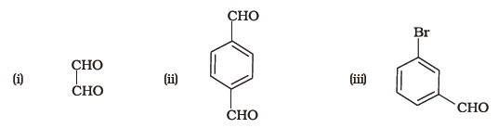
- Benzaldehyde can be obtained from benzal chloride. Write reactions for obtaining benzal chloride and then benzaldehyde from it.
- Name the electrophile produced in the reaction of benzene with benzoyl chloride in the presence of anhydrous AlCl₃. Name the reaction also.
- Oxidation of ketones involves carbon-carbon bond cleavage. Name the products formed on oxidation of 2, 5-dimethylhexane-3-one.
- Arrange the following in decreasing order of their acidic strength and give reason for your answer.
CH₃CH₂OH, CH₃COOH, ClCH₂COOH, FCH₂COOH, C₆H₅CH₂COOH
- What product will be formed on reaction of propanal with 2-methylpropanal in the presence of NaOH? What products will be formed? Write the name of the reaction also.
29. Compound ‘A’ was prepared by oxidation of compound ‘B’ with alkaline KMnO 4 . Compound ‘A’ on reduction with lithium aluminium hydride gets converted back to compound ‘B’. When compound ‘A’ is heated with compound B in the presence of H₂SO₄ it produces fruity smell of compound C to which family the compounds ‘A’, ‘B’ and ‘C’ belong to?
- Arrange the following in decreasing order of their acidic strength. Give explanation for the arrangement.
C₆H₅COOH, FCH₂COOH, NO₂CH₂COOH
- 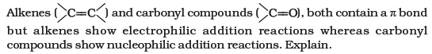
- Carboxylic acids contain carbonyl group but do not show the nucleophilic addition reaction like aldehydes or ketones. Why?
- Identify the compounds A, B and C in the following reaction
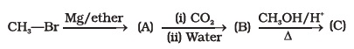
- Why are carboxylic acids more acidic than alcohols or phenols although all of them have hydrogen atom attached to a oxygen atom (—O—H)?
- Complete the following reaction sequence.
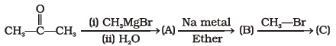
- Ethylbenzene is generally prepared by acetylation of benzene followed by reduction and not by direct alkylation. Think of a possible reason.
- Can Gattermann-Koch reaction be considered similar to Friedel Craft’s acylation? Discuss.

