- Which of the following polymers of glucose is stored by animals?
  - (i) Cellulose
  - (ii) Amylose
  - (iii) Amylopectin
  - (iv) Glycogen
- Which of the following is not a semisynthetic polymer?
  - (i) cis-polyisoprene
  - (ii) Cellulose nitrate
  - (iii) Cellulose acetate
  - (iv) Vulcanised rubber
- The commercial name of polyacrylonitrile is ______________.
  - (i) Dacron
  - (ii) Orlon (acrilan)
  - (iii) PVC
  - (iv) Bakelite
- Which of the following polymer is biodegradable?
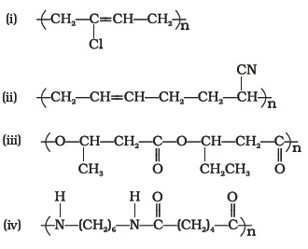
- In which of the following polymers ethylene glycol is one of the monomer units?
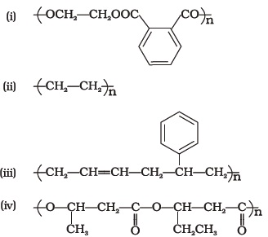
- Which of the following statements is not true about low density polythene?
  - (i) Tough
  - (ii) Hard
  - (iii) Poor conductor of electricity
  - (iv) Highly branched structure
- 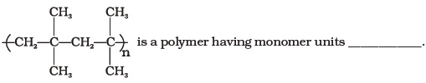
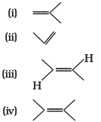
- Which of the following polymer can be formed by using the following monomer unit?
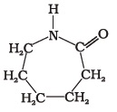
(i) Nylon 6, 6
(ii) Nylon 2–nylon 6
(iii) Melamine polymer
(iv) Nylon-6
- Which of the following polymers, need atleast one diene monomer for their preparation?
(i) Dacron
(ii) Buna-S
(iii) Neoprene
(iv) Novolac
- Which of the folloiwng are characteristics of thermosetting polymers?
(i) Heavily branched cross linked polymers.
(ii) Linear slightly branched long chain molecules.
(iii) Become infusible on moulding so cannot be reused.
(iv) Soften on heating and harden on cooling, can be reused.
- Which of the following polymers are thermoplastic?
(i) Teflon
(ii) Natural rubber
(iii) Neoprene
(iv) Polystyrene
- Which of the following polymers are used as fibre?
(i) Polytetrafluoroethane
(ii) Polychloroprene
(iii) Nylon
(iv) Terylene
- Which of the following are addition polymers?
(i) Nylon
(ii) Melamine formaldehyde resin
(iii) Orlon
(iv) Polystyrene
- Which of the following polymers are condensation polymers?
(i) Bakelite
(ii) Teflon
(iii) Butyl rubber
(iv) Melamine formaldehyde resin
- Which of the following monomers form biodegradable polymers?
(i) 3-hydroxybutanoic acid + 3-hydroxypentanoic acid
(iii) Ethylene glycol + phthalic acid
(iv) Caprolactum
- Which of the following are example of synthetic rubber?
(i) Polychloroprene
(ii) Polyacrylonitrile
(iii) Buna-N
(iv) cis-polyisoprene
- Which of the following polymers can have strong intermolecular forces?
(i) Nylon
(ii) Polystyrene
(iii) Rubber
(iv) Polyesters
- Which of the following polymers have vinylic monomer units?
(i) Acrilan
(ii) Polystyrene
(iii) Nylon
(iv) Teflon
- Vulcanisation makes rubber ______________.
(i) more elastic
(ii) soluble in inorganic solvent
(iii) crystalline
(iv) more stiff
12. The incorrect statement about LDP is:
(i) It is obtained through the free radical addition of ethene.
(ii) It consists of linear molecules.
(iii) It is obtained by the H-atom abstraction.
(iv) Peroxide is used as an initiator.

