C 1. The conditions necessary for transfer of heat from one body to another by conduction are:
  - The two objects must be in contact;
  - Their temperatures should not be the same.

- Substances which allow heat to be conducted through them easily are called good conductors of heat. For example, iron and silver are good conductors of heat.
Substances which do not allow heat to be conducted through them easily are called bad conductors of heat. For example, wood and plastic are bad conductors of heat.
- Wool fibres have pores in them which are filled up with air which is a bad conductor of
heat. Thus, wool (an insulator) and air together prevent the heat from our bodies from escaping out. So, woollen clothes keep us warmer in winters than cotton clothes.
- Ventilators in houses are provided high up on the walls because the air we breathe out is warmer and lighter, and rises up. Warm air
escapes from the ventilators. It is replaced by cool and heavier fresh air coming in from doors and windows below due to the convection.
- The heat from the sun reaches us through millions of miles of empty space by radiation only. This heat travels with the same speed as light.
- The polished curved surface at the back of the heating rod in a room heater reflects almost all the radiant heat from the heating element that falls on it. This makes the room heater more effective.

D1. Take an iron rod. Fix thumb-tacks along the length of the rod, using wax. Heat one end of the rod. As the rod gets heated, the wax melts and the thumb-tacks fall off. We will find that the thumb-tack nearest to the end being heated falls off first. The farthest thumb-tack falls off last. This shows that heat is travelling along
the length of the rod from the hot end to the cold end.
- Use of good conductors of heat: We use good conductors of heat whenever we want heat to be transferred fast, e.g. cooking utensils are made of metals such as brass or aluminium which are good conductors of heat.
Use of bad conductors of heat: We use bad conductors of heat whenever we do not want heat to be transferred quickly, e.g. handles of cooking utensils are made of bad conductors of heat such as wood or plastic.
- Take a closed rectangular glass box. With two holes in its top, fit two wide glass tubes to form chimneys. Put a small lighted candle below one of the chimneys. Hold a smouldering piece of paper at the top of the other chimney. We will see smoke entering the box through that chimney. It then gets heated up by the candle and comes out of the other chimney. As the
air above the candle gets heated, it becomes
lighter and rises up. It is replaced by fresh air sucked in from the other chimney. The
smoke is sucked in along with air and sets the convection current shown in the box.
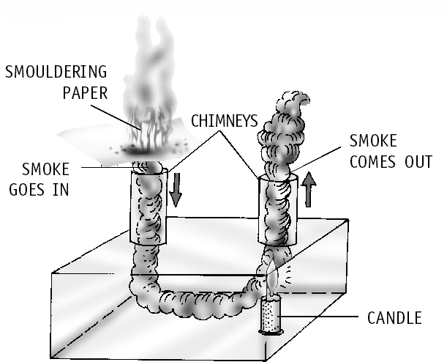
- Sea breeze: During the day, land heats up more than water. The air over the land
becomes hotter and lighter and rises up. The air from the sea, which is cooler and heavier, rushes to take the place created by the hot rising air. Therefore, a sea breeze blows during the day.
Land breeze: During the night, land loses heat faster than water and becomes cooler. The air over the sea is now warmer. It rises up and the cooler air over the land rushes to take its place. Thus, we observe a land breeze at night.

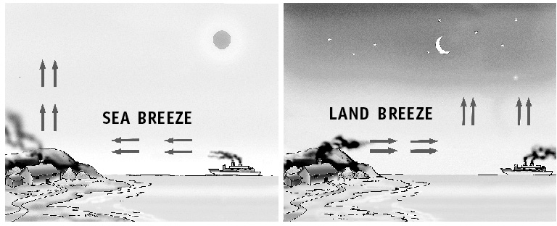
- Black objects absorb more heat than white or polished ones. Two daily uses of this are:
  - The outer base of a cooking utensil is painted black so that it absorbs more heat so that cooking can be done in less time.
  - Dark-coloured clothes are suitable in winters as they absorb more heat.
- Black objects radiate more heat than white objects. Two everyday uses of this principle are:
Living Science Companion – 7
  - The back of refrigerators are coloured dull black to radiate heat more effectively in order to cool down the refrigerator pipes.
  - Electric hot plates are also coloured dull black to radiate maximum heat.
- The vacuum between the two glass walls of the
thermos flask considerably reduces the flow
of heat by conduction and convection. This is because both conduction and convection need molecules of a medium for transfer of heat. The silvered surfaces reflect the heat back, thus, reducing radiation.
11

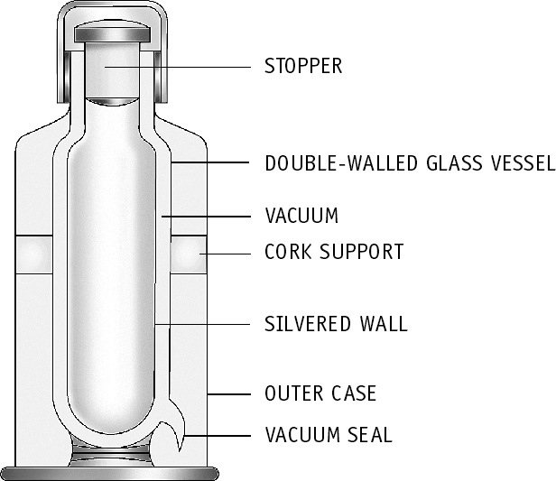

- The water in the test tube which is heated from below will heat up faster. Water is a bad conductor of heat. So, in case of the test tube heated from top, it will not easily conduct heat from the top to the bottom.
But, water transfers heat through convection. In case of the test tube heated from the bottom, water molecules getting heated become lighter and rise up. These molecules pass on their heat energy to the surrounding cold molecules and this heat is carried to all parts of water.

