Train
Humayun Kabir
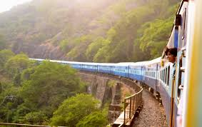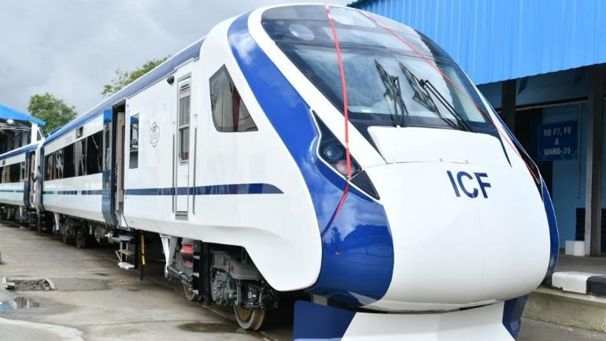

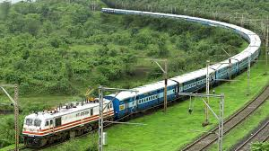
Humayun Kabir was a Bengali poet, novelist, educationist and politician. He was educated at Exeter College, Oxford and graduated in 1931. Kabir had been heavily involved with the Oxford Union during his student days, having been elected secretary in 1930 and librarian in 1931. He made his farewell speech on the motion: 'This House condemns the Indian policy of His Majesty's Government'. Kabir had also been involved with the student newspapers, the Isis and the Cherwell, and the Oxford Majlis journal, Bharat.
Upon his return to India, Kabir taught at a number of universities. He also became involved in trade union politics and was elected to the Bengal Legislative Assembly in 1937. He took up a number of government posts after 1947, including Minister for Education.
Kabir published a book of poems in Oxford in 1932, and continued to write poetry, short stories and novels after his return to India. He also wrote essays and was a well-respected orator. He died in Kolkata in 1969
