Unit 4 FORCES OF NATURE
Section 1 Tsunami: The Slayer of Lives

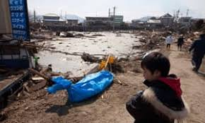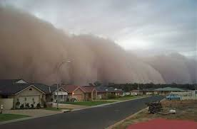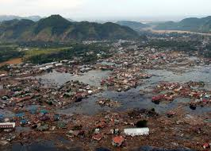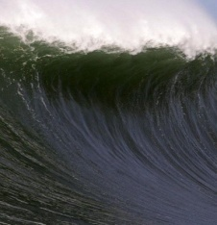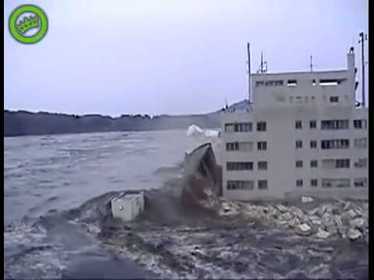

Tsunami the Slayer of lives" is a story that depicts the willpower of people who survived the natural calamity and then rebuild whatever they have lost. Some of the people lost their dear and loved ones but they began their lives in a normal way after survival.

It shows the story of Harumi who could not save his parents because they were old and could not survive the vast tidal wave. However Harumi saved himself by standing upon a piece of furniture with his neck deep down in water.

The story follows many different characters and how they managed to survive the earthquake and the tsunami. The stories within this book are real and are of real people. The book was a worldwide hit but we can’t help but feel sad for the loss of those people in the tsunami.
- tsunami: a cataclysm resulting from a destructive sea wave. ...
- wavelength: a shared orientation leading to mutual understanding. ...
- devastate: cause extensive destruction or ruin utterly. ...
- submerge: put under water. ...
- amplitude: greatness of magnitude. ...
- tidal wave: an unusual (and often destructive) rise of water along the seashore caused by a storm or a combination of wind and high tide
- tidal: of or relating to or caused by tides
- wave: a movement up and down or back and forth
- decreases: a change downward

