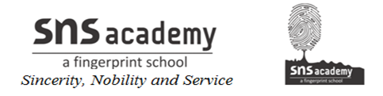
SYLLABUS DIVISION FOR – 2019-20
STD –IV
SUBJECT: SOCIAL SCIENCE

MONTH | CHAPTER
JUNE | CH -1 I LOVE INDIA  CH -2 THE NORTHERN MOUNTAINS  CH -3 THE NORTHERN AND COASTAL  PLAINS  MONTHLY TEST
JULY | CH-4 THE WESTERN DESERT  CH -5 THE SOUTHERN PLATEAUS AND THE ISLANDS  CH -6 OUR CLIMATE  MONTHLY TEST
AUGUST | CH-7 OUR SOILS  CH -8 OUR AGRICULTURE  CH -9 OUR INDUSTRIES  CH-10 TRANSPORT AND COMMUNICATION
SEPTEMBER | TERMINAL EXAMINATION-1
OCTOBER | CH 11 OUR NATURAL RESOURCES  CH-12 OUR FORESTS  CH -13 OUR WATER RESOURCES
NOVEMBER | CH-14 OUR MINERAL RESOURCES  CH -15 EMPEROR AKBAR  MONTHLY TEST
DECEMBER | CH-16 THE AGE OF EXPLORATION  CH -17 OUR RICH CULTURE  MONTHLY TEST
JANUARY | CH -18 OUR RIGHTS AND DUTIES
FEBRUARY | CH -19 LOCAL SELF-GOVERNMENTS IN CITIES
MARCH | ANNUAL EXAMINATION

