Grade:IV Addition
Addition is finding the total of different values.
The important thing to remember when adding is to line up the numbers carefully according to place value.
The numbers which we add are called ADDENDS and the answer of an addition operation is called SUM.
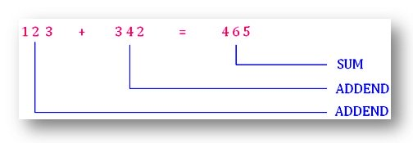
Properties of Adddition
1. Changing the order of addends does not change the sum.
46 + 17 = 63 | 17 + 46 = 63
2. Adding 0 to a number does not change the number.
142 + 0 = 142 | 0 + 176 = 176
How to add the numbers?
Add: 4572 and 7255
Step I: Line up the numbers according to place value add the ONES
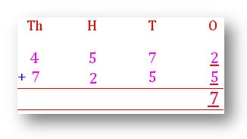
Step II:
Add the TENS 7 + 5 = 12 TENS
REGROUP as 1 HUNDRED 2 TENS
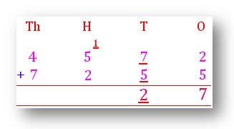
Step III:
Add the HUNDREDS
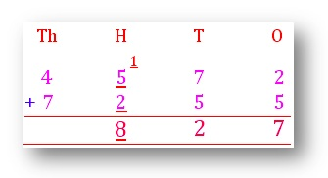
Step IV:
Add the THOUSANDS
4 + 7 = 11 Regroup
1 TEN THOUSAND 1 THOUSAND
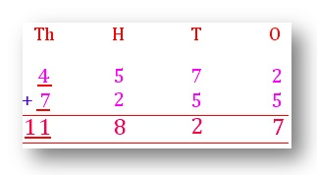
We start from the right and move to the left when we are adding. After adding each place, we need to check. If the sum is 10 more, and then REGROUP.
Example 1. Add 3127 and 1652
Solution:
