Fractions
Fraction of a whole numbers are explained here with 4 following examples.
(i)
Each one is divided into 4 equal parts. One part is shaded, i.e., one-fourth of the shape is shaded and three parts of the shape is unshaded.
We say that, 1/4 of the shape is shaded and 3/4 of the shape is unshaded.
This 1/4 or 3/4 is a fraction or a fractional number.
1/4 = Out of 4 equal parts of a whole, one part is taken.
3/4 = Out of 4 equal parts of a whole, 3 parts are taken.
There is a collection of 7 glasses, of which 4 glasses are colorful.
.
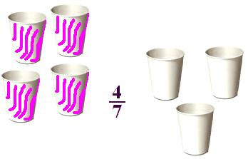

There are 12 hearts in a collection. 5 hearts are in shaded parts.
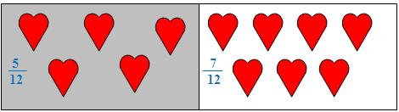
0Save
5 out of 12 hearts are in shaded portion and the rest 7 out of 12 hearts are in unshaded portion.
They represent 5/12 and 7/12 as fractions

