Grade:IV Subtraction

The answer of a subtraction sum is called DIFFERENCE.

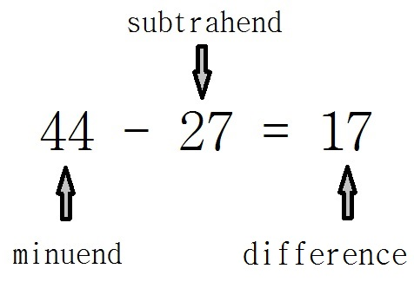
How to subtract 3-digit numbers?
Steps are shown to subtract 3-digit numbers.
Subtract 189 from 638.
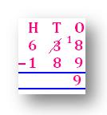
REGROUP 38 as 2 TENS 18 ONES
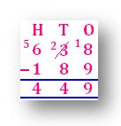
REGROUP 62 as 5 TENS 12 ONES
Answer: 449

Examples:
1. Subtract 2684 from 6795.
Solution:
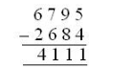
The numbers are arranged in column form
(i) Ones are subtracted, 5 – 4 = 1
(ii) Tens are subtracted, 9 – 8 = 1
(iii) Hundreds are subtracted, 7 – 6 = 1
(iv) Thousands are subtracted, 6 – 2 = 4
Hence, difference = 4,111

2. Subtract 6732 from 9340 (with borrowing).
Solution:
The numbers are arranged in column form
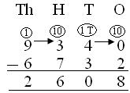
1Save
(i) Ones are subtracted, 0 < 2, so 1 ten is borrowed from tens.
Now 1 Ten or 10 + 0 = 10, 10 – 2 = 8
(ii) Tens are subtracted, 3Tens – 3Tens = 0
(iii)Hundreds are subtracted, 3 Hundreds < 7 Hundreds so, 1 Thousand is borrowed,
so 10 Hundreds + 3 Hundreds = 13 Hundreds,
13 Hundreds – 7 Hundreds = 6 Hundreds.
(iv) Thousands are subtracted, 8Thousands – 6Thousands = 2Thousands
Hence, difference = 2,608

