Circles
A circle is such a closed curve whose every point is equidistant from a fixed point called its center.
The symbol of circle is O.

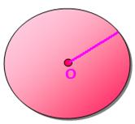
Parts of a Circle:
(i) Center:
The center of a circle is a fixed point within the circle from which all the points of the closing curve are equidistant.
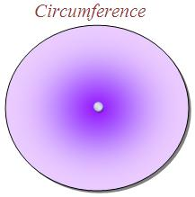
O is the centre.
(ii) Circumference:
The curve which closes a circle is called its circumference. The length of the circumference is called the length of the circle.

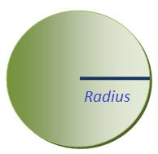
(iii) Radius:
The distance from the centre to any point on the circumference of a circle is called the radius of the circle. The symbol of the radius is r.

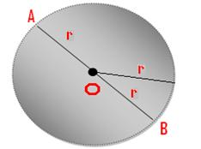
(iv) Diameter:
The line-segment passing through the centre and meeting the points on the circumference is called the diameter of the circle. Diameter is denoted by 'D'.
AB is a diameter of the circle.
Diameter is twice the length of the radius concerned.
Thus, D = 2r [Diameter = 2radius]
or
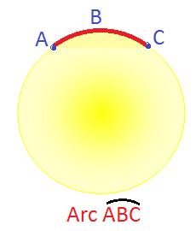
r = D/2 [Radius = Diameter/2]

(v) Arc:
Any part of the circumference is called an arc of the circle.

(vi) Chord:
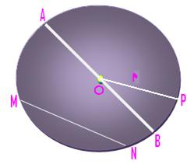
The line-segment joining the two ends of an arc is known as a chord. A diameter is the longest chord of a circle.
Here,
O is the centre.
OP is one radius.
AB is a diameter.
MN is a chord . (line-segment)
OA and OB are also radii.

