Fractions
Fractions are numbers representing part of a whole.
A fraction is a number of the form p/q, such that q is not equal to zero or one.
A fraction has two parts. The number on the top is numerator and the number below is the denominator.
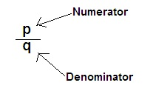
The numerator can be greater or smaller than the denominator.
For e.g. 1/5th of a pizza is a fraction , that is, written as 1/5.
