Introduction
Data is a collection of numbers gathered to give some information. To get particular information from the given data quickly, the data has to be organized first.
The organization of data can be done in various ways. One way to organize data is by using tally marks. Tally marks are a way of expressing numbers in groups of 5. The numbers are represented as follows:
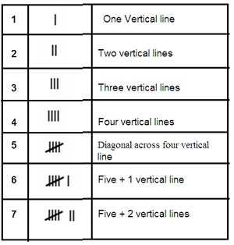

Problem: Following is the choice of sweets of 30 students of Class VI.
Ladoo, Barfi, Ladoo, Jalebi, Ladoo, Rasgulla, Jalebi, Ladoo, Barfi, Rasgulla, Ladoo, Jalebi, Jalebi, Rasgulla, Ladoo, Rasgulla, Jalebi, Ladoo, Rasgulla, Ladoo, Ladoo, Barfi, Rasgulla, Rasgulla, Jalebi, Rasgulla, Ladoo, Rasgulla, Jalebi, Ladoo.
- Arrange the names of sweets in a table using tally marks.
- Which sweet is preferred by most of the students?
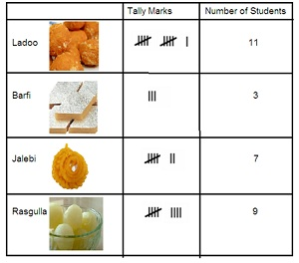
Ladoo is most preferred by people as 11 people prefer it.

