Pictograph
A pictograph can be used to represent data in the form of pictures, objects or parts of objects. A pictograph represents data through pictures of objects. It helps answer the questions on the data at a glance.
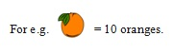
Problem: Total number of students of a school in different years is shown in the following table:
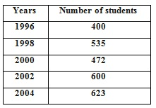
Prepare a pictograph of students using one symbol ⚴ to represent 100 students and answer the following questions:
Q: How many symbols represent total number of students in the year 2002?
Ans: Year 2002 has 600 students. One picture is equivalent to 100 students. Hence 2002 is represented by 6 symbols.
Q: How many symbols represent total number of students for the year 1998?
Ans: Year 1998 has 535 students. Hence it is represented by 5 complete symbols and 1 incomplete symbol.
