Grade: V Division
Relation between Dividend, Divisor, Quotient and Remainder is.
Dividend = Divisor × Quotient + Remainder
Example: Divide 537809 by 35 and find the quotient and remainder.
We need to divide the dividend i.e. 537809 by the divisor i.e. 35 to get the quotient and remainder.
5 cannot be divided by 35 as 5 < 35. So, we will move to the next digit of the dividend i.e. 3 and now we have 53 which can be divided by 35 as 53 > 35. We first divide 53 by 35. 35 into 53 is 1 leaving 18.
Then we bring down the next digit of the dividend i.e. 7 and we have 187. Now we divide 187 by 35 so, 35 into 187 is 5 leaving 12.
Again we bring down the next digit of the dividend i.e. 8 and we have 128. Now we divide 128 by 35 so, 35 into 128 is 3 leaving 23.
Similarly, again we bring down the next digit of the dividend i.e. 0 and we have 230. Now we divide 230 by 35 so, 35 into 230 is 6 leaving 20.
And at last we bring down the last digit of the dividend i.e. 9 and we have 209. So, we divide 209 by 35 then, 35 into 209 is 5 leaving 34.
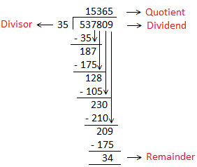
Check the answer of the division:
Dividend = Divisor × Quotient + Remainder
537809 = 35 × 15365 + 34
537809 = 537775 + 34
537809 = 537809

