Grade: V DMAS

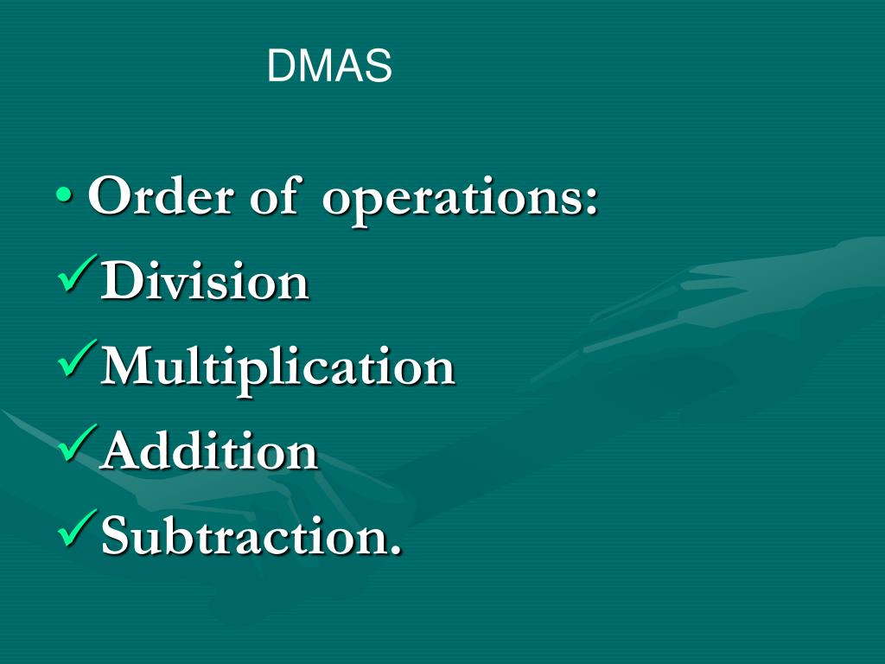

1. Simplify: 24 - 4 ÷ 2 x 3
Solution:
24 - 4 ÷ 2 x 3
[Here order is expressed in short as ‘DMAS’ where ‘D’ stands for division, ‘M’ for multiplication, ‘A’ for addition and, ‘S’ for subtraction]
= 24 - 2 x 3 [Performing division - 4 ÷ 2 = -2]
= 24 - 6 [Performing multiplication 2 x 3 = 6]
= 18. [Performing subtraction 24 – 6 = 18]
Answer: 18.
2. Simplify: 48 ÷ 8 x 3 + 2
Solution:
48 ÷ 8 x 3 + 2
[Here order is expressed in short as ‘DMAS’ where ‘D’ stands for division, ‘M’ for multiplication, ‘A’ for addition and, ‘S’ for subtraction]
= 6 x 3 + 2 [Performing division 48 ÷ 8 = 6]
= 18 + 2 [Performing multiplication 6 x 3 = 18]
= 20. [Performing addition 18 + 2]
Answer: 20.
3. Simplify: 52 - (2 x 6) + 17
Solution:
52 - (2 x 6) + 17
= 52 – 12 + 17
= 52 + 17 - 12
= 57
Answer: 57

