Grade: V Multiplication
Multiplication of whole numbers is the sort way to do repeated addition.
The number by which any number is multiplied is known as the multiplicand. The result of the multiplication is known as the product
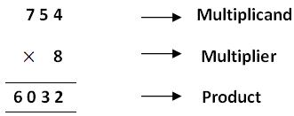
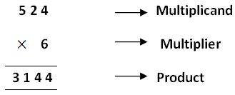
Note: Multiplication can also be referred as product.
Multiply 6285 by 289.
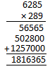
When we multiply 6285 by 289 we know, 6285 is the multiplicand and 289 is the multiplier. First with the multiplicand i.e. 6285 we will multiply by 9 and we get 56565. Then we will multiply 6285 by 8 and we get 50280 and atlast when we will multiply 6285 by 2 and we get 125700.
Therefore, after adding we get 1816365.

