Angles
ANGLE:
When two rays have a common end point they from an angle. In this figure two rays OA and OB have a common end point O. So they form an angle AOB. The common end point is called the Vertex and rays OA and OB are the arms of the angle.
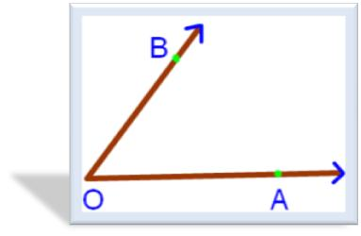In the above figure, AOB is angle whose two arms are the rays OB and OA. The symbol for an angle is < and angle AOB can be written as <AOB. Every angle has a measure. The unit of measurement of an angle is degree (°). In a figure the measure of an angle is generally written between the arms of the angle, close to the vertex.
Always remember, while naming the angle, the vertex is always in the centre.The figure formed by two rays with the same initial point is called an angle.

Types of Angles
1. Acute Angle:
An angle whose measure is less than 90° is called an acute angle.
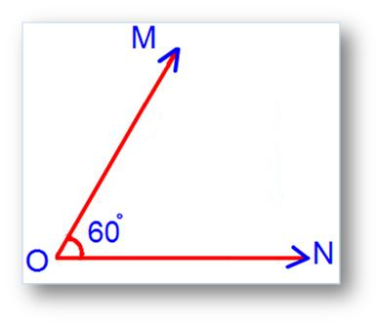

∠MON shown in adjoining figure is equal to 60°. So, ∠MON is an acute angle.
2. Right Angle:
An angle whose measure is 90° is called right angle.
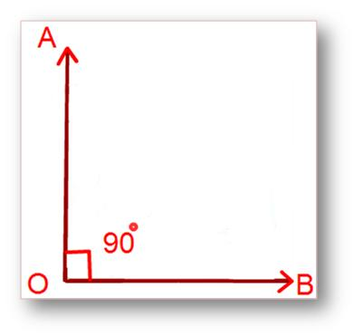
In the above figure, ∠AOB is a right angle. In this case, we say that the arms OA and OB are perpendicular to each.Therefore, ∠AOB shown in adjoining figure is 90°.
So, ∠AOB is a right angle.
3. Obtuse Angle:
An angle whose measure is greater than 90° but less than 180° is called an obtuse angle.
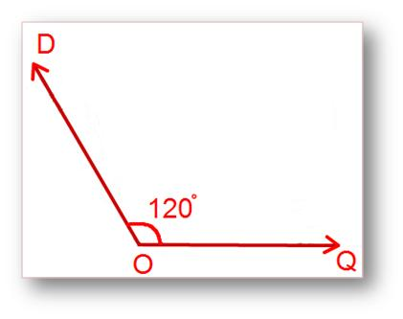
∠DOQ shown in the above figure is an obtuse angle.

4. Straight Angle:
An angle whose measure is 180° is called a straight angle.
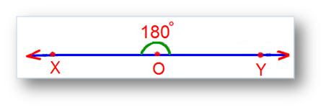
2Save
∠XOY shown in the above figure is a straight angle.
A straight angle is equal to two right angles.

Protractor:
It is an instrument for measuring or constructing an angle of a given measure. It is a circular or semicircular piece of metal or plastic.
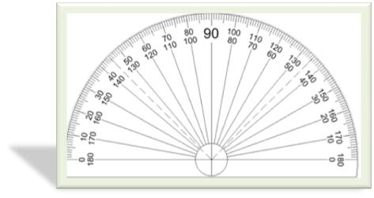
For Example:
1. Use your protractor to draw 60°.
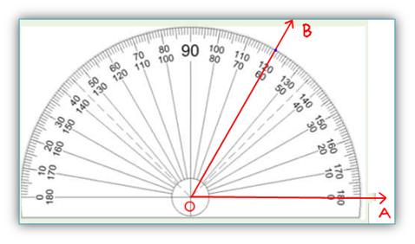
The centre O of the piece is also the midpoint of its base line. In order to measure ∠AOB, place the protractor in such a way that its centre is exactly on the vertex O of the angle, the base line lies along the arm OA. We need to read the mark through which the arm OB passes, starting from O on the side A, as we observe in the above figure.

