All about Time

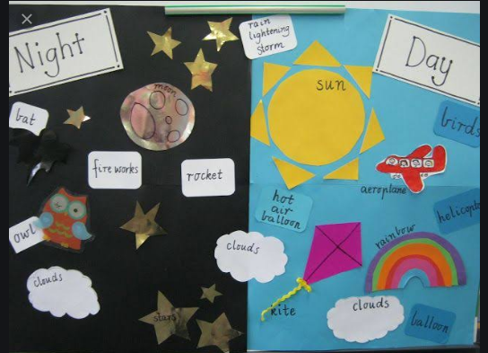

When the Sun is usually seen in the sky and it is bright, it is day.
When the Sun is not seen in the sky and it is dark, it is night.

