CHRISTMAS:
CHRISTMAS -
TREE
CHRISTMAS -
STARS
CHRISTMAS -
CAKE
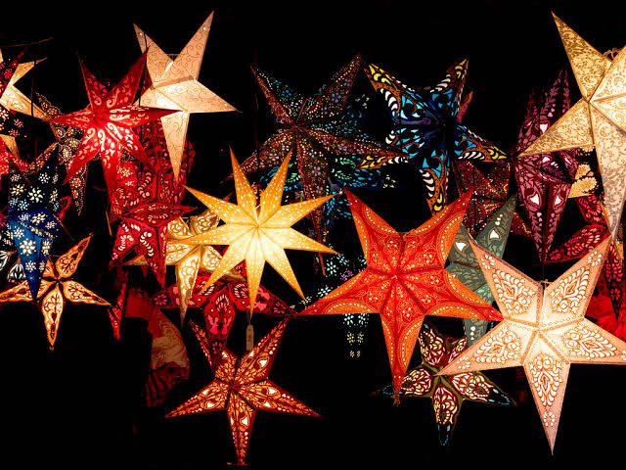
CHRISTMAS -
GIFTS
CHURCH
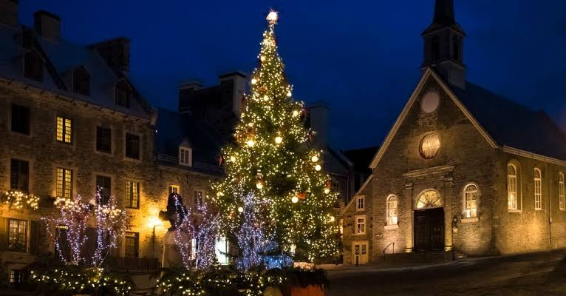
- On Christmas eve, people go to the church to pray.
- Christmas trees are kept at home for the entire month of December and decorated with many materials.
- Gifts are exchanged in the family.
- People make plum cake and distribute it among friends and relatives.

