FLOWERS:

|  |
| --- |
| ROSE |

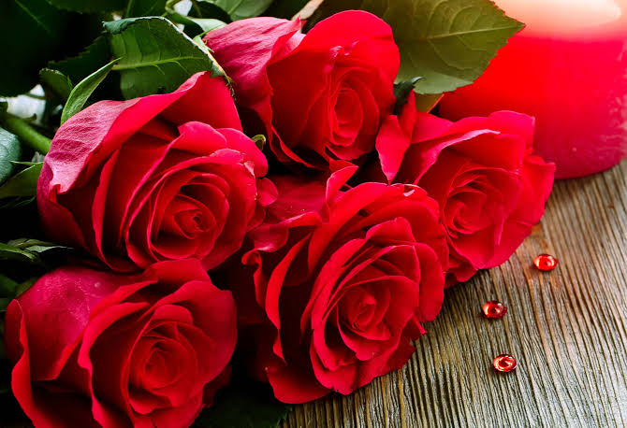

|  |
| --- |
| JASMINE |

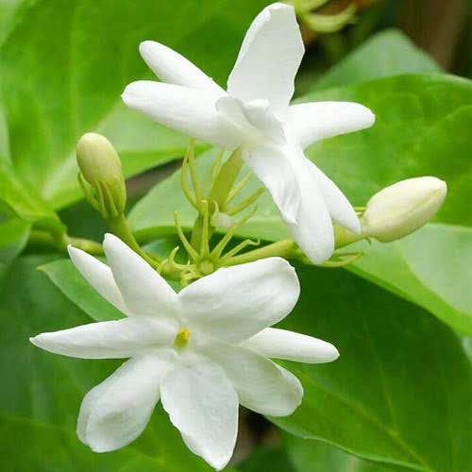

|  |
| --- |
| HIBISCUS |

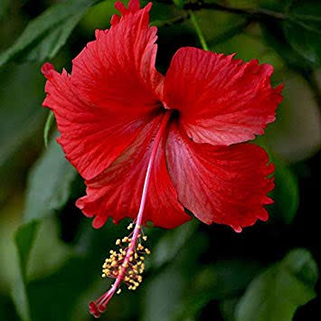

|  |
| --- |
| LOTUS |

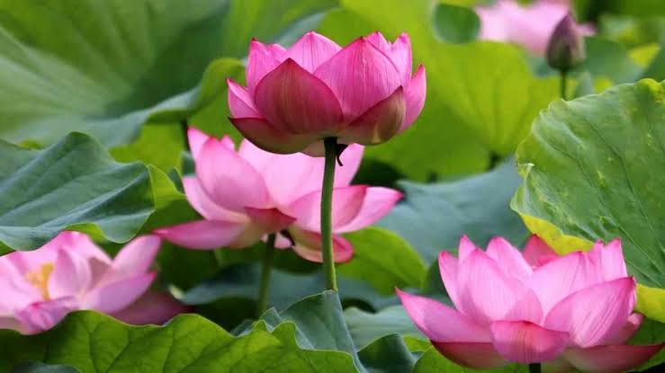

|  |
| --- |
| LILY |

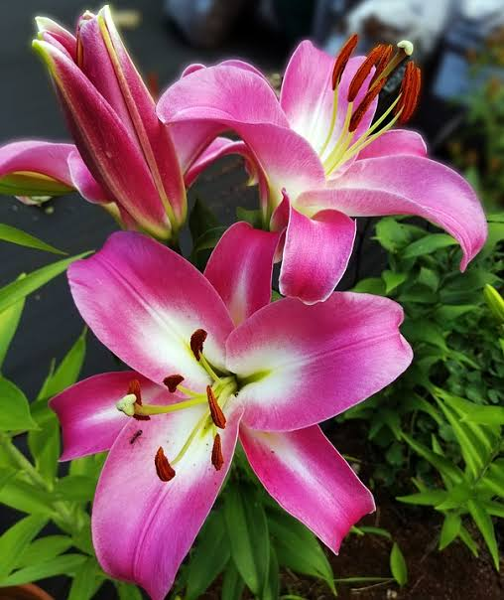

|  |
| --- |
| KURINJI |

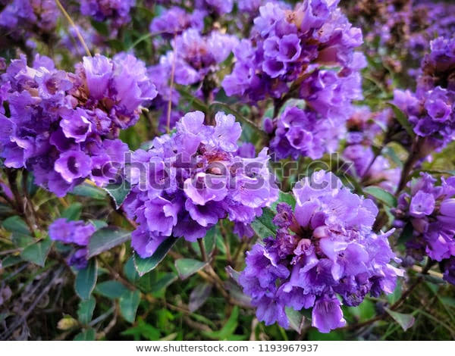

|  |
| --- |
| BLUEBELL |

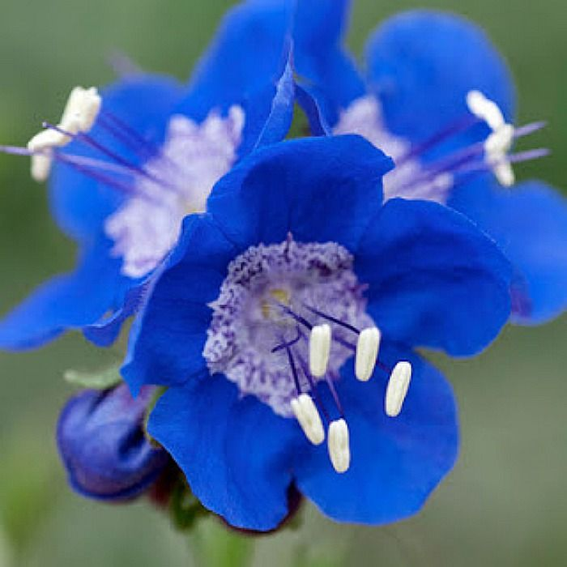

|  |
| --- |
| SUNFLOWER |

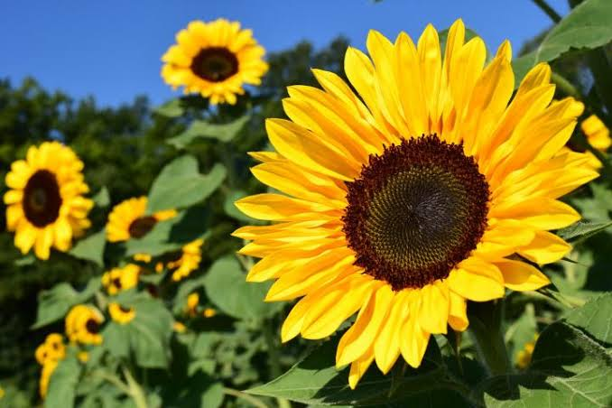

|  |
| --- |
| MARIGOLD |

