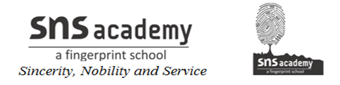
I. Write the antonyms for the following:
- Above
- After
- Bad
- Big
- Boy
- Clean
- Close
- Cold
- Day
- Happy
- Long
- Lost
- Polite
- Poor
- Sell
- Ugly
- Wet
- Young
- Up
- Stop

