MONTHLY TEST – JULY 2019
SOCIAL SCIENCE
GRADE : III TIME : 1hr
DATE : MAX.MARKS: 30
- Choose the best answer. (5 x 1 = 5)

- The Sun is a ______________
- Planet b. Star c. Satellite

- There are ___________ Planets in our solar system
- 10 b. 8 c. 6

- Earth has ______________ Moon
- 1 b. 2 c. Many

- ____________ has several hundred rings around it.
- Saturn b. Mars c. Mercury

- _________________ and ____________ are called Twin Planets
a. Mercury and Venus b. Uranus and Neptune c. Jupiter and Saturn

- True or False (3 X 1 = 3)

- Earth takes 365 days to revolve around the Sun

- Neptune is the first planet of the Solar system

- Earth is called Red planet

- Label the Solar system and colour it. (9 X 1 = 9)
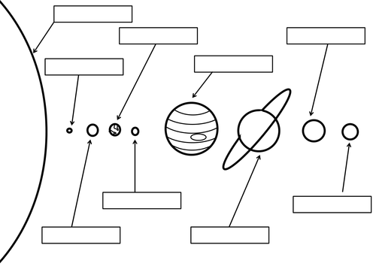

- Match the following (4 X 1 = 4)

- Bright Star - Earth
- Blue planet - Neptune & Uranus
- Ice Giants - Saturn
- Ringed planet - Sun

- Answer the following (3 X 3 = 9)
- Write down two main features of Mercury.

- In what way is Saturn an unique planet?

- Which planet is most suitable for living? Why?

