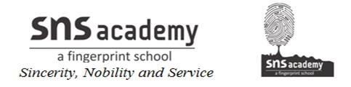
MONTH | UNIT/TOPIC
JUNE | 1)A CURVE OF COLOURS
JULY | 2)THE WEB OF LIFE  3)LOOK BEFORE YOU LEAP
AUGUST | 4)MY FRIEND AND I  5)A CLEAN WORLD
SEPTEMBER | REVISION
OCTOBER | 6)THE PROBLEM PUZZLE  7)THE GOLDEN TOUCH
NOVEMBER | 8)MINDING MY MANNERS
DECEMBER | REVISION
JANUARY | 9)A FRIEND IN NEED
FEBRUARY | 10)WHERE IS THE WIND
MARCH | REVISION

ANNUAL PLAN (2019-2020)
SUBJECT : ENGLISH GRADE : II – A&B

