Respiration
Question Bank

D.1. The two main processes of respiration are:
  - External respiration or breathing, that is, taking in air rich in oxygen (inhalation) and giving out air rich in carbon dioxide (exhalation).
  - Internal respiration or cellular respiration, that is, using oxygen to break down food to release energy. Internal respiration occurs in the body cells.
- a. Fishes use gills for exchange of gases. Gills are made up of a large numbers of filaments, richly supplied with thin blood veins called capillaries. As water enters
through the mouth it flows over the gills. The blood in the capillaries absorbs oxygen and gives out carbon dioxide through its walls.
b. Cockroaches have openings called spiracles on their bodies. Air enters through these openings and reaches all parts of the body through respiratory tubes called trachea and their branches called tracheoles.
- The air around us is impure. Our lungs require air which is moist, warm and clean. As the air, we breathe in, passes through the nostrils,
it is moistened by the slimy mucous present in the nose. Mucous is secreted by the inner lining of the nose. The air becomes warm by the blood circulating in the nose. The mucous and the hair present inside our nose trap dirt, dust particles and disease-causing germs,and prevent them from entering the respiratory system.
19
4.
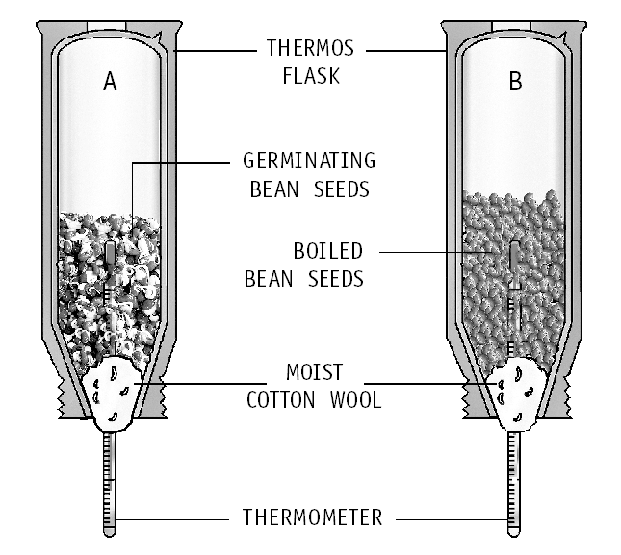
Two flasks were used in the experiment because two types of seeds were taken in them – flask A contains germinating bean seeds whereas flask B contains boiled bean seeds.
  - The air we breathe in eventually reaches the tiny air sacs called alveoli through the bronchus and its smaller branches, the bronchioles. The sacs are surrounded by blood vessels. The oxygen present in the air we breathe in, goes into the blood contained in blood vessels. The carbon dioxide present in the blood (as a waste product of respiration) passes out of the blood into the air sacs. Thus, exchange of gases takes place in the lungs.
  - In the lungs, each bronchus branches out into smaller tubes called bronchioles. At the end of these tubes are tiny air sacs called alveoli. Each lung contain about 300 million alveoli.
The air we breathe in eventually reaches these air sacs. The sacs are surrounded by blood vessels. The oxygen present in the air we breathe in, goes into the blood contained in blood vessels. The carbon dioxide present in the blood passes out of the blood into the air sacs. Thus, exchange of gases takes place in the lungs.

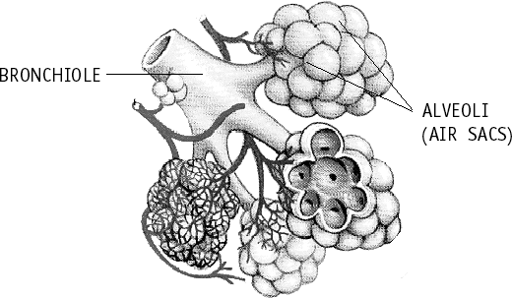
  - Similarity between cellular respiration and combustion is that the similar kind of chemical reaction occurs in both of them. Both the processes release energy.
Differences between combustion and cellular respiration are:Combustion
20
- Combustion is a fast process and can occur anywhere.
- It occurs at high temperature.
- Energy is released in a single step in the form of heat and light.
Cellular respiration
- Cellular respiration is a slow process which occurs only in living cells.
- It occurs at body temperature.
- Energy is released in steps, and stored in chemical molecules called ATP.
  - Let us take two test tubes each of them half- filled with lime water. Using two-holed stoppers, glass tubes and clips, we set up the apparatus as shown. We use the rubber tube at the middle to breathe in and out through the mouth. As
we suck in air through the rubber tube, clip X is opened and clip Y is closed. The inhaled air
passes through lime water in test tube A. As we exhale through the rubber tube, clip Y is opened and clip X is closed. The exhaled air passes through the lime water in test tube B.
Lime water turns more milky in test tube B. This shows that exhaled air has more carbon dioxide.
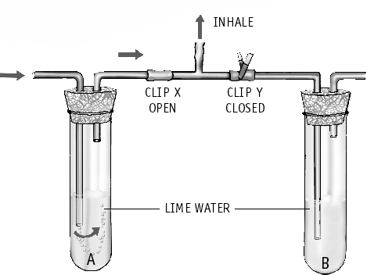

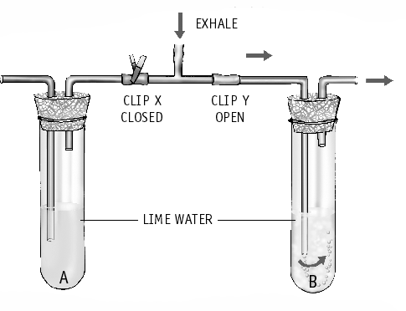
  - Breathing
    - It is a physical process of exchange of gases. No chemical reaction takes place.
    - It takes place outside the cells.
    - There is no release of energy.
Cellular respiration
- Chemical reaction of oxidation of food takes place.
- It takes place within the cells.
- There is release of energy.
  - Some organisms such as yeast and some
bacteria can live without oxygen. In their cells, glucose is broken into alcohol and cabon dioxide without using oxygen, to give energy. This process is called anaerobic respiration. The amount of energy given out in anaerobic respiration is much less than that in aerobic respiration.
Sometimes during strenuous activity such as long distance running, our body cannot get enough oxygen to produce the required
energy. To get the additional energy, anaerobic respiration occurs within our muscle cells.
  - During exercise, our body can not get enough oxygen to produce the required energy. To get the extra energy, anaerobic respiration takes place in our muscle cells. In this process, there is partial breakdown of glucose to produce lactic acid. The accumulation of lactic acid in the body causes muscular cramps. That is why we sometimes have cramps after heavy exercise.

