DECIMALS

- Write the following as decimals?
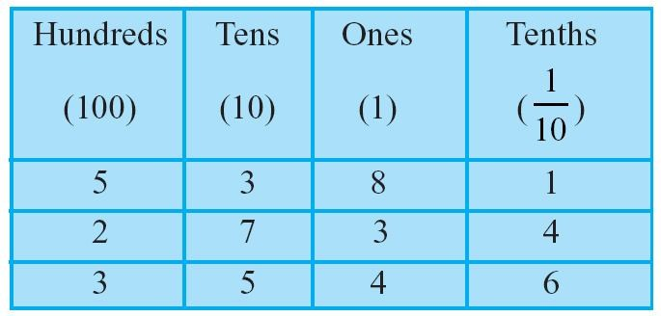

- Write the following numbers in the place value table : (a) 20.5 (b) 4.2

- Write each of the following as decimals : (a) Two ones and five-tenths (b) Thirty and one-tenth

- Express the following as cm using decimals. (a) 2 mm (b) 30 mm (c) 116 mm (d) 4 cm 2 mm (e) 162 mm (f) 83 mm

- Show the following numbers on the number line. (a) 0.5 (b) 1.3 (c) 1.8 (d) 2.1

Write as fractions in lowest terms. (a) 0.04 (b) 2.34 (c) 0.342

- Write each of the following as a decimal.

Three hundred six and seven-hundredths
  - Eleven point two three five

Nine and twenty five thousandths

- Which is greater? (a) 1 or 0.99 (b) 1.09 or 1.093

- Express as rupees using decimals.
  - 15 paise
  - 175 paise
  - 270 paise
  - 95 rupees 9 paise

- Express as metres using decimals.
  - 13 cm
  - 5 cm
  - 4 m 5 cm
  - 8 m 7 cm

