MCQ WORKSHEET-I

CLASS VI: CHAPTER - 7
FRACTIONS

- Write the fraction representing the shaded region in the below left figure.

  - 3 7
  - 5 7
  - 4 7
  - none of these

- Write the fraction representing the shaded region in the above sided right figure.

  - 3 7
  - 5 7
  - 4 7
  - none of these

- Write the fraction representing the shaded region in the below left figure.

  - 1 4
  - 2 4
  - 3 4
  - none of these

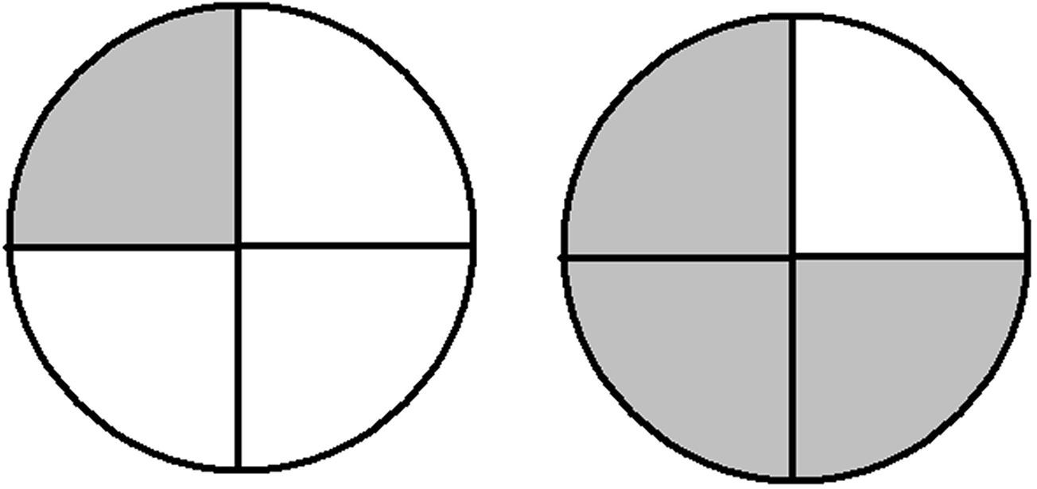
- Write the fraction representing the shaded region in the above sided right figure.

  - 1 4
  - 2 4
  - 3 4
  - none of these

- Write the fraction representing the shaded region in the below left figure.

  - 1 4
  - 2 4
  - 3 4
  - none of these

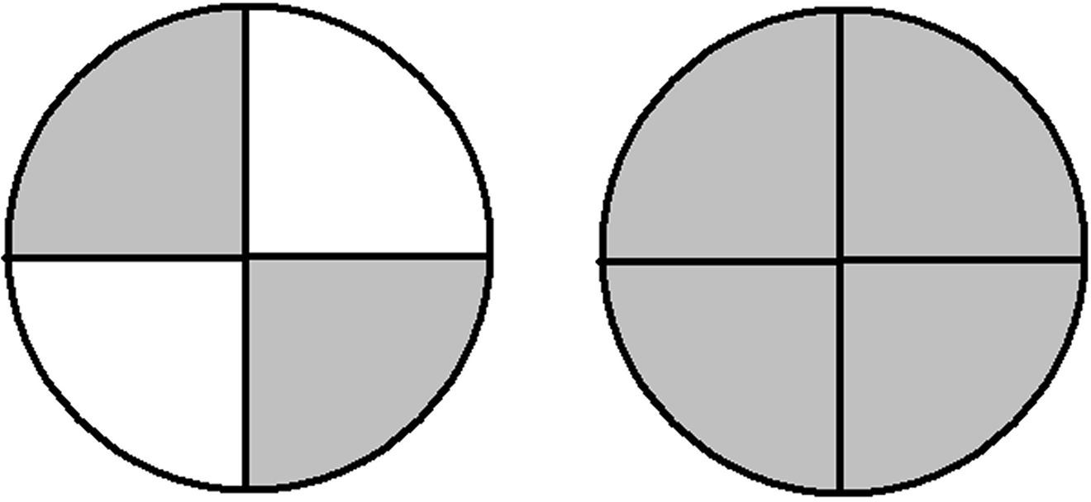
- Write the fraction representing the shaded region in the above sided right figure.

  - 1 4
  - 2 4
  - 3 4
  - none of these

- Write the fraction representing the shaded region in the below left figure.

  - 1 8
  - 4 8
  - 5 8
  - 3 8

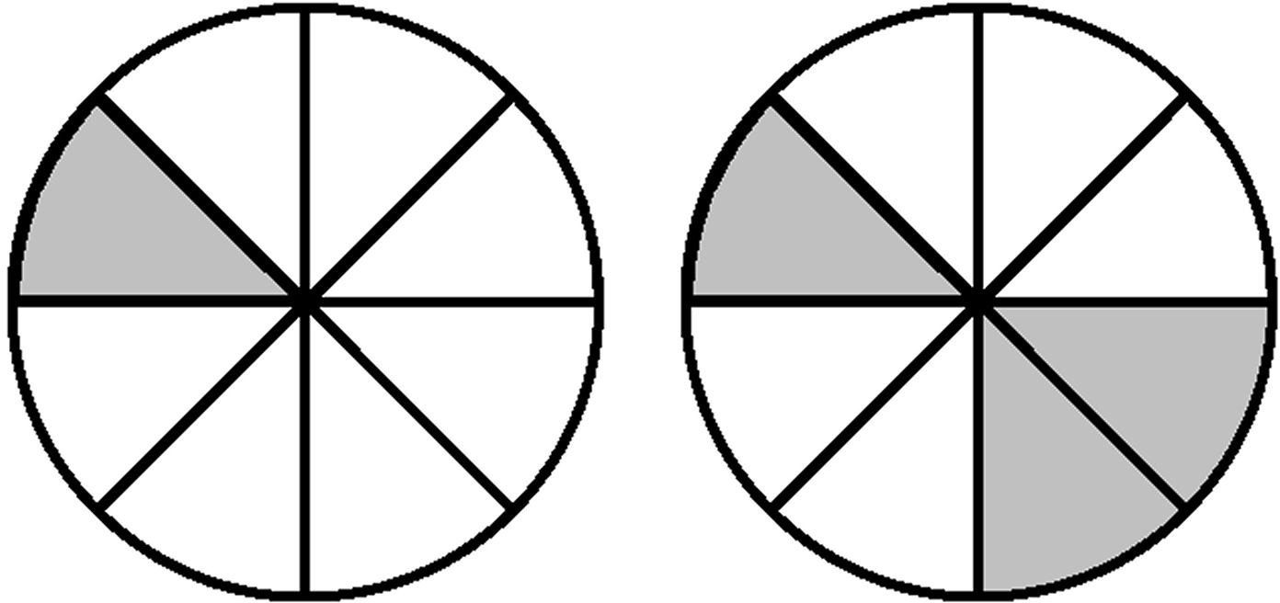
- Write the fraction representing the shaded region in the above sided right figure.

  - 1 8
  - 4 8
  - 5 8
  - 3 8

- Write the fraction representing the shaded region in the below left figure.

  - 1 8
  - 4 8
  - 5 8
  - 3 8

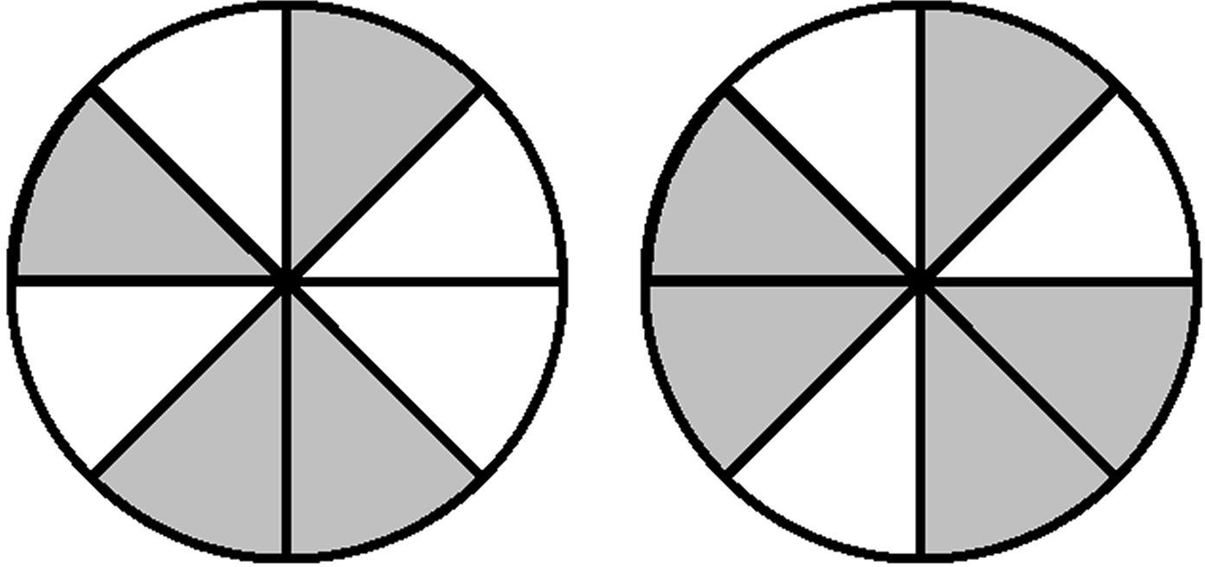
- Write the fraction representing the shaded region in the above sided right figure.

  - 1 8
  - 4 8
  - 5 8
  - 3 8

