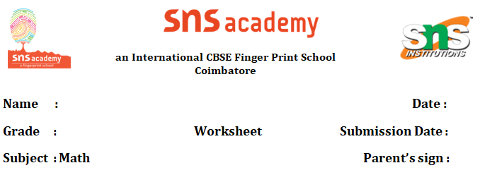

**Matrices & Determinants**

1. Total number of possible matrices of order 2 × 3 with each entry 1 or 0 is

(a) 6 (b) 36 (c) 32 (d) 64

2. If A is a square matrix such that A²=A, then (I + A)² – 3A is

(a) I (b) 2A (c) 3I (d) A

3. If matrices A and B are inverse of each other then

(a) AB = BA (b) AB = BA = I (c) AB = BA = 0 (d) AB = 0, BA = I

4. The diagonal elements of a skew symmetric matrix are

(a) all zeroes

(b) are all equal to some scalar k(≠ 0)

(c) can be any number

(d) none of these

5. If a matrix A is both symmetric and skew symmetric then matrix A is

(a) a scalar matrix

(b) a diagonal matrix

(c) a zero matrix of order n × n

(d) a rectangular matrix

6. If *n* = *p*, then the order of the matrix 7X – 5Z is:

 (a) p × 2                    (b) 2 × n (c) n × 3                     (d) p × n

7. If A, B are symmetric matrices of same order, then AB – BA is a

(a) Skew symmetric matrix     (b) Symmetric matrix

(c) Zero matrix                            (d) Identity matrix

 8. Assertion(A)    : Only square Matrices can be multiplied

 Reason(R)        :  Square matrices have the same order

a) Assertion is true and Reason is true . Reason is correct explanation for Assertion.

b) Assertion is true and Reason is true . Reason is not the correct explanation for Assertion.

 c) Assertion is true and Reason is false.

 d) Assertion is false but Reason is true.

9. Assertion(A) : A Square matrix can be expressed as sum of two different

Matrix

 Reason(R)        :  These matrices essentially are symmetric and skew symmetric

a)Assertion is true and Reason is true . Reason is correct explanation for

Assertion.

b) Assertion is true and Reason is true . Reason is not the correct explanation for   Assertion.

c) Assertion is true and Reason is false.

d) Assertion is false but Reason is true.

10. For what values of k the system of linear equations  
x + y + z = 2  
2x + y – z = 3  
3x + 2y + kz = 4 has a unique solutions?

11. Solve the system of equations x + y + z = 6, x + 2z = 7, 3x + y + z = 12.

12. Using matrices, solve the following system of equations.  
 x – y + 2z = 7 , 3x + 4y – 5z = – 5 , 2x – y + 3z = 12

13. A total amount of ₹ 7000 is deposited in three different savings bank accounts with annual interest rates of 5%, 8% and 8 12 %, respectively. The total annual interest from these three accounts is ₹ 550. Equal amounts have been deposited in the 5% and 8% savings accounts. Find the amount deposited in each of the three accounts, with the help of matrices.