ELO 1: | Multiply numbers using the long multiplication method
I. | Circle the option which is NOT true.
1. | 12 × 6 = 6 × 12
2. | 15 × 100 = 100 × 15
3. | 16 × 200 = 3,200
4. | 0 × 37 = 37

II. | Shiva arranged some balls in the pattern shown here. Which number sentence represents his arrangement of balls?
 | 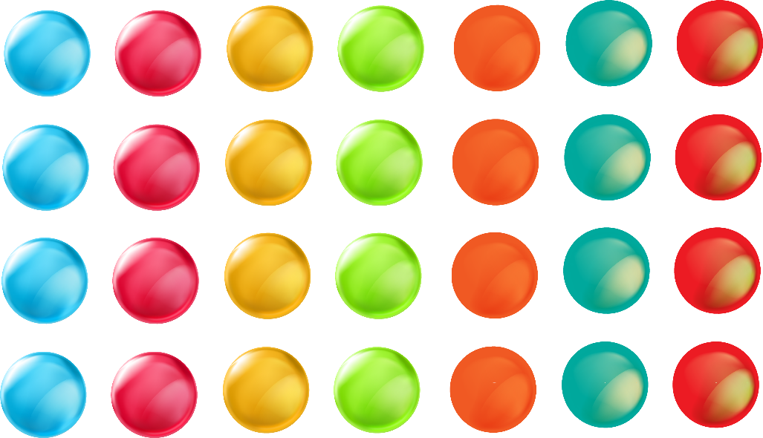
 | 7 + 4 = 11 | 7 × 4 = 28
 | 7 × 7 = 49 | 28 – 4 = 24

III. | Fill in the blanks.
1. | 2,456 × _____________ = 2,456
2. | 684 × _____________ = 6,840
3. | 319 × _____________ = 31,900
4. | 12 × 800 = _____________
5. | 18 × 500 = _____________

IV. | Fill in the blanks.
1. | 451 x 100 = _____________
2. | 5,121 x 10 = _____________
3. | 3,515 x 100 = _____________
4. | 398 x 1000 = _____________
5. | 7,812 x 1000 = _____________

V. | Find the product.
1. | 1,231 x 23 = _____________
2. | 2,214 x 12 = _____________
3. | 234 x 22 = _____________
4. | 9,012 x 11 = _____________
5. | 6,123 x 11 = _____________
6. | 4,321 x 21 = _____________

VI. | Fill in the blanks.
1. | 231 x 121 = _____________
2. | 443 x 211 = _____________
3. | 330 x 105 = _____________
4. | 2,341 x 21 = _____________
5. | 675 x 42 = _____________

VII. | Match the following.
1. | 413 x 62 | 20,406
2. | 948 x 24 | 23,838
3. | 537 x 38 | 28,028
4. | 822 x 29 | 22,752
5. | 572 x 49 | 25,606

VIII. | Multiply.
 | 3 × 4 × 5 =
 | 4 × 2 × 3 =
 | Now answer the following.
 | What digit will be in the one’s place in the product of (12 × 6 × 4)?

IX. | Circle those with the same value as.
 | a) | 30 × 70 |  | 70 × 30 | 700 × 3 | 700 × 30
 | b) | 15 × 100 |  | 15 × 10 | 10 × 150 | 150 × 100
 | c) | 46 × 1,000 |  | 460 × 1 | 1,000 × 46 | 10 × 4,600
 | d) | 657 × 20 |  | 2 × 657 | 6,570 × 2 | 20 × 657

X. | Solve the word problems.
1. | A bicycle costs ₹3,536. How much will 28 such bicycles cost?
2. | There are 150 clips in a packet. How many clips are there in 275 such packets?
3. | One packet contains 340 marbles. How many marbles will 20 such packets contain?
4. | Pavitra bought 7 cartons of orange juice and 4 cartons of litchi juice. Each carton contains 9 small bottles of juice in it. How many bottles of juice did she buy in all?
5. | A safety pin box contains 54 pins in it. John bought 348 such boxes for his shop. What is the total number of pins with him now?
6. | There are 60 minutes in 1 hour. How many minutes are there in 12 hours?
7. | Sam saves 7,345 rupees per month. How much money will he be able to save in a year?
8. | Rishi collected 3,320 stamps. His friends Abu and Nidhi too had the same number of stamps. How many stamps do they have altogether?
9. | Cost of a book is ₹240 . How much will you pay for 15 such books?
10. | Raghav wrote down a digit. Then he wrote another digit to its right to form a two-digit number. When he divided this number by 9, he got 5. What was the first digit that he wrote?
11. | Create a 2-digit by 2-digit multiplication question and a 3-digit by 1-digit multiplication question that have the same answer.

XI. | Find the product of the given numbers using lattice method.
1. | 435 x 22
 | 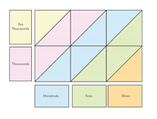
2. | 675 x 15
3. | 987 x 12

ELO 2: | Estimate the product of two numbers
1. |  |  | Round off to the highest place | Estimated product | Actual product | Difference
 | - 321 x 54
 | - 198 x 13
 | - 4328 x 51
 | - 659 x 329
 | - 7651 x 48

II. | Solve the word problems.
1. | Felix places a bulk order for 19 guitars for his musical instruments store. The cost of one guitar is ₹2895. Round off the two numbers to the highest place and then proceed to find the estimated cost that Felix would require to pay?
2. | Suhasini buys 56 litres of milk in the entire month. The cost of one litre milk is ₹48. Round off the two numbers to the highest place and then proceed to find the estimated cost that Suhasini would require to pay.
3. | Raj packs 156 apples in a sack. How many apples will be there in 109 such sacks? Estimate the product by rounding off the two numbers to the highest place.
4. | The cost of a television is ₹14,399. What is the cost of 9 such televisions? Estimate the product by rounding off the two numbers to the highest place.
5. | Shyam buys a book for ₹1179. Find the cost of 18 such books. Estimate the product by rounding off the two numbers to the highest place.
6. | There are 38 name slips in a sheet. The school needs to print 2546 sheets. What is the total number of name slips the school needs to print? Estimate the product by rounding off the two numbers to the highest place.
7. | An auditorium has 866 seats in it. If there are 12 such auditoriums in a city, how many people can be accommodated in all those auditoriums? Estimate the product by rounding off the two numbers to the highest place.
8. | Mike has a farm. He planted 28 pineapple plants in a row. There are 132 such rows in the farm for pineapples. How many pineapple plants did he plant? Estimate the product by rounding off the two numbers to the highest place.
9. | There are 1238 rooms in a hotel. Each room has 7 glasses in it. How many glasses are there in the rooms together? Estimate the product by rounding off the two numbers to the highest place.
10. | The Delhi Mumbai air ticket costs ₹4,234 per person. Mona is travelling with 16 of her relatives. What will be the total cost of tickets for them? Estimate the product by rounding off the two numbers to the highest place.

