What is a Computer Network?
- Computer Network is a group of computers connected with each other through wires, optical fibres or optical links so that various devices can interact with each other through a network.
- The aim of the computer network is the sharing of resources among various devices.
- In the case of computer network technology, there are several types of networks that vary from simple to complex level.

Components Of Computer Network:
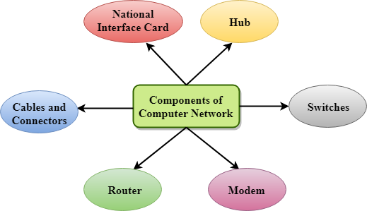
Major components of a computer network are:
NIC(National interface card)

NIC is a device that helps the computer to communicate with another device. The network interface card contains the hardware addresses, the data-link layer protocol use this address to identify the system on the network so that it transfers the data to the correct destination.
There are two types of NIC: wireless NIC and wired NIC.
Wireless NIC: All the modern laptops use the wireless NIC. In Wireless NIC, a connection is made using the antenna that employs the radio wave technology.
Wired NIC: Cables use the wired NIC to transfer the data over the medium.

