About the Tutorial
Design thinking has become an integral part of corporate strategy and planning these days. The five-step model of design thinking has been explained extensively in this tutorial, along with case studies and exercises. This tutorial teaches the principles of design thinking.

Audience
This tutorial is meant for designers, engineers, planners, managers, strategists, economists, teachers, and many other professions.
This tutorial will be useful for anyone who works in an industry that deals with addressing the needs of customers or works for external clients. The tutorial will help professionals from diverse spheres of profession to find innovative solutions to the problems that they or their departments are facing.

Prerequisites
Before proceeding with this tutorial, you are expected to have a calm mindset and be open to exploring the suggestions mentioned here.

Copyright & Disclaimer
© Copyright 2016 by Tutorials Point (I) Pvt. Ltd.
All the content and graphics published in this e-book are the property of Tutorials Point (I) Pvt. Ltd. The user of this e-book is prohibited to reuse, retain, copy, distribute or republish any contents or a part of contents of this e-book in any manner without written consent of the publisher.
We strive to update the contents of our website and tutorials as timely and as precisely as possible, however, the contents may contain inaccuracies or errors. Tutorials Point (I) Pvt. Ltd. provides no guarantee regarding the accuracy, timeliness or completeness of our website or its contents including this tutorial. If you discover any errors on our website or in this tutorial, please notify us at contact@tutorialspoint.com.

Table of Contents

About the Tutorial 1
Audience 1
Prerequisites 1
Copyright & Disclaimer 1
Table of Contents 2
- DESIGN THINKING - INTRODUCTION 5
Origin of Design Thinking 5
Application Across Professions 5
- DESIGN THINKING - DEFINITION 7
Features of Design Thinking 7
Strategy of Innovation 8
Use of Design Thinking 8
- DESIGN THINKING - APPLICATIONS 10
Business 10
Information Technology 10
Education 10
Healthcare 11
- DESIGN THINKING – SOLUTION-BASED THINKING 12
Design Thinking vs. Scientific Method 12
Problem Focused vs. Solution Focused 12
Analysis vs. Synthesis 13
Divergent Thinking vs. Convergent Thinking 13

DESIGN THINKING - ANALYSIS VS. SYNTHESIS 14

Analysis 14

Reductionism 14

Synthesis 14

Analysis + Synthesis = Design Thinking 15

Case Study 15

DESIGN THINKING - DIVERGENT THINKING 17

Case Study 18

DESIGN THINKING - CONVERGENT THINKING 19

Aspects of Convergent Thinking 19

DESIGN THINKING - ATTRIBUTES 21

The Principles of Design Thinking 21

The Challenges 22

The Aha-Moment 22

Design Methods 22

The Five-step Process of Design Thinking 22

Use of Analogies 23

DESIGN THINKING – EMPATHIZE STAGE 24

DESIGN THINKING – DEFINE STAGE 27

DESIGN THINKING – IDEATE STAGE 29

Rules for Brainstorming 29

Mind Maps 30

DESIGN THINKING – PROTOTYPE STAGE 34

Primary Guidelines for Prototyping 34

Final Prototype 35

DESIGN THINKING – TEST STAGE 37

Iterate Phase 37

DESIGN THINKING - D-REV EXAMPLE 39

DESIGN THINKING - EDUCATION SECTOR 41

REDLab Group 41

Tools at Schools 42

Degrees and Certification in Design Thinking 42

DESIGN THINKING - SOCIAL INNOVATION 43

IDEO Example 43

Naandi Foundation’s Example 43

Case study - Embrace Baby Warmer 44

DESIGN THINKING - IT INDUSTRY 45

DESIGN THINKING - HEALTHCARE INDUSTRY 47

Case Study – Venice Family Clinic 47

Case study – Eric Duncan 47

Case Study – Access to Clean Water 47

DESIGN THINKING - CONCLUSION 49

Design thinking is a methodology that designers use to brainstorm and solve complex problems related to designing and design engineering. It is also beneficial for designers to find innovative, desirable and never-thought-before solutions for customers and clients.
Design Thinking

1. Design Thinking - Introduction
Design thinking is used extensively in the area of healthcare and wellness, agriculture, food security, education, financial services, and environmental sustainability, to name a few. Design thinking has helped in the digital space, contributed to the development of physical products, spurred social innovation projects and much more.
The iterative design process helps the designers to involve clients and customers in meaningful ways. It is not just a strategy to come up with feasible solutions to a problem, but also a method to think of unimaginable solutions and then trying to make them not just feasible, but also viable.
Design thinking is a blend of logic, powerful imagination, systematic reasoning and intuition to bring to the table the ideas that promise to solve the problems of the clients with desirable outcomes. It helps to bring creativity with business insights.

Origin of Design Thinking
It is a methodology of design that originated in Stanford University and is today considered to be one of the most sought after skills in the industry. The concept of design thinking began only with a few domains under consideration, but is now found to be applicable to a myriad of disciplines, ranging from medicine and aeronautics to management, operations, and human resource planning.
The teaching and acquisition of design thinking skills has assumed so much importance that it is now being taught at some of the leading universities of the world, as well as the leading global corporate houses across the globe.
Infosys Ltd., India’s second largest IT-based company providing business consulting, information technology and software engineering services, has also made design thinking a mandatory skill to be acquired by each of its employee.
Stanford University in the United States and the University of Potsdam in Germany have also promoted design thinking, citing it as one of the most useful skills for professionals.

Application Across Professions
In the wake of such support and encouragement for design thinking by big entities, it is easy to understand the significance and influence that design thinking will assume in the near future for all sorts of professions. Design thinking is a methodology for finding simplicity in complexity, improving quality of experience with the designed products and serving the needs of customers by addressing the target problem faced by them. Design thinking is at the core of the development of efficient and effective strategies for organizational change.

Design Thinking

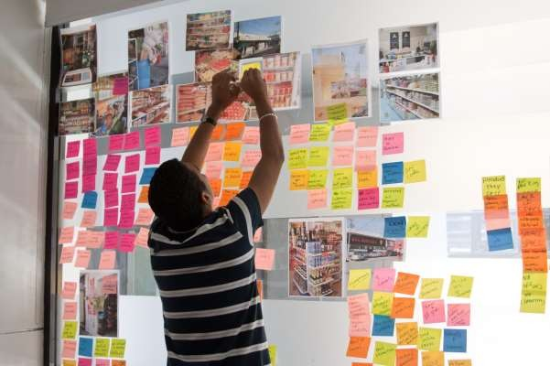

Design thinking is a five-step process, where each step focuses on a specific goal. Each of the steps is independent of the next step but is borne out of the previous step. Design thinkers are expected not to think of the following steps when working on one step.
For example, it is not recommended to think of solutions, when the problem is being defined. The problem definition must be written in detail without missing any point, even if it makes finding a solution difficult. In this tutorial, we will understand the importance of design thinking, its impact of strategy development and we will then explore each of the steps of design thinking.

The idea of using design as a way of solving complex problems in a simplified manner in sciences originated in the book, ‘The Sciences of the Artificial’, authored by Herbert A. Simon in 1969. The same purpose was achieved for design engineering by the book ‘Experiences in Visual Thinking’, authored by Robert McKim in 1973.
Design Thinking

2. Design Thinking - Definition
In 1987, Peter Rowe’s book titled, “Design Thinking” described methods and approaches that planners, designers, and architects use. The work of Robert McKim was consolidated by Rolf Faste at Stanford University during 1980s to 1990s and then, David
M. Kelly adapted design thinking for business interests. David M. Kelly founded IDEO in 1991.
Most of the industries trying to solve customers’ problems and address their needs are failing just because they look at the problems outside in. However, many problems can be solved in a better manner if we look at them inside out.
According to an article in Forbes, a large number of problems faced by organizations worldwide are multi-faceted and are a part of increasingly complex business models. The expansion of global transactions, growth of international partnerships and decentralized base of human resources are leading to challenges that require a global outlook and hence, a different outlook to solve the problems.

Features of Design Thinking
Such problems require multidimensional solutions. Design thinking helps in this regard. It not only assists a professional to come up with a solution, but it also helps the organization to gain a competitive edge over its rivals. Following are the benefits conferred by design thinking. These are incidentally also the distinguishing features of design thinking.
- Finding simplicity in complexities.
- Having a beautiful and aesthetically appealing product.
- Improving clients’ and end user’s quality of experience.
- Creating innovative, feasible, and viable solutions to real world problems.
- Addressing the actual requirements of the end users.

Find
Simplicity
User
Requirements
Appealing
Product
Client
Experience
Innovative
Solutions

Most of the challenges in the world do not get solved because people trying to address those problems focus too much on the problem statement. At other times, the problem statement is overlooked and there is too much stress to find a solution.
Design thinking helps to gain a balance between the problem statement and the solution developed. A design-oriented mindset is not problem focused, but solution focused and action oriented. It has to involve both analysis and imagination. Design thinking is the way of resolving issues and dissolving problematic situations by the help of design.

Strategy of Innovation
Design thinking is also considered to be a strategy for innovation. It leads to dramatic improvements in innovation. This is why design thinking forms the core of effective strategy development and seamless organizational change. Anything that involves human interaction, from products, services, processes etc., can be improved through design thinking. It all depends on the designer’s way to create, manage, lead, and innovate.

Use of Design Thinking
The basic principle of design thinking is that innovation can be disciplined. Innovation is not an elusive entity that only a few genius people can experience. It is, rather, a practice that can be systematically approached by a set of practical and meticulous tools, methodologies, and frameworks.

Design thinking helps you learn the following.
- How to optimize the ability to innovate?

- How to develop a variety of concepts, products, services, processes, etc. for end- users?

- How to leverage the diverse ideas of innovation?

- How to convert useful data, individual insights and vague ideas into feasible reality?

- How to connect with the customers and end-users by targeting their actual requirements?

- How to use the different tools used by designers in their profession for solving your customers’ problems?

Optimization of capabilities

Addressing the needs of customers
Design thinking helps in
Feasibility and viability analysis

Design thinking helps people of every profession to arrive at solutions in a planned, organized, and systematic manner. The step-by-step process helps to create solutions with both the problem statement and the required solution in mind.

Design thinking finds its application across a variety of professions. From sports, education and research to business, management and design, design thinking is widely used by professionals around the globe.
Design Thinking

3. Design Thinking - Applications
Design thinking is halfway between analytical thinking and intuitive thinking. Analytical thinking involves purely deductive reasoning and inductive logical reasoning that utilize quantitative methodologies to come to conclusions. However, intuitive thinking refers to knowing something without any kind of reasoning.
These are two extreme kinds of thinking. Design thinking makes use of both the extremes in an optimum manner. The intuitive thinking helps in invention for the future, whereas analytical thinking to create something creative in the present, which is replicable. The willingness to use these futuristic solutions is what is called abductive logic.

Business
Design thinking helps in businesses by optimizing the process of product creation, marketing, and renewal of contracts. All these processes require a companywide focus on the customer and hence, design thinking helps in these processes immensely. Design thinking helps the design thinkers to develop deep empathy for their customers and to create solutions that match their needs exactly. The solutions are not delivered just for the sake of technology.

Information Technology
The IT industry makes a lot of products that require trials and proof of concepts. The industry needs to empathize with its users and not simply deploy technologies. IT is not only about technology or products, but also its processes. The developers, analysts, consultants, and managers have to brainstorm on possible ideas for solving the problems of the clients. This is where design thinking helps a lot.

Education
The education sector can make the best use of design thinking by taking feedback from students on their requirements, goals and challenges they are facing in the classroom. By working on their feedback, the instructors can come up with solutions to address their challenges.
For example, Michael Schurr, a 2nd grade instructor from New York, realized that his students would be more comfortable with bulletin boards lowered. He also found the idea of creating comfortable semi-private space for working students as it provided them space to study. As a result, his students became more engaged and felt free to move.

Design Thinking

Healthcare
Design thinking helps in healthcare as well. The expenditure on healthcare by the government and the cost of healthcare facilities is growing by the day. Experts worldwide are concerned about how to bring quality healthcare to people at low cost.
Venice Family Clinic in Venice, California has come up with innovative solutions to the challenge of opening a low-cost children’s clinic to serve the low-income families. Problems of finance, transportation, and language barriers had to be solved. And all this had to be done at low cost for the poor kids. Fostering good health along with profits was a challenge, as it does not sound sustainable. Using design thinking, the inefficiencies in the system and the perennial crises were addressed.
This was followed by mind-blowing innovations to serve the children. How they solved the various issues will be seen in the later sections of the tutorial.

Design thinking promises to provide a realistic, practical, and innovative solutions to problems of organizational concern and gives a systematic approach to finding solutions. The distinguishing feature of design thinking is that it encourages solution focused thinking or solution based thinking. The design thinker is supposed to have a clear idea of the goal of the entire process. The design thinkers are not supposed to solve every specific problem, but to start the process with the end goal in mind.
Design Thinking
4.
Design Thinking – Solution-based Thinking
This methodology helps because by focusing on both the present and the future conditions as well as the parameters of the problem statement, alternative solutions can be explored simultaneously.

Design Thinking vs. Scientific Method
The design thinking approach is altogether different from the scientific method. The scientific method begins with rigorously defining all the parameters of the problem, so as to arrive at a solution. But a design thinker is supposed to identify both the known and the ambiguous facets of the problem statement along with the current situation. This method of thinking helps to unearth hidden parameters and open alternate paths to reach the solution.
Iterative approach: As design thinking is an iterative approach, intermediate solutions in the process of developing the larger solution to achieve the end goal can also act as prospective starting points for chalking out alternative paths. This can, at times, also lead to redefinition of the problem statement.

Problem Focused vs. Solution Focused
Where does the difference lie between problem focused solvers and solution focused solvers? The answer to this question was found by Bryan Lawson, a psychologist, in 1972.
In one of his experiments, he took two groups of students; one group consisted of final year students in architecture, whereas the other group comprised of post graduate science students. The two groups were asked to create one-layer structures with a set of colored boxes. The perimeter of the structure had to optimize either the red or the blue color; however, there were unspecified rules governing the placement and relationship of some of the blocks.
Lawson found that:
“The scientists adopted a technique of trying out a series of designs which used as many different blocks and combinations of blocks as quickly as possible. Thus they tried to maximize the information available to them about the allowed combinations. If they could discover the rule governing which combinations of blocks were allowed they could then search for an arrangement, which would optimize the required color around the layout. [problem-focused] By contrast, the architects selected their blocks in order to achieve the appropriately colored perimeter.

Design Thinking

If this proved not to be an acceptable combination, then the next most favorably colored block combination would be substituted and so on until an acceptable solution was discovered. [solution-focused]”

— Bryan Lawson, How Designers Think

Analysis vs. Synthesis
Analysis refers to the process of breaking down something substantial into multiple fragments or components. Synthesis is the total contrast of analysis. In Synthesis, we combine fragmented elements to form an aggregated and coherent whole.
It is to be noted that analysis and synthesis are complementary to each other and go hand in hand. Design thinkers have to synthesize based on the analysis they have done and the analysis will then follow based on what has been synthesized to verify the results and to measure the parameters.

Divergent Thinking vs. Convergent Thinking
Divergent thinking involves finding many possible solutions in the first stance. This is the essence of design thinking process. The design thinkers are required to think of as many solutions as strike their brain, even if some of them don’t look viable.
Convergent thinking is a method of narrowing the available solutions to a final solution. Divergent thinking is the ability to come up with various unique ideas adherent to a single theme. Convergent thinking is the ability to find the correct solution to the given problem. Design thinking delves on divergent thinking in the beginning to ideate many solutions and then resort to convergent thinking to zero-in on the best solution.

In this chapter, we will see the difference between two ways of solution-based thinking,
Design Thinking

5. Design Thinking - Analysis vs. Synthesis
i.e. Analysis and Synthesis, and also get to know how it helps in design thinking.

Analysis
Analysis is derived from the Greek word ‘analusis’, which translates into ‘breaking up’ in English. Analysis is older than the times of great philosophers like Aristotle and Plato. As discussed in the previous section, analysis is the process of breaking down a big single entity into multiple fragments. It is a deduction where a bigger concept is broken down to smaller ones. This breaking down into smaller fragments is necessary for improved understanding.
So, how does analysis help in design thinking? During analysis, design thinkers are required to break down the problem statement into smaller parts and study each one of them separately. The different smaller components of the problem statement are to be solved one-by-one, if possible. Then, solutions are thought for each of the small problems. Brainstorming is done over each of the solutions.
Later, a feasibility check is done to include the feasible and viable solutions. The solutions that don’t stand firm on the grounds of feasibility and viability are excluded from the set of solutions to be considered.
Design thinkers are, then, encouraged to connect with the diverse ideas and examine the way each idea was composed. This process of breaking down the bigger problem statement at hand into multiple smaller problem statements and examining each as a separate entity is called analysis.

Reductionism
The underlying assumption in analysis is reductionism. Reductionism states that the reality around us can be reduced down to invisible parts. The embodiment of this principle is found in basic axioms of analytic geometry, which says “the whole is equal to the sum of its parts”. However, understanding of a system cannot be developed by analysis alone. Hence, synthesis is required following analysis.

Synthesis
Synthesis refers to the process of combining the fragmented parts into an aggregated whole. It is an activity that is done at the end of the scientific or creative inquiry. This process leads to creation of a coherent bigger entity, which is something new and fresh. How does synthesis come into picture in design thinking?
Once the design thinkers have excluded the non-feasible and non-viable solutions and have zeroed-in on the set of feasible and viable solutions, it is time for the thinkers to put together their solutions.
Out of 10 available solutions, around 2-3 solutions may need to be excluded since they may not fit into the larger picture, i.e. the actual solution. This is where synthesis helps.

The design thinkers start from a big entity called the problem statement and then end up with another bigger entity, i.e. the solution. The solution is completely different from the problem statement. During synthesis, it is ensured that the different ideas are in sync with each other and do not lead to conflicts.

Analysis + Synthesis = Design Thinking
Analysis and synthesis, thus, form the two fundamental tasks to be done in design thinking. Design thinking process starts with reductionism, where the problem statement is broken down into smaller fragments. Each fragment is brainstormed over by the team of thinkers, and the different smaller solutions are then put together to form a coherent final solution. Let us take a look at an example.

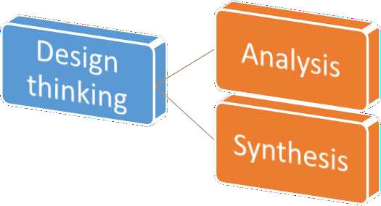

Case Study
Problem Statement: Suppose the problem statement at hand is to contain the attrition that happens in companies worldwide. High quality employees leave the organization, mainly after the appraisal cycle. As a result, an average company loses its valuable human resources and suffers from an overhead of transferring the knowledge to a new employee. This takes time and additional human resource in the form of a trainer, which adds to the company’s costs. Devise a plan to contain attrition in the company.
Analysis: Now, let’s break down the problem statement into various constituent parts. Following are the subparts of the same problem statement, broken down to elementary levels.
- The employees are not motivated anymore to work in the company.
- Appraisal cycle has something to do with attrition.
- Knowledge transfer is necessary for new employees.

- Knowledge transfer adds to the cost of the company.
Synthesis: Now, let's start solving each problem individually. In this step, we will do synthesis. Let's look at one problem at a time and try to find a solution only for that problem statement, without thinking of other problem statements.
- To solve the problem of lack of motivation, the management can plan some sort of incentives that can be given on a regular basis. The efforts put in by the employees must be rewarded well. This will keep the employees motivated.

- To solve the issue of occurrence of attrition during appraisal cycle, the management can conduct a meeting with the employees leaving the organization, and take their insight as to what led them to leave the company.

- For knowledge transfer, the management can hire only those people who are experts in a domain.

- Regarding concerns for budget of knowledge transfer, the management can have a document prepared by experts in a domain and this document can be uploaded on intranet. This can be made available to new joinees. Hence, additional human resource is not required for knowledge transfer and this will reduce the figures in the company's budget.

Now, if we observe carefully, the third solution may not be feasible all the time. We cannot be assured of expert professionals coming for interviews all the time. Moreover, expert professionals demand more compensation than not-so-expert professionals. This will increase the company's budget.
Hence, we will now combine the other three solutions to form a coherent one. The final solution will be for the management to first have a talk with the employees leaving the organization to know the reasons behind attrition, then come up with awards in suitable categories and then, create an easily and universally accessible document in the organization for knowledge transfer.
This way, analysis and synthesis together help in design thinking process. Design thinkers start with breaking down a problem into smaller problems that can be handled and studied easily. Then, the different solutions are combined to form a coherent single solution.

Design thinking involves two types of thinking, viz. convergent thinking and divergent thinking. One needs to think of many solutions to a common problem statement and then arrive at the correct and the best solution.
Design Thinking

6. Design Thinking - Divergent Thinking
Divergent thinking is the process of devising more than one solution for a problem statement. It refers to the thought process of generating creative solutions. The main features of divergent thinking are:
- It is a free flowing chain of ideas.

- It happens in a non-linear manner, i.e. it does not follow any particular sequence of thinking. Moreover, multiple ideas can emerge at the same time, rather than one idea coming up only after the other has occurred.

- Non-linearity also means that multiple solutions are thought of and explored at the same time. This happens in a very short amount of time and unexpected connections are developed between the ideas.

Divergent thinking

Non linear thinking

Free flow of ideas

Unexpected connections

Multiple ideas

A stimulus is provided to the design thinker and that prompts creative elaboration of ideas by the thinker.
Divergent thinking is supposed to enhance creativity of thinkers. The term ‘Divergent Thinking’ was first coined by J. P. Guilford in 1956. The Free Association Theory of Creativity says that concepts are connected inside our brains as semantic networks. Psychologists

Design Thinking

have claimed that the difference in creativity levels of people is dependent on the type of semantic networks of concepts inside the human mind. Following are the two types of connections:
- Flat
- Steep
The design thinkers with flat networks are those with numerous loose conceptual connections. They are more creative. The people with steep networks are more logical, because of the linear associations between the nodes. Because divergent thinking proceeds in a non-linear fashion, a person with flat associative network will be more successful in divergent thinking.
Before getting into the exercise of design thinking, a person has to find out what type of thinker the person is. If a person can think of diverse solutions, without any pre-determined set of solutions, then the person is a divergent thinker. Let’s take a look at an exercise on divergent thinking.

Case Study
Problem Statement: The process of knowledge transfer is a huge problem for the organization. Let’s call our organization ‘DT’. DT wants to eliminate the overhead of shelling out extra money and investing time for transferring knowledge to its new employees. The problem statement at hand is “Knowledge transfer adds to the cost of the company”. Let’s think of ways to eliminate or at least, reduce the cost to the company.
Solution: Following can be some of the possible and even not-so-possible solutions.
- DT can eliminate the process of knowledge transfer.

- DT can conduct classroom sessions for knowledge transfer, where a large number of new employees can be seated and just one instructor can deliver sessions to many employees at once. This will reduce the cost as the number of paid instructors required will be less.

- DT can come up with a document for knowledge transfer and can mail it to every new employee. The employees can go through the document and hence, can self- help for knowledge transfer.

- DT can ask the employees to search for material online to gain knowledge of new tools and processes, which are currently in use in the industry.

- DT can hire only those employees who have adequate knowhow of tools and techniques that DT works on. This will eliminate the need of knowledge transfer.

There may be many other solutions that may come to your mind. Write them down on a sheet of paper. Here, we won’t focus on whether a solution is possible, feasible or viable. We just need to bring ideas to the table, no matter how absurd they may sound. This is called the process of divergent thinking, where a thinker is free to move or flow in any direction.

Convergent thinking is exactly opposite of what divergent thinking is. The term ‘Convergent Thinking’ was coined by Joy Paul Guilford in 1956. The concept of convergent thinking requires the design thinker to go through all the possible solutions thought during divergent thinking and come up with a correct solution. This convergence on a single solution or a mix of limited number of solutions is the essence of convergence thinking.
Design Thinking

7. Design Thinking - Convergent Thinking
Convergent thinking is the type of thinking in which a thinker is generally supposed to come up with a single well-established best-possible solution to a problem. This step delivers the best and a concrete solution to a problem statement, taking into account all the factors and requirements specified in the problem statement.

Convergent thinking requires speed, accuracy, efficiency, logical reasoning, and techniques. A thinker is supposed to recognize the patterns, reapply a few techniques, and accumulate and organize the stored information.

Aspects of Convergent Thinking
The principle aspect of convergent thinking is that it should help us arrive at a single best answer without any room for ambiguity. The ideas thought of in the process of divergent thinking are either considered to be possible or impossible in convergent thinking phase.
Another important aspect of convergent thinking is that judgment is an important part of this process. Divergent thinking requires thinkers to suspend judgment. Convergent thinking encourages thinkers to apply the power of judgment.
Let’s look at the exercise of divergent thinking and start applying convergent thinking on it
We got the following ideas in the divergent thinking exercise.
- Elimination of knowledge transfer program.

- Having a single instructor for knowledge transfer program in a classroom session.

- Preparing a document for knowledge transfer program.

- Making it mandatory for employees to search for knowledge resources online.

- Hiring only those employees who are experienced enough and who don’t need knowledge transfer.

Now, looking at the five ideas, it can be easily said that option 1 is not feasible. Every employee does not have an idea of a company’s tools and techniques and hence, cannot be expected to survive without knowledge transfer.
For the same reason, option 5 is also not acceptable. The best practices of a company are seldom known to new employees and taking an assumption about an employee’s

Design Thinking

knowledge level is a huge mistake. It is considered to be a good HR practice to have knowledge transfer session for new employees.
If we go by option 4, we are not assured of the pace at which learning will happen for the new employees. Each employee can take variable amount of time to grasp the concepts. The time taken to search materials online and read them is an overhead in itself and it cannot be monitored.
Hence, the two better options that remain are option 2 and option 3. However, one cannot correctly estimate the effectiveness of a document for knowledge transfer. It is similar to reading materials online. Hence, the best option available is to have an instructor teaching employees in a classroom program.
Although, the employees won’t get personal attention at times, yet by maintaining a fine balance between the strength of the batch and the length of class, this can be the best option to reduce cost and overhead. The reduction in the number of instructors will lead to less expenditure for DT and at the same time, the effectiveness of a paid instructor will remain, making the process of knowledge transfer as effective as before.
This is how convergent thinking comes into picture.

Design thinking is an extensive study of various attributes, like principles, methods and processes, challenges etc. Let’s have a look at the attributes of design thinking.
Design Thinking

8. Design Thinking - Attributes

The Principles of Design Thinking
According to Christoph Meinel and Larry Leifer, there are four principles to design thinking.
  - The Human Rule - This rule states that all kinds of design activity are ultimately social in nature.

  - The Ambiguity Rule - This rule requires all design thinkers to preserve ambiguity in the process design thinking.

  - The Re-design Rule - The re-design rule states that all designs are basically examples of re-design.

  - The Tangibility Rule - The tangibility rule states that making ideas tangible always facilitates communication between design thinkers.

Human
Rule
Tangibility
Rule
Principles
Ambiguity
Rule
Re-design
Rule

These four principles form the foundation of the design thinking process. A design thinker needs to form his ideas and put them forward based on these principles.

The Chal enges
The next attribute is called as the ‘wicked problems’. These are the challenges that are faced by the design thinkers. Design thinking helps the designers in almost all professions to tackle these wicked problems. These challenges are supposed to be ill-defined or tricky.
Horst Rittel was the first person to refer to such problems with the word ‘wicked problems’. In the case of ill-defined problems, the problem statement and the solution are both unknown at the beginning of the design thinking exercise. In well-defined problems, at least the problem statement is clear and the solution is available through technical knowledge.
In wicked problems, the design thinker may have a general idea of the problem, but significant amount of time and effort goes into requirement analysis. Requirement gathering, problem definition, and problem shaping are major parts of this aspect of design thinking.

The Aha-Moment
Once the design thinker has spent considerable amount of time in finding a solution, there occurs a moment when the thinker suddenly finds his way clear of all obstructions. This is the moment when the solution or a bright idea strikes the thinker’s mind. The aha-moment is the time when the results of convergent thinking and divergent thinking, analysis, problem definition and shaping, requirements analysis and the nature of the problem all come together and the best resolution is captured.
At the aha-moment, the process of design thinking begins to appear clear, which actually appears hazy and unidirectional before the moment. The focus on the solution grows clear after this moment and the final product or the final solution is constructed hereafter.

Design Methods
Every design discipline makes use of a set of specific techniques, rules, and ways of doing things. These are called design methods. The methods include tasks like interviewing, creating user profiles, searching for other available solutions in the world, creating mind maps, creating prototypes for solving a problem and asking for answers to questions like five whys.
The ‘five whys’ is an iterative interrogative technique, which is used to explore the cause- and-effect relationships underlying a particular problem. The technique helps to determine the root cause of any problem by repeating the question ‘Why?’ Each question forms the basis of the next question. This technique is developed by Sakichi Toyoda. This helps to find the root cause of many problems faced by designers. Five whys technique is used for root cause analysis.

The Five-step Process of Design Thinking
The design thinking process or method has five steps in all to be followed. The process starts with empathizing with the problem of the customer or the end-user. The process then moves to ideate on solutions using divergent thinking. The prototype is developed

after convergent thinking and then the design thinkers resort to testing the prototype. We will learn more about each of these steps in the subsequent chapters of this tutorial.

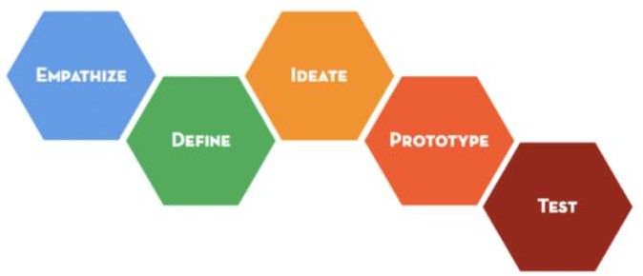

Use of Analogies
It is imperative for a design thinker to find logic even in ill-defined problems that contain obscure relationships. This issue can be addressed using analogies. Visual thinking can help by correlating different internal representations, such as images, to develop an understanding of ill-defined elements of a situation.

This step involves putting oneself into the shoes of the customer or the end-user of our solution. We need to understand the problems faced by the customer and we, as design thinkers, need to empathize with the customer. This step is carried out in the form of requirement gathering, which involves interviews and sometimes, even field visits. This step involves the process of analysis, the one which we discussed in the previous sections. There are a few points to be considered while interviewing the customer.
Design Thinking
9.
Design Thinking – Empathize Stage
- The interviewer must brainstorm for the questions beforehand and must be fully prepared for the interview.

- The questions being asked must be open questions. No such question should be asked for which the interviewee can answer only in Yes or No. Such binary questions must be avoided.

- The interviewer must have plenty of ‘why’ questions. Here, the ‘five whys’ method can help.

- The themes of the questions must not be intermingled. The themes must be arranged properly and questions pertaining to a particular theme must be asked together.

- The questions must be refined thoroughly so that no trace of ambiguity is left in them.

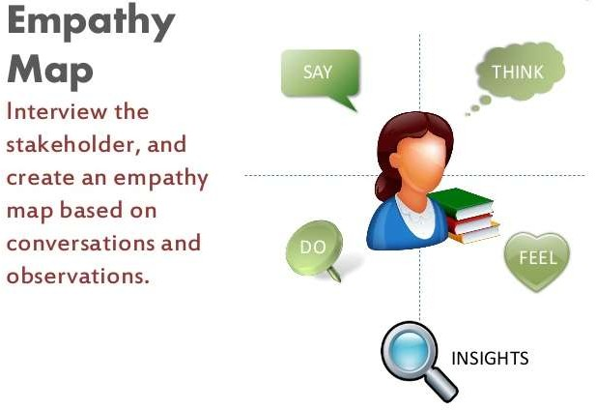

Let’s take a deeper look at this section using the example of DT’s problem statement. To fully understand DT’s problem, we need to engage in an interview with DT employees, those who are working and even those who are leaving. It is important for us, as design thinkers, to observe, engage, and listen to the interviewee. To create meaningful innovations, we need to understand the needs of the customer and know how it feels. Following can be few of the questions that can be asked to the employees.

Regarding Motivation to Work
- What motivates you to come at the workplace?
- What is the thing that drains you off energy at workplace?
- Is the factor for demoralization related to company policies or your peers?

Regarding Leaving the Company
- What are your aspirations?
- How is the other company fulfilling your aspirations?
- Is your decision related to something other than workplace motivation?

Regarding Time of Leaving
- How does this time suit your decision to leave the organization?
- Does your decision has anything to do with appraisal? If yes, how?

The following questions must be asked to DT’s management.

Regarding Employee Attrition
- Has any pattern been observed between the employees leaving the organization and their appraisal ratings?

- What are the issues that the employees have complained about in the past regarding their workplace?

Regarding Knowledge Transfer Mechanism
- What does a knowledge transfer program constitute of?

- How much money goes as expense of knowledge transfer program?

- What is the current methodology of knowledge transfer program and how effective is it?

- How can the budget allocated to knowledge transfer program be increased or decreased?

- What are the indispensable resources and pre-requisites for a knowledge transfer program?

Once these questions have been answered, we can proceed to the further steps with more clarity. This way, a design thinker will be able to cover all the necessary details related to the problem, gather all the requirements and think of the solutions with an exhaustive set of facts and information in hand. This will help in converging at a solution that takes into consideration the answers of all the questions.

Now, we have learnt the problems of our customers and the context as well. It is time to define our problem and arrive at a problem statement. This statement will give us the necessary direction to proceed towards the issue faced by the customer.
Design Thinking

10. Design Thinking – Define Stage
As a design thinker, we need to cover all the points and the answers that we got in the ‘empathize’ phase. This is where the process of synthesis comes into picture. We have to club all the answers together and convert them into a coherent single statement.
The first step towards defining a problem is to find who the user is, what is his/her/their needs and then develop insights from the answers. Think of ‘How might we?’ questions. For example, ‘how might we motivate the employees in DT?’, ‘How might we address the concern on the connection between appraisal ratings and attrition?’, ‘How might we reduce the cost of knowledge transfer program without compromising its quality and the mandatory pre-requisite resources?’ and many other questions along the similar lines.
But how do we generate such questions. In short, “How might we generate the ‘how might we’ questions?” The following guidelines will help a design thinker to come up with such questions.
  - Amplify the good: A design thinker must think how to amplify the positive
aspects of the customers’ needs. For instance, we can think of how to boost the morale of the employees who are not leaving the company or how to increase the quality of knowledge transfer program in DT.

  - Eliminate the bad: Design thinkers need to remove all the bad elements observed in the problem. In case of DT problem, we have to remove the problem of high costs of knowledge transfer and the lack of motivation in the company. We also need to remove the negative effect that appraisal ratings have on employees.

  - Explore the opposite: Design thinkers need to brainstorm on how to convert the problem into an opportunity. In the case of DT, we can think of how the lack of motivation can become an opportunity for employees to ideate and suggest a way to bring more motivation and energy in the workplace.

  - Question the Assumptions: This step involves questioning the assumption at hand. It is assumed that DT needs knowledge transfer for its new employees. Is it really indispensable to have this knowledge transfer process in place?

  - Identify the Unexpected Resources: Design thinkers should try to find whether some other resources not mentioned by the customer can be leveraged? In case of DT, think of how we can use some other resources to train the employees or to motivate the employees in the organization.

  - Create an Analogy: Design thinking also involves, among many other things, how to create connections between the problem at hand and unrelated images. DT can think of similar cases or situations where such problem of knowledge transfer and motivation of people is at stake. DT can think how problems had been solved there.

Design Thinking

  - Break the Problem into Pieces: This is where again analysis comes into picture for a short while before the problem definition can be synthesized. The points discussed from ‘empathize’ section can be broken down into elementary fragments to make the work easier.

Working over each aspect, we come across the following problem statement – "How should DT motivate its existing employees along with training its new human resources effectively at low cost?"
You can create your own problem statement as well, which may be even better than the one above.

The third component of design thinking process is the most interesting and perhaps, the most rigorous as well. In this section, called Ideate, a design thinker is supposed to bring to the table as many ideas as possible. While brainstorming for ideas, it is not checked whether the idea is possible, feasible, and viable or not. The only task of thinkers is to think of as many ideas as possible for them.
Design Thinking

11. Design Thinking – Ideate Stage
Amplify good and
eliminate bad
Explore opposites
and question
IDEATE
Analyse
Identify unexpected
resources
In this process, design thinkers also resort to the use of boards, sticky notes, sketching, chart papers, mind maps, etc. We will take a look at mind maps later in this section. Design thinkers also build on the ideas of other design thinkers. All solutions suggested by design thinkers are brought to the table and thought over. There are rules for brainstorming. They are as follows.

Rules for Brainstorming
- Only one conversation is allowed at a time. No other person must intervene when an idea is being given.

- Focus must be on the quantity and not on quality. In this step, the group must have large number of ideas with them.

- Think out of the blue. Wild ideas must be encouraged even if they invoke plain humor or seem impossible.

- The group leader must defer judgment. The fellow thinkers also need to suspend judgment. Judgmental attitude leads to an obstruction for the thinkers.

- Visualization is important. The design thinkers must create a visual picture of the problem statement and then try to see a visual image of their ideas as well.

- Build on each other’s ideas. Support other ideas and build on them through group discussions and healthy debates.

Following is one of the techniques to brainstorm for ideas.

Mind Maps
Mind map is a diagram that helps to observe and study information in a visual manner. Mind map is created around a single problem statement and all the ideas to solve the problem are written around it. The problem statement usually is written at the center of a blank page as a hub and branches shoot out in all directions representing the solutions.
The ideas can be represented as text, images, trees, and even smaller mind maps. The entire map looks like a top view of a tree, with the problem statement as the trunk and the solutions as branches. It is also known by the name of spider diagram.
However, mind map is not a mere haphazard diagram. It is a well-structured organized diagram meant to aid the thinking process and to streamline the analysis and synthesis process. The guidelines to create a mind map are as follows.

Guidelines to Create Mind Maps
- Begin with the problem statement at the center of a blank white page.

- Use images, different colors, symbols, caricatures, abbreviations and codes to depict your ideas. Text can be boring, but different depictions can add an altogether different charm to your mind map.

- Keywords must replace long statements. The mind map must give a hint to the design thinker about an idea quickly. Reading a long statement is waste of time.

- Each and every word written in the mind map must be connected to the central hub by some or other line or set of lines.

- Use multiple colors for visual stimulation.

- Use radial hierarchy and make use of emphasis, italics, and underlines to stress on a point.

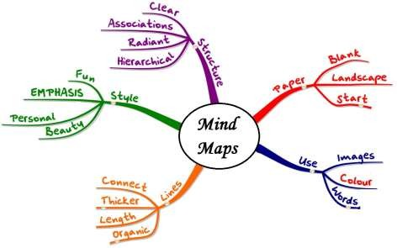

Ideate process can also be done with the help of sketches, screens, and storyboards. There are teams in corporate organizations which have large whiteboards and they paste their ideas on it using sticky notes. Different categories of ideas are represented in sticky notes of different colors and this helps in segregation of ideas.
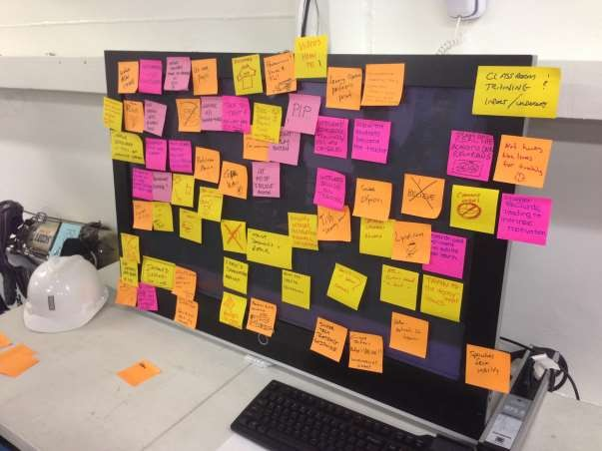

The main idea behind the ideate step in design thinking process is to generate ideas and try to segregate them into categories. This helps in brainstorming without judgment, helps in bringing all the ideas to the table and helps proceed to the next step called ‘Prototyping’, where the ideas are checked for their feasibility and value.
Let’s try to ideate the DT problem.
Let’s bring out all the ideas. Some of the ideas can be as follows.
- Have a different mechanism for appraisal of employees.

- Organize events that feature team-building activities. This will help boost the morale of employees and will make them work in a team in a better fashion.

- Discard the appraisal system.

- Paste motivational posters in cubicles and pantry area.

- Call a motivational speaker and conduct a session.

- Encourage fellow employees to take the onus of motivating other employees.

- Introduce a bond period for the employees so that they don’t leave soon.

- Eliminate knowledge transfer program.

- Ask only for expert employees to join the organization.

- Ask employees to fend for themselves for knowledge transfer.

- Conduct large classroom sessions with a huge audience listening to one instructor.

- Make an online document for knowledge transfer program.

- Make video tutorials.

- Have online instructor teaching across geographies.

And the list goes on endlessly….

You can come up with even more and better ideas. There is no limit to the generation of ideas. Let’s represent these ideas using a mind map.
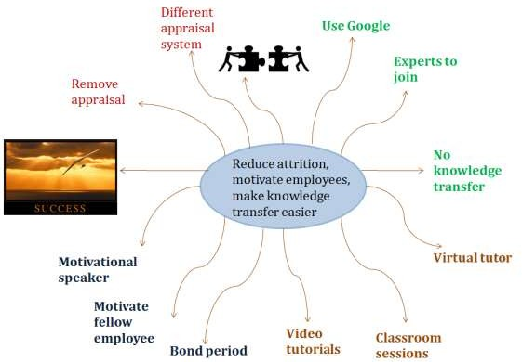
This is when we can draw analogy with similar situations. Take for example the case of schools. The knowledge transfer program is nothing much different than schools teaching the students. How does a school manage to keep the students motivated towards studies? How does a school teach the kids?
If we draw the analogy, we would understand that in schools, a single teacher teaches around 30-40 kids in a classroom. To keep them focused on studies, exams are conducted periodically. Using digital technology, smart classrooms teach kids using videos, presentations, and audio aids.
The same model can be replicated in DT company as well. We can have a single instructor teaching the new employees with the help of videos and presentations. A proctored exam will help to assess the learning levels of the new employees.

This step deals with building the ideas and checking for their feasibility to arrive at the final solution. This is the step in which three things are mainly taken care of.
Design Thinking

12. Design Thinking – Prototype Stage

Creation of experience

Getting feedback

Iteration
The step of prototyping is the one in which the end user comes into picture. The end user is actively involved in this component of design thinking. All the feedback is taken from the customer, and based on the criticisms, suggestions, and appreciations received, the design thinkers create a better solution after iterating the process of design thinking’s first three steps, viz. Empathize, Define, and Ideate.
Prototyping requires thinkers to create tangible products, which can be small-scale models of the exact solution.

Primary Guidelines for Prototyping
- Take the first step and start to build the prototype. Don’t procrastinate.

- Don’t waste too much of time on building a single prototype.

- The prototypes must be built with the end user in mind.

- The prototype must not be a mere piece of trash; it must create an experience for the user.

- Think of open questions that the user can shoot towards you when he experiences the prototype.

The prototype is meant solely for the end user. There is no value in the prototype in case the user does not feel comfortable and satisfied with it. Once the prototype has been developed, the next steps are as follows.
- Take the end user through the prototype and let him/her experience it completely.

- Throughout the experience, make the user speak about his moment-by-moment experience. This will help you, as a design thinker, to capture the minute details of the experience.

- Try to actively observe and enthusiastically engage with the user during the experience.

- Once the experience is over, follow up with the user who had the experience with a set of questions. It will be better if the set of questions is not impromptu and is prepared beforehand.

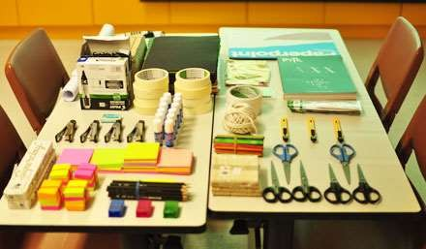

Let’s have a look at the DT example.
Knowledge transfer program cannot be eliminated as it is not wise to assume that all new employees will possess adequate knowhow of the technologies in the industry beforehand. It is considered to be a good HR practice to provide a knowledge transfer program to each new employee. Even if we question this, we can find that the assumption that applicants for a job will already possess all the knowledge can fire back at us.
Moreover, asking the employees to motivate other fellow employees can be unsustainable as there will be too much of reliance of employees for managing this issue. There will be no regulation over what employees might say in the name of motivation, and hence, employees can even end up inciting others to leave the company.
The best option for knowledge transfer program, at present, is to have a classroom session where many people can study at once. This will reduce the cost and streamline the knowledge transfer program making it effective as well. Moreover, team-building activities can add to the budget of the company if done outside the premises.
However, small activities outside the working hours inside the company itself can help in team-building amongst employees. This bond can help to make them stay together as a team and stay longer in the company. Motivational posters and timely appreciation can also help.

Final Prototype
So, our prototype looks like this. We can renovate a small section of the company’s premise, for example, a small section in the ground floor of a building of the company, which will have motivational posters pasted on walls. A set of team-building activities will

be conducted for a week and feedback will be taken from the employees on how they felt about it. We need to understand if they felt happy to have such an activity inside DT.
In the meantime, a single instructor led classroom session can be organized for a week for all new joinees and feedback can be taken on their level of satisfaction over the session. An exam will check their learning levels as well.
Along similar lines, many other prototypes can be created for testing.

This phase is also called as 'Execute’. This is the phase where the final solution is tested on a full scale basis. The idea that seems the best according to the feedback of the customers and end users in the prototype phase will be executed. In this step, the design thinkers are supposed to be collaborative and agile.
Design Thinking

13. Design Thinking – Test Stage
Testing will help to understand what actually works and what does not. This step can be the most rewarding, if the prototypes succeed to give positive results, or can be the most annoying, if the prototype fails. After testing, the entire process of design thinking may have to be repeated. If the end user approves the solution, then the process of design thinking stops here.

Iterate Phase
If the end-user is not satisfied with the results, the design thinker will need to frame a new problem definition by incorporating the insights from the last Test phase and will have to again empathize in a better way with the end user. Ideate process will be repeated, followed by prototyping and another round of Testing. If Test phase fails to give positive results again, another round of iteration will have to be done. This way, the process of design thinking can stretch infinitely as well.
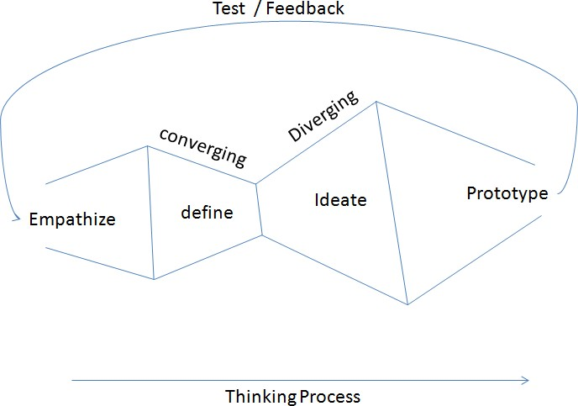

Let’s take a look at the DT problem.
Suppose the prototype has given us positive results for the small scale model. We can then replicate the model on a larger scale inside the entire company building. We can perhaps take it to all the buildings as well. Motivational posters will be pasted over the walls and team-building activities will be conducted. Moreover, classroom session aided with digital technology will be instrumental in driving our prototype forward.

Design Thinking

There can be cases where some problems may arise. For instance, an employee who works at the client location outside the company’s premises may feel left out since he/she cannot participate in the activities that happens inside the company premises. Such people can also ask for similar activities in the offices of DT’s client, which may not be possible since the client may not grant permission.
However, classroom sessions may work for tutoring on some technologies. For instance, a software tool can be taught to the new employees of DT via huge classroom session, but operating machines requires each employee to learn the techniques under careful personal supervision. This model won’t find place in the areas were the operations deal with operating large machines. For getting hands-on experience, the employees will need to have the instructor giving them individual attention. For this, either a large number of instructors are required or the duration of knowledge transfer program has to be increased, which will lead to increase in costs.
The design thinkers will need to draft a new problem definition and will have to brainstorm for ideas to solve the new issue and to have a uniform solution implemented across the company.

D-Rev is a non-profit development company. It designs, develops, and delivers products to people who live below $4 a day. Their projects are in the field of mobility, newborn’s health, agriculture, healthcare, and a few other domains.
Design Thinking

14. Design Thinking - D-Rev Example
Their products have been a result of design thinking process. The organization drives all the aspects of design process, from identification of high impact opportunities to scaling up its impact. Its process is as follows.
- Identify: The organization identifies high impact opportunities that can increase the incomes or health of more than 1 million people who live on less than $4 a day.

- Design: The design of products take place considering the fact that it must be capable of meeting the target customers’ needs. This step takes care of manufacturing, distribution, and servicing.

- Deliver: The products are integrated into the market to maximize and sustain the impact. These products are delivered to the users.

- Scale and Measure: Maximum global impact requires scaling up. The organization also measures if the product is reaching the people and places in need of the products.

The organization has come up with an innovative idea of ReMotion Knee. This is a high performance knee joint for the amputees of the developing world. The team realized the issue that globally over 30,000,000 people need mobility devices for their locomotion. Around 80% of the amputees globally don’t have access to modern prosthetics.
Existing low cost knees throw up a lot of limitations to mobility to the users. Using design principles, D-Rev came up with a solution called ‘ReMotion Knee’. The device is durable, water resistant, and lightweight along with being affordable. Its price is below $80. The universal design, noise dampening facility, and other features make it a good solution for amputees.
Similarly, design principles helped D-Rev to come up with a solution for the death of newborn babies due to diseases like jaundice. Every rear, around 6 million babies don’t receive the adequate treatment that they must receive to survive severe jaundice. Current treatment devices are quite expensive. 95% of the devices in the low-cost hospitals and clinics did not meet the standards set forth by American Academy of Pediatrics.
The product called ‘Brilliance’ brought by the innovative minds of D-Rev is set to solve this issue in hospitals where the sickest kids are treated. The product needs minimal maintenance, which helps to save cost. It is energy efficient and holds the promise of solving the issue of newborn deaths.
The problem of people, especially kids, dying of malaria in Africa was also addressed by D- Rev. Moreover, the non-profit organization also realized that the farmers who live below
$4 a day cannot afford access to appropriate information on the latest farming practices and technologies. However, the awareness of the latest farming practices and technologies

Design Thinking

can increase the income of these farmers by manifolds. Bill and Melinda Gates Foundation funded the Access for Agriculture, which was a comparative landscape study.
D-Rev surveyed 12 available devices for information on their cost and features. The farmers’ feedback was also taken. This experiment happened in India. D-Rev was interested in creating an affordable and effective solution to provide the farmers with the latest farming practices and technologies.
A number of other projects were also taken up by D-Rev. D-Rev remains as one of the leading examples of design thinking success.

One domain in which design thinking finds a huge application is the education sector. These days, educators are using design thinking extensively to improve the quality of education in schools, especially in the kindergarten classes. Design thinking has been used in schools to upgrade the curriculum, or to redesign the student spaces or to make the entire experience of the students worthwhile.
Design Thinking

15. Design thinking - Education Sector
Design thinking helps the school administrators to solve institution-based problems, helps in making the curriculum more valuable to the students and to engender design thinking skills in students as well.

REDLab Group
Stanford University’s Graduate School of Education has a REDLab group which conducts research on how to apply design thinking in kindergarten, 1st to 12th grade, secondary and post-secondary academic settings. The REDLab group has teamed up with Hasso Plattner Institute to create Hasso Plattner Design Thinking Research Program, which works for applying rigorous academic methods to understand the reasons behind the success and failure of design thinking programs.
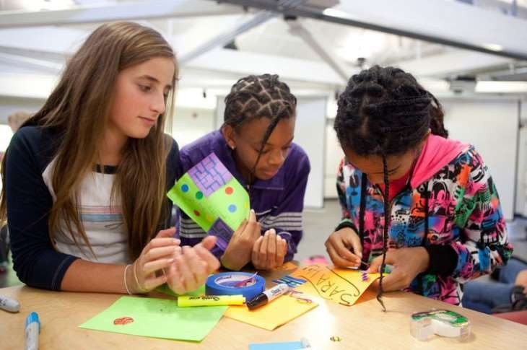

In schools, students normally attempt exams in the form of question-answers based test, fill in the blanks or match case type of questions. All these don’t prepare the students for a society that is complex and has much more to it than plain facts.

Design Thinking

Tools at Schools
The Tools at Schools group once conducted an activity with the 8th grade students in The School at Columbia University. The activity included redesigning a locker, chair or desk to suit the requirements of 21st century students. Design thinking was applied in this activity and the results were displayed in International Contemporary Furniture Fair. Design thinking also helps the pupils to learn how to work collaboratively in a team.

Degrees and Certification in Design Thinking
Design thinking has become so popular in the education sector that Radford University has begun offering a Master of Fine Arts degree in design thinking. It is an online degree emphasizing of design principles and design methodologies.
The Victoria-Cedar Alliance in Singapore offers a six-year Imagineering Program. This program offers an opportunity for the students to gain a deeper understanding of social issues, develop empathy and work to improve the lives of fellow human beings.
In education, design thinking helps the students to understand that they can create their own future by borrowing frameworks from other areas. This enables them to design their own experiences and participation.
Design thinking also helps in pedagogy. Teachers find it easy to find solutions by learning from the experiences of others, rather than just reading contents of a book. The collaborative activities help the teachers to teach the concepts in a better fashion to the kids.

Social issues are always complex problems, which have too many strands attached to them. There are too many aspects of a problem, that many a times get ignored by the social innovators. However, solving a social problem requires taking into consideration all the facts and figures, and then working on them. This is the reason why design thinking is being widely used for social innovation. As a result, non-profits have begun to use design thinking extensively these days.
Design Thinking

16. Design Thinking - Social Innovation

IDEO Example
In 2008, Bill and Melinda Gates Foundation asked IDEO to codify the process of design thinking. The foundation wanted the code to be used by grassroots level NGOs to solve problems for small farmers in the developing nations. A team from IDEO worked for months in association with the International Center for Research on Women, Heifer International, and International Development Enterprise to get insights into the process of designing new products. These products, processes, and services were to be integrated with IDEO’s new process.
As a result of this partnership program, the Human Centered Design Toolkit was developed. This methodology allowed organizations to use design thinking process themselves.

Naandi Foundation’s Example
In the city of Hyderabad in India, Naandi Foundation’s community water treatment plant provides safe water. However, villagers still use free water which is not safe for consumption and makes people sick. The villagers use unsafe water not because of affordability issues or accessibility issues, but because of the flaws in the overall design of the system.
The problem is that the womenfolk cannot bring the heavy containers of water back to their homes from the plant. Such problems can be solved by design thinking process. Consider it as an exercise to think of ideas how this problem faced by the villagers can be solved by design thinking methodology.

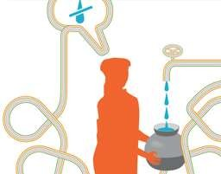

Design Thinking

Case study - Embrace Baby Warmer
Design thinking gives a collaborative, human centered approach to solve some of the most pressing issues of the world. The Embrace Baby Warmer is a solution that a team of students from Stanford University came up with to solve the issue of providing a maintained temperature for six hours to a newborn baby. This has helped more than 22,000 low birth weight babies around the world to stay warm. In Nepal, low birth weight babies often developed fatal hypothermia because of the dysfunctional incubators. The areas which lacked electricity were suffering from this problem.
Using design thinking methodology, the students came up with an innovative solution. The sleeping bag which they developed for newborns is portable and does not need electricity. This way, lives are saved without any dependency on incubators.
Design thinking puts stress on quickly prototyping the solution and tests it so that the designers can take feedback quickly and work on the suggestion at the earliest. There have been many examples of social innovation in the past by the students of Stanford University in countries like Bangladesh, Nepal, India, Pakistan, etc. and many are still ongoing. Design thinking helps people from all disciplines to try and look out for solutions to the pressing situations and problems of the world around.

The Information Technology (IT) industry has been booming across the world since a few decades. The industry employs a large number of people across the globe and is the hub for innovation every day. The IT industry is now working mostly on Agile methodology, which is a technique of project management.
Design Thinking

17. Design Thinking - IT Industry
Agile is an iterative or incremental method of managing development and design. Each day, the engineers have a set of tasks at hand, which they are required to complete in a day or two. Moreover, the complex problems shot by the customers to the engineers are required to be solved quickly. In such a scenario, design thinking helps to solve the problems and address the exact needs of the customer.
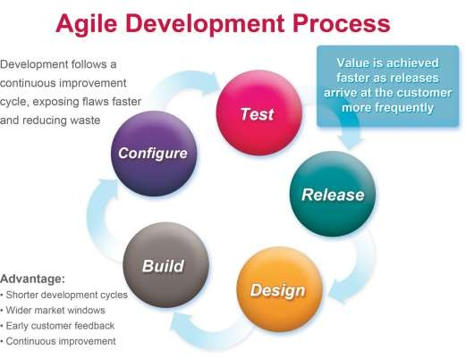

Solving the customers’ problems requires an intuitive thinking and understanding by observing exemplary use cases or scenarios. Hypotheses and theories are not encouraged. This intuitive understanding is developed by design thinking principles. After getting the problem statement from the client, the engineers are supposed to brainstorm on ideas and suggest solutions to the client.
Before ideas can be thought of, it is imperative for the engineers to do an in-depth requirements gathering. This helps to understand the exact needs of the client and also helps to make the analysis and synthesis easier. In a Waterfall model, which is different than the Agile model, the process starts with requirements gathering, followed by creating

Design Thinking

the visual designs and then occurs the development of solution. Testing is the last step in the model. Looking closely, it is similar to the process of design thinking.
The IT engineers today are supposed to understand the problem statement in the exact manner as felt by the client. Otherwise, both the solution and the time invested will fail. Once requirements have been gathered, only then can the developers start thinking of programmatic solutions.
The solutions that are developed are sent for the client’s experience. The feedback given by the client helps the designers and developers to iterate the process of software development. Design thinking has been used extensively in IT companies to brainstorm for solutions towards customer’s problems. The advantages of using design thinking in IT industry for software development are as follows.
- The solutions are prototyped.
- The results are verified.
- The best solutions are accepted.
- The solutions are experienced by the client before approval.
- Short iterations are possible to improve the user experience.
- Small cross-functional teams.
- Incremental delivery is possible.
- Fast feedback helps the designers and developers.
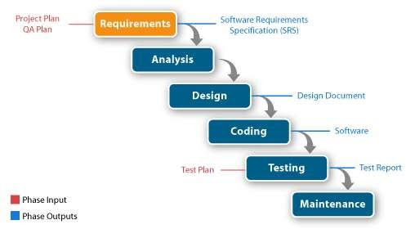
- Continuous improvement is possible.

The use of design thinking principles have grown so much in the IT industry that nowadays world-renowned companies like Infosys have made it mandatory for its employees across the globe to undergo design thinking courses and get certified as a design thinker.
The concept of design thinking is central to the process of developing software solutions, which target the exact needs of the customer and have the flexibility of getting modified in an iteration process based on the feedback given by the client.

Design thinking has proven to be a very useful tool for healthcare. Healthcare is one area where there are a lot of processes in place and a lot of scope for innovation. On a daily basis, new innovative techniques are coming up to improve the healthcare condition of the countries across the world. The end users of healthcare are always those who need and deserve the best healthcare facilities.
Design Thinking

18. Design Thinking - Healthcare Industry
Design thinking can certainly help the healthcare experts to come up with solutions that plague the healthcare system. The basic question for every healthcare expert is ‘how to provide quality healthcare at low and affordable prices to everyone?’

Case Study – Venice Family Clinic
The example of Venice Family Clinic, cited in one of the earlier sections, is the best example to be quoted. The innovators at Venice Family Clinic found that the pit crews at auto races worked in a coordinated manner to save every fraction of a second. They thought if this model could be replicated in the reception area of the clinic. They then came up with the idea of making the reception mobile. The idea was to have someone walk up with an iPad or a tablet to the patient and welcome each of the patients individually.
They collaborated with the Art Centre College of Design in Pasadena and architects from Houston/Tyner in Torrance, and they simulated the entire idea in the area of a future children’s clinic. The healthcare providers and operation staff could actually move about easily and play their respective roles.

Case study – Eric Duncan
A similar experience was observed in the emergency department of Texas Health Presbyterian Hospital, Dallas, where a patient called Eric Duncan reported with a few symptoms like low-grade fever, dizziness, and pain. He was later diagnosed with Ebola. How could the doctors miss the symptoms of Ebola when he was first diagnosed? The Electronic Health Record (EHR) was checked and was found to be flawless too.
The problem was that the EHR system worked only when the patients conformed the way they worked to the way EHR worked. The major flaw, hence, in EHR was that it was engineered. Now stress was put on gaining an understanding of how a system is likely to be used and then create the system in accordance with that understanding.

Case Study – Access to Clean Water
According to Tim Brown, the CEO of IDEO, design thinking in healthcare is important. In one of TEDMED talks, he asked how can there be better access to clean drinking water for people from rural areas and at the same time, usher in innovation for local water providers. His team teamed with 11 water providers across India, brainstormed on how to bring innovation in water supply.

Design Thinking

A competition was held amongst the providers. Five of these providers were provided seed funding for their ideas and this helped in buying new vehicles, new equipment, etc. In another case, in India, an NGO found that with better water filtration systems and good transport facilities, the subscription to clean water increased fourfold. These examples show how design thinking can help in healthcare.

The concept of design thinking can be applied across diverse disciplines. From education, law, and medicine to ICT, business management, human resource management and design itself, design thinking principles enable and empower a professional to approach the problem statement in a step-by-step manner and take into account all the necessary factors for arriving at the best solution.
Design Thinking

19. Design Thinking - Conclusion
Design thinking has its foundation in the concept of analysis and synthesis. Analysis teaches a thinker how to break down the big problem statement into smaller parts and elementary problem statements. Each elementary problem statement is then studied and attempted for solution. Synthesis is done to put all the suggested solutions together to form a coherent big final solution.
During analysis, divergent thinking is applied and multiple solutions are thought for each of the elementary problem statements. The suggested solutions need not be feasible or viable. The main aim of divergent thinking is to bring up as many ideas as possible to the table.
Divergent thinking is followed by convergent thinking, where the suggested ideas are tested on the grounds of feasibility, viability, and innovation. Synthesis takes the help of convergent thinking to come up with the final best possible solution.
The entire flow of design thinking is generally broken down into five components. These components are:
- Empathize or Understand
- Define
- Ideate
- Prototype
- Test or Verify

In Empathize stage, the design thinker puts himself or herself into the shoes of the end user and tries to understand the needs of the customer. A lot of interview, field visits, etc. are required for gathering the information on the requirements. This phase has the customer directly involved in the design thinking process.
Once the requirements are clear, the Define stage helps to frame the problem definition. Problem shaping occurs in this phase itself.
In the Ideate phase, a design thinker brainstorms on the ideas suggested by others and also brings forward his/her own ideas. The ideas are not tested on the grounds of feasibility or viability.
The influx of ideas is represented as a mind map or as a storyboard or a document. In the Prototype phase, a design thinker focuses on testing the ideas on the grounds of feasibility and viability. The unfeasible ideas are discarded and the feasible ones are converted to prototypes. The process of prototyping helps the design thinker to understand

Design Thinking

the issues related to an idea, which were never thought before. This helps the team of design thinkers to come up with the best prototype and decide the best solution at hand. Moreover, the customer is directly involved in this phase and its feedback is critical for the design thinkers.
In the Test phase, the prototype or the model is presented to the customer and the customer experiences it completely on a full scale. The feedback from the end user decides whether the solution suggested by the design thinkers has been fruitful or not. If the end user does not approve of the solution, then the entire process has to be iterated. The concept of iteration is hence central to the process of design thinking.
Design thinking not only helps to come up with innovative solutions, but also helps to address the exact problems faced by the customer and target the customer’s requirements in the best possible manner.

