Understanding Color Model

Object Color Dialog
The Object Color dialog contains two preset palettes of colors that you use to set an object’s wireframe color. This is also the surface color you see in a shaded viewport.
- Click the color swatch by the object's name in any command panel.
- Object Properties / Layer Properties dialog > Click the color swatch.

Using Random Color Assignment
By default, 3ds Max assigns colors randomly as objects are created. The colors are chosen from the current palette in the Object Color dialog. If you turn on Customize Preferences General panel Default to By Layer for New Nodes, new objects are assigned the color set by the layer.
For individual objects, you can click the By Layer / By Object button on the Object Color dialog to change the method used to set the object color.

Defining Custom Colors
When using the 3ds Max palette, the Object Color dialog contains a palette of 16 custom color swatches. You can define any color for each of the 16 color swatches by selecting a swatch from the Custom Colors group, then clicking Add Custom Colors.

Switching Between Palettes
You can alternate between two versions of the Object Color dialog at any time by clicking the appropriate Basic Colors toggle:
- 3ds Max palette: Contains a fixed palette of 64 colors, plus a custom palette of 16 user-defined custom colors.
Use this version when you want to work with a smaller palette of colors or when you want to define custom object wireframe colors.
- AutoCAD-compatible version: Contains a fixed palette of 256 colors matching the colors in the AutoCAD Color Index (ACI).
Use this version when you want to assign object colors that match the AutoCAD Color Index. Using ACI colors is useful if you plan to export objects to AutoCAD and want to organize them by object color, or when you want a wide selection of colors to choose from.

Procedures
To set object color:
- Select one or more objects.
- On any command panel, click the color swatch to the right of the Object Name field to open the Object Color dialog.
- On the Object Color dialog, if you see a button labeled By Layer, click it to toggle it to By Object.
- Click a color swatch from the palette, and then click OK to apply the color to the selection.
To create objects of the same color:
- On the Object Color dialog, choose the color you want to apply to new objects and turn off Assign Random Colors.
Newly created objects appear in this color until you change the setting.
To define a custom color:
- With the 3ds Max palette option active, click one of the 16 custom color swatches.
- Click Add Custom Colors to open the Color Selector dialog.
- Define a custom color and click Add Color.
The custom color is stored in the selected color swatch of the Object Color dialog and is set as the current color.
To copy a custom color from an object in your scene to one of your custom color swatches:
- Drag the Active Color swatch up to one of the custom color swatches.
The Active Color swatch is in the Object Color dialog, to the left of the OK button.
To select objects by color:
- Click (Select By Color). This displays the Select Objects dialog. All objects that have the same color as the current object are highlighted in the list. Click Select.

Interface

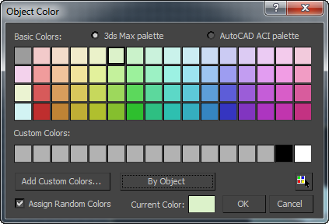

Palette
Choose one of these:
- 3ds Max palette When chosen, the dialog displays Basic Colors and Custom Colors groups, and you have the option to add custom colors.
- AutoCAD ACI palette When chosen, the AutoCAD ACI palette is shown. When you click a color, its ACI# is displayed at the bottom of the dialog.
Basic Colors
A set of 64 default colors, available only when 3ds Max Palette is active.
Custom Colors
Displays 16 custom colors when 3ds Max Palette is active. To choose a custom color, click its swatch. To define or change a custom color, click its swatch and then click Add Custom Colors.
Add Custom Colors
Available only when 3ds Max Palette is active. Clicking this option displays the Color Selector, which allows you to modify the currently selected custom color. If you click Add Custom Colors with a basic color chosen, the dialog switches to the first custom color before opening the Color Selector.
By Object / By Layer
Toggles between setting an object's color directly or using its layer's color.
- By Object - Choosing a new color with the Object Color dialog changes the object's wireframe color in viewports.
- By Layer - The object uses the color of the layer it belongs to. The color swatch of an object set to By Layer, as shown on this dialog and on the command panel, is black and white: . In Scene Explorer, the color swatch of an object is this: .
To change a layer's color, use Layer Explorer.
Unavailable for layers.
ACI#
Displays the ACI number for the selected color. Available only when AutoCAD ACI palette is active.
Select by Color
Opens the Select Objects dialog listing all objects that use the current color as their wireframe color.
Note: This button is available only if at least one object in the scene has the Current Color as its wireframe color.
Assign Random Colors
When on, 3ds Max will assign a random color to each object created. When off, 3ds Max will assign the same color to every object created until the color swatch is changed. This setting affects wireframe colors only when By Object is turned on as the color method.
Active/Current Color
Displays the active color (if no object is selected) or current color. When you click the color swatch, the Color Selector dialog opens, where you can mix a custom color.

Color Selector Dialog
Use the Color Selector to specify various color parameters including light colors, material colors, background colors, and custom object colors. You can set values in either the rendering space or the display space using three different color models to help you zero in on the exact color you want.
- Any command panel > Name and Color fields > Click color swatch. > Object Color dialog > Add Custom Colors button or Current Color swatch.
- Material Editor > Click any color swatch.
- Select or add a light object. > Modify panel > Intensity/Color/(Distribution/Attenuation) rollout > Click color or Filter Color swatch.
- Default menu: Rendering menu > Environment > Environment and Effects dialog > Click color swatch for Background, Tint, and Ambient components of Global Lighting, and various components of atmospheric effects such as Fire, Fog, and so on.
- Alt menu: Rendering menu > Environment and Effects > Environment and Exposure Settings > Environment and Effects dialog > Click color swatch for Background, Tint, and Ambient components of Global Lighting, and various components of atmospheric effects such as Fire, Fog, and so on.

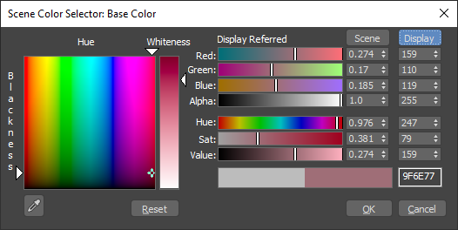
There are two versions of the Color Selector. The version that you see depends on the color that you are editing:
- For UI colors and non-color data, the numbers under Float represent the values in floating-point format and the numbers under Integer represent the equivalent values as an 8-bit integer.
- For other colors, the numbers under Scene represent the color values in the rendering space in floating-point format, and the numbers under Display represent the equivalent colors in the display space (after the view transform and display encoding have been applied) as integers. Click either label to show the sliders in the corresponding space. Note that the Hue/Blackness box and Whiteness slider are always displayed in the rendering space. The color transform that is used to convert between the rendering and display spaces depends on your Color Management Settings.
The dialog shows three different color selection models. You can use the controls of any model to define a color. As you adjust the controls of one color model, the controls of the other two models change to match. The three color models are:
- Hue/Whiteness/Blackness (HWB)
The HWB model represents a natural, pigment-based way of mixing color by starting with a pure color (hue) and then making it darker by adding black, or lighter by adding white.
The main feature of the HWB model is a large square box displaying the color spectrum. Across the top of this box is the spectrum of pure colors, or hue. Down the side of the box you see increasing levels of blackness, making the color dark as you approach the bottom.
To the right of the color spectrum box is the Whiteness box, which controls the amount of white in the color. Use higher positions to decrease the whiteness, or lower positions to increase the whiteness.
- Red/Green/Blue (RGB)
The RGB model adjusts the mix of red, green, and blue to define a color. This model represents the way colored light can be mixed. This is additive color mixing, as opposed to the subtractive color mixing for paint and other pigments. You can adjust values using the color sliders, the numeric fields to their right (via the keyboard), or the spinners to the right of the numeric fields.
- Hue/Sat (Saturation)/Value (HSV)
The HSV color model adjusts hue, saturation, and value. Hue sets the color; saturation (labeled Sat) sets the color's purity; and value sets the color's brightness, or intensity. You can adjust values using the color sliders, the numeric fields to their right (via the keyboard), or the spinners to the right of the numeric fields.
When using OCIO-based color management and setting colors in the Scene space, the sliders indicate colors that cannot be reproduced on your display using black stripes. You can still select these colors, and the display will show the closest possible screen color. In addition, a warning symbol appears — hover the pointer over the icon to see whether the color is outside the display gamut, the rendering gamut, or both.

In most contexts, the Color Selector is modeless; that is, it remains on the screen until you dismiss it, and you can use other controls or work in a viewport while it is still visible. In other contexts, the Color Selector is modal, and you must close the dialog before proceeding.

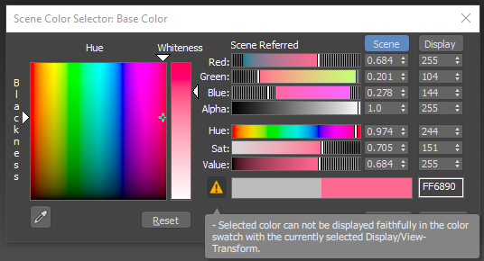

Interface
Hue/Blackness
Select a color by clicking anywhere in the box. To change the hue without affecting blackness or vice versa, drag the pointer along the top or left side of the box.
Whiteness
The vertical bar to the right controls the amount of whiteness. The color set by the hue and blackness pointers is displayed at the top of the bar and pure white at the bottom. Drag the whiteness pointer down to lighten the color by adding white.
Red, Green, and Blue
When a slider is all the way to the left, its numeric field contains 0; none of the color controlled by that slider is used. If the slider is all the way to the right, the maximum amount of that color is being used.
The spinners to the right of each slider are another way of setting the red, blue, or green component.
The colors in the sliders change to show an approximation of what the color result will be if you move the slider to that location, without adjusting any other color parameter.
Hue
Sets the pure color. Locating the slider all the way to the left gives you pure red. As you drag the slider to the right you move through the spectrum of Red, Yellow, Green, Cyan, Blue, Magenta, and back to Red again.
Sat (Saturation)
Sets the purity or strength of the color. A weak color, with a saturation near 0, is dull and gray. A color with high saturation is very strong and pure.
Value
Sets the lightness or darkness of a color. Low values darken the color toward black. High values lighten the color toward white. A value in the middle gives you the color defined only by hue and saturation.
Color Output
The pair of color swatches below the Value slider lets you compare the new color (shown on the right) to the original color (shown on the left) in the display space.
Hex Box
The text box to the right of the Color Output swatches shows the RGB triplet of the display-space color in hexadecimal format. You can overwrite the value here if you know the hex value of the display color you want. You can enter values in the following formats:
- rrggbb (short form: rgb)
- #rrggbb (short form: #rgb)
- xrrggbb (short form: xrgb)
- 0xrrggbb (short form: 0xrgb)
Some examples:
- 8a9fbb
- f80 (same as ff8800)
- #ffaabb (same as fab)
- 0xa1b2c3
- x7a9855
- x732 (same as 773322)

Color Clipboard Utility
The Color Clipboard utility stores color swatches for copying from one map or material to another.
- Tools menu > Color Clipboard
- Utilities panel > Utilities rollout > Color Clipboard button
For example, if in the Material Editor, you want to copy a color from a swatch in one level of a material to a swatch in another level (or from another material), there would be no way to do it with drag and drop. This is because you can't have two materials/maps visible at the same time. However, you can drag the color from one material to the color clipboard, switch to the other material, and then drag the color from the clipboard to the swatch in the new material.
You can save and load color clipboard files. The saved file, which is given a .ccb (color clip board) extension, is an ASCII file that contains a palette description. The first 12 lines of the file consist of three RGB numbers, so you can easily edit or create your own clipboard files. This file format is also used by the VertexPaint modifier.

Procedures
To copy a color from a swatch to the color clipboard:
- On the Utilities panel, click Color Clipboard.
- Open the Material Editor.
- Right-click on any swatch and choose Copy.
- Right-click on a swatch in the Color Clipboard and choose Paste.

Interface
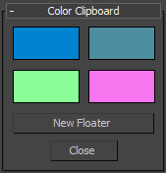
Color swatches
Click a color swatch to edit its value with the Color Selector.
Note: The Color Selector invoked by this utility uses decimal numbers in the range 0.0 to 1.0, instead of integers in the range 0 to 255 as with other color-selection dialogs in 3ds Max.
New Floater
Displays a floating clipboard with 12 slots, plus buttons for opening and saving color clipboard files. You can open up as many of these floaters as you want and you can minimize them. If you exit the Utilities panel or select the Close button to exit the Color Clipboard utility, any visible floaters remain open. When you close a floater, any changed values are lost.
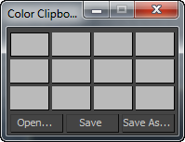
Close
Exits the Clipboard utility.

Working with Lights
The procedures in this topic apply to both standard and photometric lights.
Here are some general tips about working with lights:
- One simple way to light a scene is to convert the default lighting into light objects by using the command Add Default Lights To Scene.
Note: Add Default Lights To Scene works only if you have used the Viewport Configuration dialog to have the scene use two default lights.
- You can turn the display of light objects on and off with an option in the Display panel.
- You can change the renderability of lights in your scene using the Renderable option on the General panel of the Object Properties dialog.
- You can change the renderability of a group of lights in your scene using the Layer Manager.
Note: In order to be turned on/off through the Layer Manager, lights must have their Render Options set to ByLayer in the General panel of the Object Properties dialog.
Tip: To automatically set new lights as renderable ByLayer, turn on New Lights Renderable By Layer on the General panel of the Preferences dialog.
- You can use the Place Highlight button to change a light's position.
- A Light viewport can be a useful way to adjust spotlights in your scene.

Procedures
To create a light:
- On the Create panel, click Lights.
- Choose Photometric or Standard from the drop-down list. (Photometric is the default.)
- On the Object Type rollout, click the type of light you want to create.
- Click a viewport to create the light. This step varies slightly depending on the type of light. For example, if the light has a target, you drag and click to set the target’s location.
Light objects replace the default lighting. As soon as you create a light, the default lighting is turned off. If you delete all lights in the scene, the default lighting is restored.
- Set the creation parameters.
Like all objects, lights have a name, a color, and a General Parameters rollout.
To create shadows, do one of the following:
- In the General Parameters rollout, make sure On is checked in the Shadows group. Adjust shadow parameters in the Shadow Parameters rollout and the additional (Shadow Map, Advanced Ray-traced, Area Shadows, or Ray Traced Shadows) shadow rollouts.
- Right-click the light, and turn on Cast Shadows in the Tools 1 (upper-left) quadrant of the quad menu.
Turning on Cast Shadows also turns on the On toggle in the Shadows group of the General Parameters rollout, and vice versa.
Shadows are visible only when rendered, either in a full rendering, in a viewport, or with ActiveShade.
To control the display of light objects:
- On the Display panel, on the Hide By Category rollout, turn on Lights.
All light objects in the scene disappear, but the lighting itself is unchanged.
Light objects can cast light whether or not their display is turned off. The Zoom Extents commands are affected by whether light icons are displayed or not. When lights are displayed, Zoom Extents and Zoom Extents All includes the lights in the zoom.
Tip: To control whether a light casts light in the scene, you can use its On toggle, or you can toggle its Renderable property on the light's Object Properties dialog.
To change a light's parameters:
- Select the light.
Tip: Lights can be hard to select by clicking. You can use the keyboard shortcut H to select the light by name.
- Open the Modify panel.
- Change the light's parameters in the General Parameters rollout and other rollouts available for that light.
To position a light so it highlights a face:
- Make sure the viewport you plan to render is active, and that the object you want to highlight is visible in it.
The result of Place Highlight depends on what is visible in the viewport.
- Select a light object.
- On the main toolbar, choose Place Highlight from the Align flyout.
You can also choose Tools menu Place Highlight.
- Drag over the object to place the highlight.
When you place an omni light, free direct light, or a photometric Free Light, 3ds Max displays a face normal for the face the mouse indicates.
When you place a target direct light or photometric Target Light, 3ds Max displays the light’s target and the base of its cone.
- Release the mouse when the normal or target display indicates the face you want to highlight.
The light now has a new position and orientation. You can see the highlight illumination in shaded viewports that show the face you chose, and when you render those views.
Place Highlight works with any kind of selected object. You can also use Place Highlight with a selection set of multiple objects. All objects maintain their initial distance from the face.
Note: For materials, highlight rendering depends on the material's specular properties and the type of rendering you use.

Properties of Light
This topic describes light in the real world. When you light a scene, it can be helpful to know how light naturally behaves.
When light rays strike a surface, the surface reflects them, or at least some of them, enabling us to see the surface. The appearance of a surface depends on the light that strikes it combined with the properties of the surface material, such as color, smoothness, and opacity.

Intensity
The intensity of light at its point of origin affects how brightly the light illuminates an object. A dim light cast on a brightly colored object shows only dim colors.
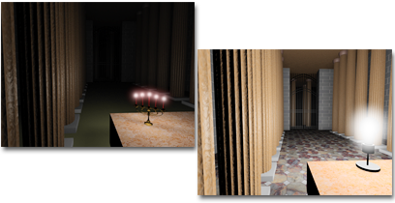
Left: A room lit by candles, which are a low-intensity source.
Right: The same room lit by a higher-intensity light bulb.

Angle of Incidence
The more a surface inclines away from a light source, the less light it receives and the darker it appears. The angle of the surface normal relative to the light source is known as the angle of incidence.
When the angle of incidence is 0 degrees (that is, the light source strikes the surface perpendicularly), the surface is illuminated with the full intensity of the light source. As the angle of incidence increases, the intensity of illumination decreases.
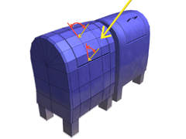
Angle of incidence affects intensity.

Attenuation
In the real world, light diminishes over distance. Objects far from the light source appear darker; objects near the source appear brighter. This effect is known as attenuation.
In nature, light attenuates at an inverse square rate. That is, its intensity diminishes in proportion to the square of the distance from the light source. It is common for attenuation to be even greater when light is dispersed by the atmosphere, especially when there are dust particles in the atmosphere, or fog or clouds.
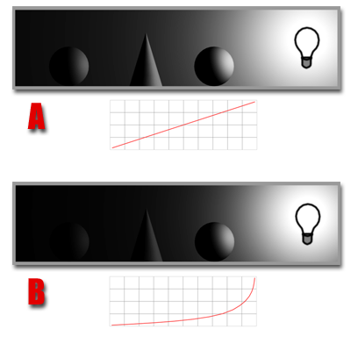
A. Inverse decay
B. Inverse square decay
The graphs show the decay curves.

Reflected Light and Ambient Light
The light an object reflects can illuminate other objects. The more light a surface reflects, the more light it contributes to illuminating other objects in its environment.
Reflected light creates ambient light. Ambient light has a uniform intensity and is uniformly diffuse. It has no discernible source and no discernible direction.
A. Direct light
B. Reflected light
C. Resulting ambient light

Color and Light
The color of light depends partly on the process that generates the light. For example, a tungsten lamp casts orange-yellow light, a mercury vapor lamp casts cold blue-white light, and sunlight is yellow-white. Light color also depends on the medium the light passes through. For example, clouds in the atmosphere tint daylight blue, and stained glass can tint light a highly saturated color.
Light colors are additive colors; the primary light colors are red, green, and blue (RGB). As multiple colored lights mix together, the total light in the scene gets lighter and eventually turns white.
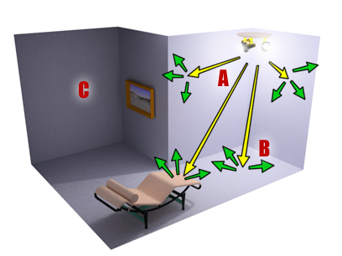
Additive mixing of colored lights

Color Temperature
Color temperature describes a color in terms of degrees Kelvin (K). This is useful for describing the color of light sources and other color values that are close to white. The following table shows color temperatures for some common types of light, with the equivalent hue number (from the HSV color description).
If you use these hue numbers for lights in a scene, set the value to full (255) and then adjust the saturation to meet the needs of your scene. Mentally we tend to correct light color so that objects appear to be lit by white light; usually the effect of color temperature in a scene should be subtle.
Light source | Color Temperature | Hue
Overcast daylight | 6000 K | 130
Noontime sunlight | 5000 K | 58
White fluorescent | 4000 K | 27
Tungsten/halogen lamp | 3300 K | 20
Incandescent lamp (100 to 200 W) | 2900 K | 16
Incandescent lamp (25 W) | 2500 K | 12
Sunlight at sunset or sunrise | 2000 K | 7
Candle flame | 1750 K | 5

Lighting in 3ds Max
Lighting in 3ds Max simulates natural lighting.

Intensity
The intensity of a standard light is its HSV Value. At full value (255), the light is at its brightest; at 0, the light is completely dark.
The intensity of a photometric light is set by a real-world intensity value, measured in either lumens, candelas, or lux. See Intensity/Color/Attenuation Rollout (Photometric Lights).

Angle of Incidence
3ds Max uses a vector from the light object to the face, along with the face normal, to calculate the angle of incidence.
A surface is fully illuminated when the angle of incidence is 0 degrees (that is, the light source strikes the surface perpendicularly). If the angle of incidence increases, attenuation is in effect, or if the light has a color, the surface intensity can be reduced.
In other words, the position and orientation of the light, relative to the object, are what control the angle of incidence in a scene. The Place Highlight command is one way to fine-tune the location of a light.

Attenuation
For standard lights, attenuation is turned off by default. To shade or render a scene with attenuation, you turn it on for one or more lights. All types of standard lights support attenuation. You can set explicitly where attenuation begins and where it ends. This is partly so you don’t have to worry about setting up strictly realistic distances between light objects and the objects they illuminate. More importantly, this feature lets you fine-tune the effect of attenuation.
In outdoor scenes, attenuation can enhance the effect of distance. (Another way to model environmental effects is to use the atmospheric settings when you render. See Environment and Exposure Settings.) In an indoor setting, attenuation is useful for low-intensity light sources such as candles.
Photometric lights always attenuate, using an inverse-square falloff, as in nature. (In the case of the IES Sun Light, its great intensity makes its attenuation hardly apparent.)

Reflected Light and Ambient Light
Rendering with the default renderer and standard lights does not calculate the effect of lights reflected from objects in the scene. Because of this, lighting a scene with standard lights often requires you to add more light objects than would be needed in real life. You can, however, use radiosity to show the results of reflected light.
When you do not use a radiosity solution, you can use the Environment panel to adjust the color and intensity of ambient light. Ambient light affects contrast. The higher the intensity of ambient light, the lower the contrast in the scene. The color of ambient light tints the scene. Sometimes ambient light is bounced light that gets its color from other objects in the scene. Most of the time, however, the color of ambient light should be the complement of the color of the principal light source for the scene.
Tip: To better simulate reflected light and variations in it due to the varying reflectivity of objects in the scene, you can add more lights to a scene and set them to exclude the objects you don’t want them to affect. You can also set up lights to affect only the ambient component of surfaces. See General Lighting Parameters.

Color
You can set the color of 3ds Max lights. You can use the RGB values for color temperatures as a guide for the principal lighting of a scene; see Properties of Light. Be aware, however, that we tend to perceive scenes as always being lit by white light (this is a perceptual phenomenon known as color constancy), so accurately reproducing the color of a light source can make the rendered scene appear to be tinted oddly. Use the light source values as a general guideline only.

Guidelines for Lighting
The guidelines for lighting used by photographers, filmmakers, and stage designers can also help you set up the lighting for scenes in 3ds Max.
Your choice of lighting depends on whether your scene simulates natural or artificial illumination. Naturally lit scenes, such as daylight or moonlight, get their most important illumination from a single light source. Artificially lit scenes, on the other hand, often have multiple light sources of similar intensity.
Note: If you use standard instead of photometric lights, both kinds of scenes require multiple secondary light sources for effective illumination.
Whether a scene is indoors or outdoors can also affect your choice of material colors. See Designing Materials.

Natural Light
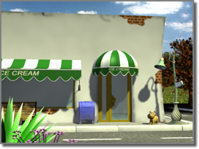
Outdoor scene with natural sunlight
At ground level, for practical purposes, sunlight has parallel rays coming from a single direction. The direction and angle vary depending on the time of day, the latitude, and the season.
In clear weather, the color of sunlight is a pale yellow: for example, RGB values of 250, 255, 175 (HSV 45, 80, 255). Cloudy weather can tint sunlight blue, shading into dark gray for stormy weather. Particles in the air can give sunlight an orange or brownish tint. At sunrise and sunset, the color can be more orange or red than yellow.
3ds Max provides several daylight systems to simulate the sun. See Sunlight and Daylight Systems. A single daylight system is appropriate as the main light source for sunlit scenes.
Shadows are more distinct the clearer the day is, and can be essential for bringing out the three-dimensionality of a naturally lit scene.
A directional light can also simulate moonlight, which is white but dim compared to the sun.

Artificial Light
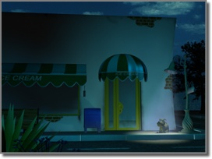
Outdoor scene with natural twilight and one streetlight
Artificial light, whether used indoors or outdoors at night, uses multiple lights. The following guidelines are for creating normally lit, easily legible scenes. You don’t have to follow the guidelines, of course, but then you call attention to the lighting itself, rather than to the subject of the scene.
The subject of a scene should be lit by a single bright light, known as the key light. Position the key light in front of the subject and slightly above.
In addition to the key light, position one or more other lights to illuminate the background and the side of the subject. These are known as fill lights. Fill lights are less bright than the key light.
When you use only one fill light, the angle at ground level between it, the subject, and the key light should be approximately 90 degrees.
Key-and-fill lighting emphasizes the subject of a scene. It also emphasizes the three-dimensionality of the scene.
In 3ds Max, a spotlight is usually best for the key light, and either spotlights or omni lights are good for creating the fill lighting. See Target Spot, Free Spot, and Omni. Ambient light can be another element of your fill lighting.
You can also add lights to emphasize secondary subjects in a scene. In stage terminology, these lights are known as specials. Special lights are usually brighter than the fill light but less bright than the main key light.
To design using physically based energy values, distributions, and color temperature, you can create photometric lights.

Ambient Light
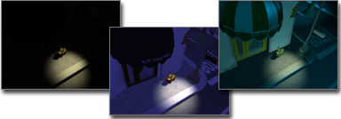
Left: No ambient light
Middle: Default ambient light
Right: User-adjusted ambient light
Ambient light in 3ds Max simulates the general illumination from light reflecting off diffuse surfaces. Ambient settings determine the illumination level of surfaces in shadow, or those not receiving direct illumination from light sources. The Ambient level on the Environment dialog establishes the scene’s basic illumination level before any light sources are taken into account, and is the dimmest any portion of the scene can ever become.
Ambient light is most often used for exterior scenes, when the sky’s broad lighting produces an even distribution of reflected light to surfaces not in direct sun. A common technique for deepening the shadows is to tint the ambient light color to be the complement of the scene’s key light.
Unlike the outside, interior scenes typically have numerous lights, and a general ambient light level is not ideal for simulating the diffuse reflection of local light sources. For interiors, it’s common to set the scene’s environment ambient level to black, and use lights that effect ambient only to simulate the regional areas of diffuse reflection.
You set the scene’s ambient light using the Environment And Effects dialog Environment panel. You set a light to affect only ambient illumination with its Advanced Effects rollout Ambient Only checkbox.

Positioning Light Objects
Once you have placed lights in your scene, you can use transforms to change a light's position or orientation.

Transforming Lights
Use transforms on light objects as follows:
Move: Use Move to change the position of lights. You can also use it to change the position of light targets.
Rotate: Use Rotate to change the orientation of lights.
Note: You can't rotate a target light about its local X or Y axes. Instead, use Move to move the light or its target. Rotating the light about its local Z axis can be useful if the light uses a rectangular beam or projects a bitmap.
Rotating a plain omni light or a photometric light with spherical distribution has no effect, as these lights cast light uniformly in all directions. However, rotating an omni light or a spherical light with projection causes the projected image to rotate.
Scale: Scaling Point, Linear, or Area lights has no effect. Using Scale with spotlights and directional lights changes the size of their light beam and attenuation ranges. Scaling omni lights changes only the attenuation ranges. Scaling photometric lights changes their attenuation rate.
Light viewports are another convenient way to transform and change parameters of spotlights and directional lights.
Tip: When you adjust lights, it can be useful to turn off Adaptive Degradation. If Adaptive Degradation is on and shaded viewports begin to display in wireframe, you won't see the result of the changes you make to lights.

Placing Highlights
You use Place Highlight to position a light to create a specular highlight at a designated point on an object. Place Highlight is one of the buttons on the Align flyout. Place Highlight moves or rotates the selected light object to aim it at a face on an object you pick. The light maintains its original distance from the face. Place Highlight works with any kind of selected object. You can also use Place Highlight with a selection set that contains more than one object. All objects maintain their initial distance from the face.

Previewing Shadows and Other Lighting in Viewports
If your system has a graphics card that supports the SM (Shader Model) 2.0 or 3.0 standard, and you use the Nitrous driver or the Direct3D driver, you can preview shadows in shaded viewports.
Tip: You can check whether your system supports interactive shadows by choosing Help menu Diagnose Video Hardware.
With SM3.0 hardware shading, viewports can preview soft-edged shadows as well as hard-edged shadows. They can also preview ambient occlusion and exposure control as well as lighting and shadows.
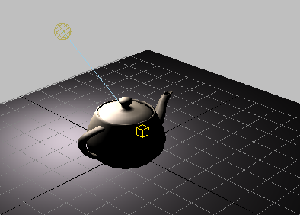

If the light is a photometric light that uses an area for shadow casting, the viewport preview can show area shadows.
Note: With the Direct3D driver, area shadows are not on by default: To enable them, enter the following line in the MAXScript Listener:
viewportSSB.AreaShadow = True

Viewport shadows cast by a light with a disc-shaped area
Viewport display of area shadows is not necessarily accurate. In general, lighting and shadow previews in viewports are a convenience. These settings and the viewport appearance don’t necessarily match what will happen when you render.
Shadows don’t appear in a viewport if they wouldn’t appear in a rendering; for example, if an object is set to not cast or receive shadows, it won’t do so in viewports, and if a light is turned off or is not shadow casting, then it has no effect on the viewport display.
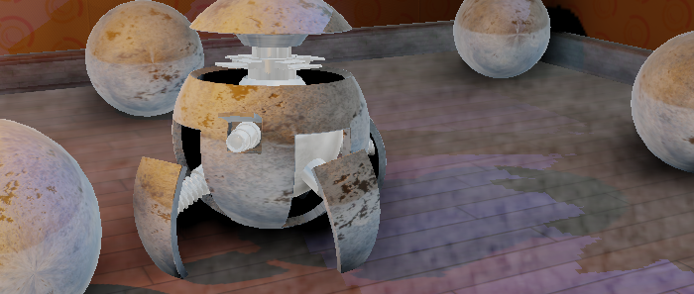

Hardware-shaded viewport with shadows and Ambient Occlusion
With AO, shadows appear denser and more realistic.
Roboball animation: Tyson Ibele
www.tysonibele.com

Procedures
To view shadows in a viewport:
- Click or right-click the Shading viewport menu label. From the Shading viewport label menu, choose Lighting And Shadows Shadows to turn it on.
- Select a light.
- Right-click a viewport, and on the Tools 1 (upper-left) quadrant of the quad menu, choose Cast Shadows to turn on shadows.
To turn on shadows for multiple lights:
- On the main menu. choose Tools Light Lister.
- In the Light Lister dialog, turn on the Shadows toggle for each light object you want to cast shadows.
If you have already enabled shadows in a viewport, their display updates immediately.
If Direct3D is the active driver, you must enable hardware shading to preview shadows. Do one of the following:
- Click or right-click the Shading viewport menu label. From the Shading viewport label menu, choose Lighting And Shadows Enable Hardware Shading (if it is not turned on already).
- In the Viewport Configuration dialog Lighting and Shadows panel Illuminate Scene With group, turn on Enable Hardware Shading.
Also on the Lighting And Shadows panel, in the Quality / Hardware Support group, you can choose the hardware shading level: either Good or Best. Good displays shadows using SM2.0, and Best displays shadows using SM3.0.

Animating Lights
You animate lights by using transforms or changing creation parameters on different keyframes while the Auto Key button is on. During animation, light transforms and parameter values are interpolated between keyframes.

Moving and Rotating Light Objects
You can use the following methods to move and rotate light objects.
- Move an omni light when it’s a "practical" light within a scene (a light that appears in the scene itself). Combine the light with a self-illuminating geometric object. If you want to move a target type of light, select both the light and its target to animate them together.
- Move a Photometric Preset light, or a Free or target light when it’s a "practical" light within a scene (a light that appears in the scene itself). Combine the light with a self-illuminating geometric object. If you want to move a target type of light, select both the light and its target to animate them together.
- Use a free spotlight when a spotlight is to move within the scene. Free spotlights are especially intended to be animated along a path, using a Path constraint. Unlike target spotlights, free spotlights can bank as they travel. Use target spotlights when the light position is fixed.
- If you do need to move a target spotlight, link both the light and its target to a dummy object, then assign the path constraint to the dummy object.
- Use a LookAt Constraint to have a spotlight track a moving object.
If the spotlight is a target spotlight, its previous target is ignored.
If the spotlight is a free spotlight, it effectively becomes a target spotlight, with the looked-at object the target.
- Change the parameters of a daylight system or sunlight system to simulate different times of day or year.

Animating Light Creation Parameters
The following techniques can be used to animate Modify panel parameters for lights.
- To dim or brighten a light over time, animate its Multiplier parameter.
- To dim or brighten a standard light over time, animate its Multiplier value or Filter Color parameter.
- To change the color of a light over time, animate its color parameters. Use a smooth tangent for color change keys unless you want the color to change abruptly.
- To make a standard light flash on and off, assign an On/Off controller to its Multiplier value, then assign a key at each frame in which the light should turn off or on.

Light Include/Exclude Tool
The Light Include/Exclude tool is a modeless dialog that lets you include or exclude objects on a light-by-light basis. When excluded, an object is not illuminated by the specified light and receives no shadows.
- Design Standard workspace > Design ribbon > Lighting and Rendering tab > Light Tools panel > Include/Exclue
This dialog requires at least one light object in your scene. For a selected light, this dialog is a shortcut to the same functionality available on the Exclude/Include dialog.
Although light exclusion does not occur in nature, this feature is useful when you need exact control over the lighting in your scene. Sometimes, for example, you'll want to add lights specifically to illuminate a single object but not its surroundings, or you'll want a light to cast shadows from one object but not from another.
Note: By default, no objects are excluded for a new light. It’s necessary only to include objects that have previously been excluded.

Light Lister
The Light Lister is a modeless dialog that lets you control a number of features for each light. You can also make global settings that affect every light in your scene.
- Default menu: Tools menu > Light Lister
- Alt menu: Lighting/Cameras menu > Tools (Lighting/Cameras Set) > Light Lister
To display information, this dialog requires at least one light object in your scene. For a selected light, this dialog is a shortcut to the same functionality available on the Modify panel Parameters rollout. Global settings are duplicated on the Environment panel.
Note: The Light Lister cannot control more than 150 unique light objects at a time (instances of a light don't count). If there are more than 150 unique lights in your scene, the Lister displays controls for the first 150 it finds, and a warning that you should select fewer lights. Select fewer lights and then use the Selected Lights configuration.

Using The Track View To Animate
Track View provides two different graph-based editors for viewing and modifying animation data in your scene. You can also use it to assign animation controllers to interpolate or control all the keys and parameters for the objects in your scene.
- Main toolbar > Curve Editor
- Graph Editors menu > New Track View
- Graph Editors menu > Track View - Curve Editor
- Graph Editors menu > Track View - Dope Sheet
- Graph Editors menu > Saved Track View > Choose a saved Track View.
- Right-click the active viewport. > Quad menu > Transform quadrant > Curve Editor or Dope Sheet
- Click or right-click the Point-Of-View (POV) viewport label. > Point-Of-View (POV) Viewport Label Menu > Extended Viewports > Track View > Choose New or a saved Track View.
Track View uses two different modes: Curve Editor and Dope Sheet. Curve Editor mode displays animation as function curves, while Dope Sheet animation appears as a spreadsheet of keys and ranges. Keys are color-coded for easy identification. Some Track View functions, such as moving and deleting keys, are also available on the track bar near the time slider, which can be expanded to show curves as well. The Curve Editor and Dope Sheet open by default as floating windows, but you can also dock them under the viewports at the bottom of the interface, or even open them in a viewport. You can name Track View layouts and store them in a buffer for later reuse. Track View layouts are stored with the MAX scene file.
The software remembers your last used Track View layout and automatically loads it the next time you open Track View.

Track View - Curve Editor

Track View - Dope Sheet (Edit Keys)

Typical Uses for Track View
Track View can perform a variety of scene management and animation control tasks. Use Track View to:
- Display a list of objects in your scene and their parameters.
- Change key values.
- Change key timing.
- Change controller ranges (see procedure).
- Change interpolation between keys.
- Edit ranges of multiple keys.
- Edit blocks of time.
- Add sound to your scene.
- Create and manage notes about the scene.
- Change the behavior of the animation outside the range of keys.
- Change controllers for animated parameters
- Select objects, vertices, and hierarchies.
- Navigate the modifier stack in the Modify panel by clicking the modifier items in the Track View Hierarchy.
Note: Tracks are created for animated vertices in Track View. A Bezier Point3 controller is the default vertex interpolation controller.

Procedures
To change the frames in which a controller takes effect:
When you apply a controller or constraint to an object's motion, the frame range over which controller takes effect is determined by the current active time segment. If you then change the active time segment or the animation length, the duration of the controller's influence doesn't change. Sometimes applying a controller (such as Path Constraint) automatically sets keys that you can use to change this range. But others, such as Noise controllers, don't set keys. In such cases, follow this procedure:
- Select the object, and then right-click it and choose Curve Editor from the menu.
- Expand the object hierarchy to find the track or tracks to adjust.
- From the Editor menu, choose Dope Sheet.
- On the Dope Sheet, click Edit Ranges.
- Adjust the range duration by dragging its endpoints, or its position in the animation by dragging between endpoints.
For more information, see Dope Sheet Introduction.
To select keys in Track View (either mode), do any of the following:
- Click the key to select an individual key.
- Drag a selection rectangle around keys to select multiple keys.
- Hold down the Ctrl key and click to create discontinuous multiple key selections.
Note: If you are in Dope Sheet - Edit Ranges mode, you can use Select Time to select multiple keys.
To delete keys in Track View (either mode):
- Select keys on the curve, or on the dope sheet.
- Press Delete to delete the selected keys.
To force Track View to always display on a second monitor:
If you are running a dual-monitor setup, you can force Track View to display on the right-hand monitor by editing a script.
- On the main toolbar, right-click Curve Editor, and then choose Edit Macro Script.
The MAXScript script that opens the Track View - Function Curve Editor appears.
- Locate the line that reads:
if (trackviews.open "Track View - Curve Editor" layoutName:"Function Curve Layout") == true then
- Replace that line with this one:
max_window = getMaxWindowSize() --get Desktop size if (trackviews.open "Track View - Curve Editor" layoutName:"Function Curve Layout" pos:[max_window.x/2,0] height:max_window.y width:(max_window.x/2) ) == true then
- Save the script and restart 3ds Max.
This should open the Track View in a new session over the right half of the desktop. Assuming that a dual-monitor setup reports twice the width, this will force the Track View on the second monitor. On a single monitor, it opens it over the right half of the monitor. Of course, you could enter your own numbers like pos:[1024,0] height:768 width:1024 in case you are running two monitors at 1024x768.
To open Track View in a viewport:
- Click or right-click the Point-Of-View (POV) viewport label, and then from the POV viewport label menu choose Views Extended Viewports Track View New, or choose the name of a saved Track View.

The Track View Key window displays function curves and keys when in Curve Editor mode. When in Dope Sheet mode, the tracks can be displayed as keys or ranges.
You select and change animation values and timing in these windows. The Key window also indicates the active time segment. Time within the active time segment is highlighted with a light gray background. The Track View Key window is sometimes referred to as the Key window.
Components of the Key window include a time slider, a time ruler, and a scale origin slider. The Track View time slider indicates the current frame and is synchronized with the viewport time slider. A time ruler at the bottom of the window can be raised to measure keys against time. A scale origin indicator (a horizontal orange line at 0) can be moved during scale value operations as a reference point for scaling.
When you close the Track View or the software itself, 3ds Max automatically loads the last layout used the next time you open Track View.

Interface
The two main sections of the Track View workspace consist of the Key window and the Controller window.

Controller Window
The Controller window displays object names and controller tracks, and determines which curves and tracks are available for display and editing. You can expand and rearrange Hierarchy-list items in the Controller window as necessary using the Hierarchy list right-click menu. Some navigation tools can also be found in the Track View Show menu. Default behavior is to show only selected object tracks. Use Manual Navigation mode to collapse or expand tracks individually, or use Alt+right-click to display an alternate menu to collapse and expand tracks.
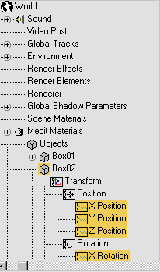
Controller window

Key window
The Key window displays the keys as either curves or tracks. The tracks can be displayed as a box graph of keys or range bars.
Note: How you zoom and pan in the Key window depends on which interaction mode, 3ds Max or Maya, is active.
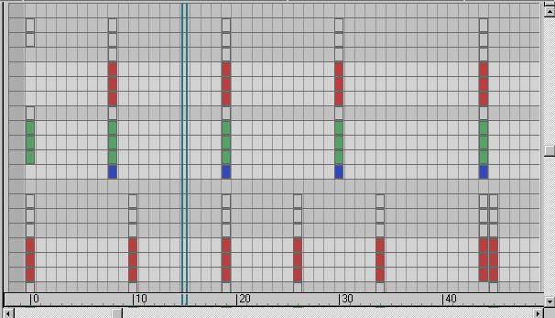
Keys displayed as box graph (Dope Sheet - Edit Keys mode)

Key Creation
You can create animation keys using a variety of methods. One way is to turn on Auto Key, move the time slider, and then transform an object or adjust its parameters. Another is to right-click the time slider to open the Create Key dialog. You can create keys directly in Track View using Add Keys. Finally, keys can be created by turning on Set Key mode, moving to a desired frame, posing the object, then clicking Set Keys.

Key Display
Keys are displayed as points on the function curves in Curve Editor, or as boxes on the Dope Sheet. Keys on the Dope Sheet are color-coded for easy identification. When multiple tracks are keyed at one frame, the boxes appear with bands of color to indicate the shared key types. Key coloration is also used to show soft selection of keys. Subframe keys (keyframes that fall between frames) are indicated as narrow rectangles within the boxes.
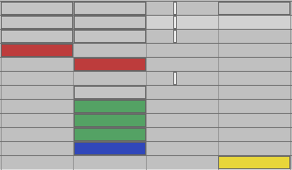
Colored keys with subframe display
Keys are also displayed on the track bar below the viewport.
Keys displayed on the function curves have tangency types. You can use the tangency buttons on the Key Tangents toolbar to change the function curve keys. Use Custom tangency to show editable curve handles. Use Step tangency to freeze motion or create classic storyboard pose-to-pose blocking.
You can also display function curves below the track bar by clicking (Open Mini Curve Editor).
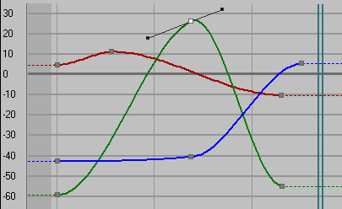
Custom Tangency handles

Range Bars
In the Dope Sheet - Edit Ranges mode (when animation keys have been created), range bars display to indicate the range of time the animation occurs. Tools specific to working with ranges (position ranges and recouple ranges) can be found on the Ranges toolbar (off by default). Right-click the toolbar, choose Show Toolbars, and then select Range-Track View to access these tools.
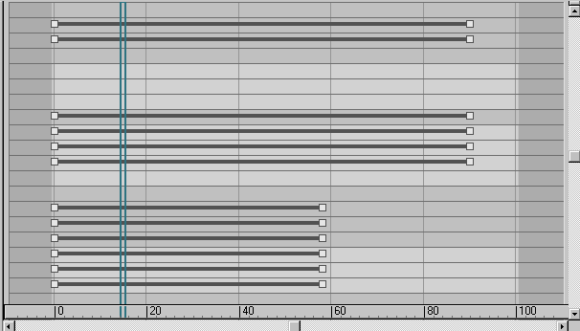
Keys displayed as range bars (Dope Sheet - Edit Ranges mode)

Function Curves
Function Curves display the values of keys, and the interpolated values between keys, as a curve. These curves express how a parameter varies over time. Only animation tracks can display function curves. You can edit the curves using tangency handles on the keys to change the shape of the curve.
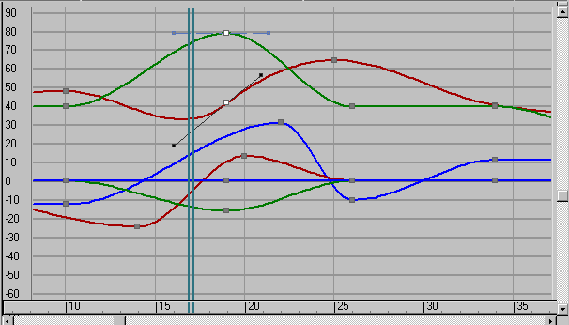
Keys displayed as function curves (Curve Editor)
Multiple curves can be viewed simultaneously by selecting tracks in the Controller window. This is especially useful when using Multiplier or Ease Curves. You can adjust the multiplier or ease curve point tangencies and watch the final result in the controller curve at the same time.

Time Ruler
The time ruler measures time. Markings on the ruler reflect the settings in the Time Configuration dialog. Move the time ruler up to the keys for more accurate key placement.
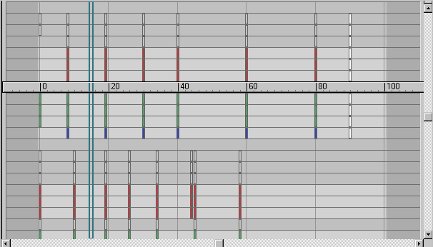
Time ruler

Track View Time Slider
The current time is indicated by the Track View time slider. This is displayed as a set of blue vertical lines synchronized with the position of the viewport time slider. You can move the Track View time slider by dragging it in the Key window. Moving either time slider updates the animation in the viewports. The blue time slider also serves as a scale origin point when scaling keys in time.
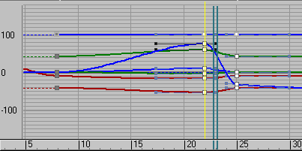
Scale keys using time slider

Scale Values Origin Line
When you scale key values (that is, scaling in space rather than time), a horizontal orange line appears at the 0 value on the vertical graph axis. This orange line is a scale values origin indicator, which you can move vertically to vary the reference point for scaling values.
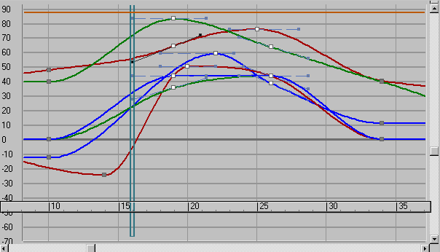
Horizontal line at the top of the illustration is the moveable scale origin line.

Using Dummy Objects
The primary use of dummy helper objects is to assist in creating complex motions and building complex hierarchies. Because dummies are invisible when rendered, they are an excellent choice for offset joints, connectors between objects, and handles for complex hierarchies. Dummies and Points can act as null objects that function as controls for transforming parts of an IK chain.

Using a Dummy to Control Motion
Breaking complex motions into simple components often makes it easier to go back and edit your animations.
Consider a bouncing ball that moves along a path. You could animate the ball by positioning it on many frames, but it would be very difficult for you to go back and adjust the height of the bounce or the path of the ball. You have to edit the motion of the ball on many frames to make even a simple change.
Using a dummy object solves this problem by breaking the motion into simple components. One component is the up and down bounce of the ball. The other is movement on the path.
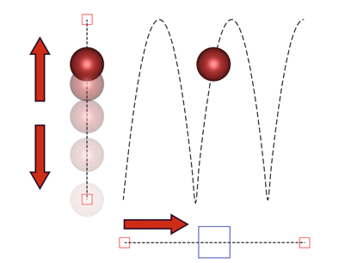
Combining the bouncing motion of a ball with the forward motion of a dummy results in a moving bouncing ball.

Using a Dummy as a Handle
You might want to move and animate a selection of objects individually but also have the ability to transform them as a single object.
A good example of this is a camera on a tripod. You want to adjust both the camera and its target individually but also want to move them together as a single unit.

Procedures
Example: To create a complex bounce motion using a dummy object:
- Start with a sphere, then create a dummy object below the sphere, and link the sphere as a child of the dummy.
- Animate the sphere bouncing up and down above the dummy.
- Animate the dummy moving.
The sphere bounces on top of the dummy object as the dummy moves around the scene. You can easily change the height and speed of the bounce by changing the sphere animation. You can change the path through the scene by changing the dummy animation.
To create a camera tripod:
- Create a dummy object below a target camera and link the camera and target as children of the dummy object.
The camera and the target follow the dummy object. You can quickly position the camera by placing the dummy object and compose your view by adjusting the camera and its target.

Animating Hierarchies
One of the most useful tools in producing computer animation is the ability to link objects together to form a chain. By linking one object to another, you create a parent-child relationship. Transforms applied to the parent are also transmitted to child objects. A chain is also referred to as a hierarchy.
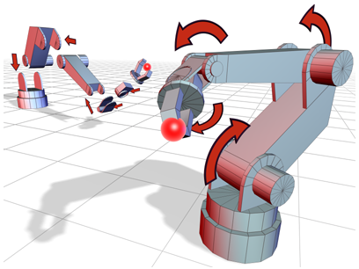
Left: A disassembled robotic arm is linked into a hierarchy.
Right: The assembled robotic arm uses rotational joints.
You can find the commands to build and manipulate hierarchies in the following places in the interface:
- The Select and Link and Unlink Selection buttons let you make and break links between objects in your scene.
- The Bones system in the Create panel Systems category lets you create a hierarchy of bones. You can also create bones by choosing Bone Tools from the Animation menu. You can turn any hierarchy of objects into bones by selecting the hierarchy and turning on Bone Tools dialog Object Properties rollout Bone On.
- The Hierarchy panel contains commands to control how links behave.
- The Motion panel contains commands to control how links behave when using an History Dependent (HD) Solver

Common Uses for Hierarchies
- Link a large collection of objects to a single parent so they can be easily animated and transformed by moving, rotating, or scaling the parent.
- Link the target of a camera or light to another object so it tracks the object through the scene.
- Link objects to dummy objects to create complex motions by combining multiple simple motions.
- Link objects to simulate jointed structures to animate characters or mechanical assemblies.

Parts of a Hierarchy
The relationship between objects linked together in a hierarchy is analogous to a family tree.
Parent
Object that controls one or more children. A parent object is often controlled by another superior parent object. In the following figure, objects 1 and 2 are parent objects.
Child
Object controlled by its parent. A child object can also be a parent to other children. In the following figure, objects 2 and 3 (the support and hub) are children of object 1. Objects 5 (the seats) are children of object 4, the Ferris wheel.
Ancestors
Parent and all of the parent’s parents of a child object. In the following figure, objects 1 and 2 are ancestors of object 3.
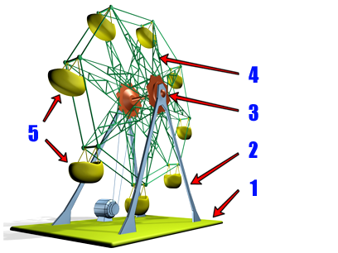
The seats of the Ferris wheel are children of the wheel, which is in turn a child of the base and support objects, as shown in the following hierarchy.
Descendants
Children and all of the children’s children of a parent object. In the figures, all the objects are descendants of object 1.
Hierarchy
Collection of all parents and children linked together in a single structure.
Root
Single parent object that is superior to all other objects in the hierarchy. All other objects are descendants of the root object. In the figures, Object 1 is the root.
Subtree
All the descendants of a selected parent. In the figure below, the Rotational Hub, Ferris Wheel, and Seats represent the subtree under the Support object.
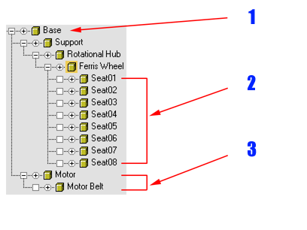
Example of a hierarchical structure:
1. Root
2. Leaves
3. Subtree
Branch
Path through the hierarchy from a parent to a single descendant. In the figure above, the Support, Rotational Hub, and Ferris Wheel objects comprise a branch from the root to the leaf objects (the seats).
Leaf
Child object that has no children. The lowest object in a branch. In the figure above, the Seat objects are leaf objects.
Link
Connection between a parent and its child. A link transmits position, rotation, and scale information from parent to child.
Pivot
Defines the local center and coordinate system for each object. You can think of a link as the connection between the pivot of a child object and the pivot of its parent.

Working In Character Studio
The character studio feature set in 3ds Max provides professional tools for animating 3D characters. It is an environment in which you can quickly and easily build skeletons (also known as character rigs) and then animate them, thus creating motion sequences. You use the animated skeletons to drive the movement of geometry, thus creating virtual characters. You can generate crowds of these characters and animate crowd movement using a system of delegates and procedural behaviors.
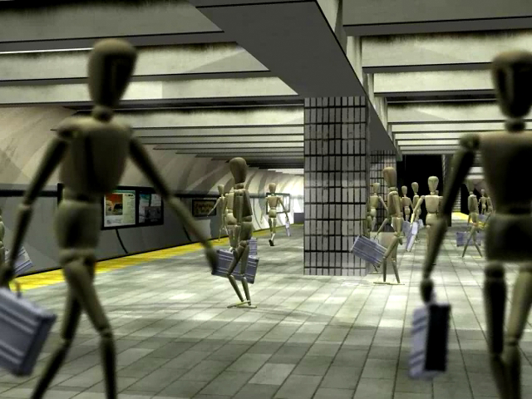
Crowd of mannequins in a subway station animated using character studio
character studio comprises three components:
- Biped builds and animates skeletal armatures, ready for character animation. You can combine different animations into sequential or overlapping motion scripts, or layer them together. You can also use Biped to edit motion capture files.
Note: Biped does not create character mesh objects. Create your character mesh before using Biped to create a skeleton for it.
- Physique uses the biped armatures to animate the actual character mesh, simulating how the mesh flexes and bulges with the movement of the underlying skeleton.
Note: You can use Physique with other hierarchies beside the biped skeleton. And, as an alternative to Physique, you can use the Skin modifier to animate a character mesh with any hierarchy, including a biped.
- Crowd animates groups of 3D objects and characters using a system of delegates and behaviors. You can create crowds with highly complex behaviors.

Understanding character studio Workflow
Biped, Physique, and the Crowd system work together within 3ds Max to provide a complete set of character-animation tools. Although these components can be used in a variety of ways, it is helpful to approach character studio with a basic understanding of how a typical character animation is created.
The following sections provide a brief summary of the basic workflow and related benefits to creating a character with Biped and Physique. You might not use all the following steps, but you’re likely to do them in the following order.

Create Skin Geometry
Create a basic skin shape for your character using any 3ds Max modeling tools and surface types. Be sure to place your character skin in a neutral pose with arms outstretched and legs spaced slightly apart. You might also want to add sufficient detail to your skin mesh or control points around joints to facilitate deformation during movement.
Note: Physique deformations are based on a volume, which means you can refine your geometry later with minimal impact to skin behavior. Thus, you can create your animation before building your model, if you like.

Create a Biped Skeleton
Biped automates the creation of bipedal character skeletons. It also lets you introduce significant changes to the skeleton structure and sizing at any point during your animation without adversely affecting character motion. As a result, you can animate your character without knowing if it is short or tall, skinny, or fat. It also means that if the director changes the character proportions, the animation still works.
For more detail on posing a biped skeleton, see Biped.

Attach the Skin
- Position the biped character within its modeled skin. Use Figure mode to scale bone lengths and to orient the skeleton correctly within the skin volume. Scale bone thickness as desired to achieve a good initial fit. Then save a figure file, so it’s easy to return to this pose.
- Use Physique to attach the skin geometry automatically to the biped or a 3ds Max bones hierarchy. The attachment is typically made to the root node in the hierarchy: the pelvis object on the biped or the root node on a bones hierarchy, not the center of mass. The attached skin is deformed as the biped or bones hierarchy moves.
- The links in the bones hierarchy are used to create a system of 3D envelopes that enclose nearby vertices. Envelopes typically overlap at the parent and child ends of links. Vertices within overlapping envelopes are blended to create smooth skin deformation over joints as the character moves.

Adjust Skin Behavior
Adjust Physique parameters and introduce skin behavior effects to achieve the desired characterization.
- Change default envelope shapes by adding cross sections and control points to isolate a more specific volume of vertices for each bone. Use exclusion lists or per-vertex weighting to apply fine-tuning control over individual vertices.
- Introduce bulge angles to change muscle shape based on the angle of a particular joint. Create tendons to simulate the motion of tendons under the skin, based on link movements.
- Adjust link parameters to change skin twisting, sliding, and creasing as the biped moves. Sliding allows the skin to compress at the biceps and forearm as the elbow is bent. Twisting controls the amount of skin twisting across a joint intersection.
- Create extra links using 3ds Max bones and dummy objects for added control. You can add links to the abdominal area to control compression, for example, or to create a link to animate the chest rising and falling as the character breathes. If a character has extra appendages, you can add 3ds Max bones to animate them. One common usage is to add a bone to animate the jaw.

Animate the Biped Skeleton
Once you’ve attached the skin to a biped structure, you can animate the biped freely and see the skin behavior update automatically, based on the current pose.
Tip: Physique skin deformation can slow down playback of your Biped animation. To improve performance, you can hide the skin object temporarily or reduce its resolution in the modifier stack.
You can also choose to develop Biped animations in a separate scene entirely, and apply them to your final skinned character when you are satisfied with your final motion.
A Biped character is essentially an integrated hierarchy of bones that you can position freely using keyframes, IK goals, and footsteps. You can position a biped character using all the rotation and transformation tools found in 3ds Max.
Many of the 3ds Max coordinate systems can be used to position the biped. Local coordinates are useful to move a limb along its axis (the local X axis is always the axis along the biped limb); world coordinates are handy when there is any confusion regarding which way is up. You can use world coordinates as a home base. In 3ds Max, the world Z axis is always up.
Note: Rotations always occur about the local axis.

Use Freeform Techniques
Biped provides a variety of methods for creating character motion easily. You can use a purely traditional approach by manually creating keyframes in freeform mode for different poses, letting the computer interpolate between joint positions and IK goals.

Use a Footstep-Driven Technique
You can also choose a partially assisted approach by using footsteps and Biped dynamics to help you create a default walk, run, or jump cycle. You can then adjust the biped keyframes and footsteps individually.
When using footsteps, biped dynamics helps you by simulating gravity and balance.
- Gravity can help in a jumping motion to accelerate a character during the falling period and to bend the legs naturally on landing.
- Balance enables retaining the character balance by adjusting its position when the spine is rotated and keyframed.
- Dynamics can be turned off on a per-key basis or for the entire animation. The animator can override center of mass keyframes created using Dynamics calculation at any time. Simply set the dynamic properties of these keys or choose Spline Dynamics for keys generated by newly created footsteps.

Convert Between Animation Types
Once you are satisfied with a particular footstep animation and its corresponding dynamic behavior, you can convert it to a freeform animation consisting of a simple combination of keyframes and IK goals. This intelligent conversion gives you control of animation behavior at every frame, for every joint of the character.

Use Layers to Apply Global Changes
Animation layers offer you a powerful tool for introducing global changes to an existing character animation. For example, you can convert an upright running motion into a crouched run by adding a layer on top of an existing run motion. The layer would contain a single keyframe with the biped's spine rotated forward. You can stack up layered changes, allowing you to refine your motion composition and eventually collapse your layers into a standard non-layered keyframe animation.

Use In Place Mode to Control the View
In Place Mode is a tool that lets you keep your biped in view during animation playback. It offers a convenient way of adjusting and adding keyframes to a character without constantly changing your view to follow the character motion.

Import Motion-Capture Files
You can import motion-capture files in BVH and CSM formats, edit them, and save them as BIP files. You can import these files with or without footsteps and dynamics and combine them in Motion Flow mode with other animations.
You can use the supplied motion-capture samples as is or adjust them to suit your needs using the collection of animation tools in Biped. The ability to import motion-capture marker files directly into character studio using the CSM file eliminates much of the cost of post-processing optical motion capture data. You can import motion-capture files with an additional prop bone, to define the motion of an object such as a sword or club.
You can also import HTR/HTR2 motion-capture files, as well as TRC files.
Motion-capture files can be imported with key reduction, making for more manageable tracks for subsequent editing.

Use Track View for Keyframe Editing
Track View allows you to edit keys and footsteps relative to the animation time line.
With Track View in Dope Sheet mode you can move footsteps in time. If you need a character to jump higher between footsteps, move the landing footsteps further away in time. Dynamics automatically compensate by making the character jump higher to keep it airborne longer.
You can also use Dope Sheet to specify a freeform period in a footstep animation. This allows you to take advantage of footsteps and dynamics for part of an animation, then switch to manual keyframing during the freeform period. This approach can be useful in animations where there is a mix of animation where the feet are on the ground and then off. Examples of this type of animation include running and diving, or walking and then sitting down.
Keyframe-adjustment tools allow the following:
- Find the next or previous key for the selected biped body part.
- Use the Time spinner to slide a key back and forth in time.
- Change Tension, Continuity, and Bias for a key.
- Display trajectories.
You can place arms and legs of a character into the coordinate space of another object or the world to simulate interaction with fixed or moving objects. In Freeform mode, for example, putting the legs into world space prevents them from sliding or moving when keyframing the center of mass of the character. Putting a hand in the coordinate space of a ball allows the hand to move wherever the ball moves.
character studio can take advantage of many 3ds Max tools. For example, you can use the Select And Link tool to attach objects to a biped.
If you want a character to pick up and carry an object and then put it down, you can use the Link controller to animate the duration of the attachment. 3ds Max bones can be used to animate character subassemblies, like pistons, and to create extra links for Physique.

Use the Motion Mixer to Mix Animations
You can use the Motion mixer to combine motions on a biped. For example, you could combine a walking motion with a cheering motion, and cause the biped to walk while cheering.

Use Motion Flow to Combine Animations
After you have created and modified various animation sequences, and stored them in biped motion files (BIP format), you can use Motion Flow mode to combine various motion files into longer animations that can be quickly previewed and edited. Motion Flow mode automatically places the animations end-to-end, allowing you to mix and match both freeform and footstep-driven motion files. Transitions between successive motions are automatically created for you, to provide a first-pass blending between overlapping frames of animation.
The Motion Flow transitions use velocity interpolation to create seamless transitions between clips. You can use the Transition Editor to modify a variety of blending parameters, including transition start frame, length, and angle between clips.

Refining Your Character
Great character animation is the result of many refinements that tune the overall personality of your character. You will find the need to refine progressively both the skinning behavior and the animation timing of your character. Biped and Physique make this iteration process straightforward by using the 3ds Max modifier stack and undo methods.
In addition, the ability of Biped to map motions between characters makes it easy to interchange great animations with existing characters, and tune their behaviors to achieve true integration of motion with character motivation and personality.

Use Crowds to Animate Groups of Characters
Once you've created animation sequences for characters or other models (such as a bird flapping its wings), you can replicate the models or characters and apply the motions to these groups using the Crowd Animation system. You can also combine them with a wide range of supplied behaviors to create lifelike activities in crowds, such as people streaming through a doorway, street traffic, or birds and fish flocking and avoiding obstacles. You can use Motion Flow mode to create motion clip networks. These allow characters to perform animation sequences appropriate to their current movement and transition smoothly between sequences. And you can use cognitive controllers in Crowd to transition between behaviors based on a variety of criteria. For more on crowd behaviors, see Creating a Crowd System.

Standard Material
The Standard material type provides a fairly straightforward way to model surfaces. In the real world, the appearance of a surface depends on how it reflects light. In 3ds Max, a standard material simulates a surface's reflective properties. If you don't use maps, a standard material gives an object a single, uniform color.
- Material/Map Browser > Materials > Scanline > Standard
Note: The material appears in the Material/Map Browser only if the active renderer supports it.
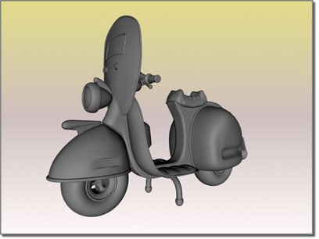
Scooter rendered with the default standard material
This topic introduces the controls for Standard material, exclusive of the use of maps.
Tip: The Standard material supports hardware-based viewport display for improved feedback while editing its parameters. For more infomation, see Viewport Display of Materials.

Standard Color Components
A surface of a "single" color usually reflects many colors. Standard materials typically use a four-color model to simulate this. (This can vary, depending on which shader you use.) The four colors are known as the material’s color components.
- Ambient color appears where the surface is lit by ambient light alone, where the surface is in shadow.
- Diffuse color appears where light falls directly on the surface, where the surface is in “good” lighting.
This component is called "diffuse" because light striking it is reflected in various directions. Highlights, on the other hand, are reflections of light sources.
- Specular color appears in highlights. Shiny surfaces usually have specular highlights, where the viewing angle is equal to the angle of incidence.
A surface can also have glancing highlights, where the angle of incidence is high, relative to the observer or camera (that is, the light ray is nearly parallel to the surface). Glancing highlights are characteristic of metallic surfaces.
Note: Some shaders generate the specular color procedurally, rather than letting you choose it.
Some surfaces are completely reflective, or nearly so. These reflect their environment as well as the light sources that illuminate them. To model such surfaces, you need to assign a Reflection map or use ray tracing.
- Filter color is the color transmitted by light shining through the object.
The Filter color component isn't visible unless the material's Opacity is less than 100 percent.
Note: The Raytrace material uses a different, six-color model to simulate surfaces. Several components are similar to those in the Standard Material, but they behave differently in Raytrace.
The three color components blend at the edges of their regions. Between ambient and diffuse, the blending is calculated by the shader. Between diffuse and specular, you set the amount of blending by using the Standard material's highlight controls.
When we describe an object's color in conversation, usually we mean its diffuse color. The choice of an ambient color depends on the kind of lighting. For moderate indoor lighting, it can be a darker shade of the diffuse color, but for bright indoor lighting and for daylight, it should be the complement of the primary (key) light source. The specular color should be either the same color

Other Standard Material Components
A standard material's specular color appears in highlights. You can control the size and shape of the highlight. A polished surface has a small and strong highlight. A matte surface has a large, weak highlight, or no highlight at all.
Standard materials also have controls for making the object appear transparent, and for making it self-illuminating so that it appears to glow.
Along with the material's color components, components also refers to the parameters that control highlights, transparency, self-illumination, and so on.
Topics in this section
- Choosing Colors for Realism
Materials add greater realism to a scene only if you choose their colors and other properties to appear like real-world objects. This topic presents some general guidelines for choosing standard material colors. When possible, you should also observe colors in the objects you are modeling, especially under different lighting conditions.
- Shader Basic Parameters Rollout
The Shader Basic Parameters rollout lets you choose the type of shader to use with a Standard material. Some additional controls affect how the material appears.
- Basic Parameters Rollout (Standard Material)
The Basic Parameters rollouts for Standard materials contain controls that let you set the color of your material, the shininess, the transparency, and so on, and specify maps to use for the various components of the material.
- Extended Parameters Rollout (Standard Material)
The Extended Parameters rollout is the same for all shading types of Standard material, with the exception of the Strauss and Translucent shaders, as noted below. It has controls related to transparency and reflection, as well as options for Wire mode.
- Maps Rollout (Standard and Raytrace Materials)
A material's Maps rollout lets you access and assign maps to various components of the material. It also lets you set an Amount value (relative strength) for each map.

Shaders (Standard Materials)
For a standard material, the shader is the algorithm that controls how the material responds to light. Shaders especially control how highlights appear. They also provide a material's color components, and control its opacity, self-illumination, and other settings. Shaders are often named for their inventors; they can also be named for the effect they provide. See Shading Type.
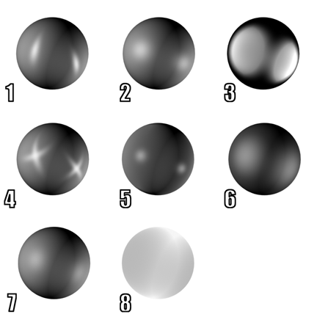
Samples of different shading for a standard material
1. Anisotropic
2. Blinn
3. Metal
4. Multi-layer
5. Oren-Nayar-Blinn
6. Phong
7. Strauss
8. Translucent
For each material, one of the available shaders is always active. You choose the shader on the material's Shader Basic Parameters rollout.
The raytrace material uses a subset of the standard material shaders: Anisotropic, Blinn, Metal, Oren-Nayar-Blinn, and Phong. You choose the raytrace material's shader on the material's Raytrace Basic Parameters rollout.
The other types of materials in 3ds Max don't give you a choice of shader.

Desktop Publishing (DTP)
Desktop publishing (DTP) is the use of personal computers to design books and booklets that are intended to be printed by ink jet or laser printers. The software that supports desktop publishing has a WYSIWYG graphical user interface (GUI) to make the set-up for publishing as easy as possible. Desktop publishing is especially helpful as an independent publishing option and can be used to produce information on a variety of topics.
For many small businesses and organizations, desktop publishing makes it possible to publish quality, professional looking informational documents and books for content that a traditional publisher might be uninterested in, perhaps for political or financial reasons. As such, desktop publishing caters to small niche markets and can be viewed as a way to enable free speech and independent voice.
Desktop publishing software makes the capacity for professionally quality literature production to just about anyone, but graphic design skills and aesthetic judgement are still required. While some templates often exist within the desktop publishing software, it is still very possible to create bad designs that hamper the success or even communication of the media’s message.
Popular desktop publishing software includes Adobe InDesign, Adobe FrameMaker, Microsoft Publisher and QuarkXPress.

