Scrum (software development)
Scrum is the type of Agile framework. It is a framework within which people can address complex adaptive problem while productivity and creativity of delivering product is at highest possible values. Scrum uses Iterative process. Silent features of Scrum are:
- Scrum is light-weighted framework
- Scrum emphasizes self-organization
- Scrum is simple to understand
- Scrum framework help the team to work together
Lifecycle of Scrum:
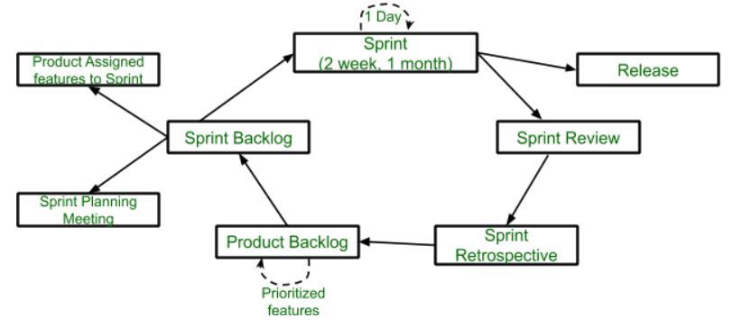
Sprint: A Sprint is a time box of one month or less. A new Sprint starts immediately after the completion of the previous Sprint. Release: When the product is completed, it goes to the Release stage. Sprint Review: If the product still has some non-achievable features, it will be checked in this stage and then passed to the Sprint Retrospective stage. Sprint Retrospective: In this stage quality or status of the product is checked. Product Backlog: According to the prioritize features the product is organized. Sprint Backlog: Sprint Backlog is divided into two parts Product assigned features to sprint and Sprint planning meeting.
Advantage of using Scrum framework:
- Scrum framework is fast moving and money efficient.
- Scrum framework works by dividing the large product into small sub-products. It’s like a divide and conquer strategy
- In Scrum customer satisfaction is very important.
- Scrum is adaptive in nature because it have short sprint.
- As Scrum framework rely on constant feedback therefore the quality of product increases in less amount of time
Disadvantage of using Scrum framework:
- Scrum framework do not allow changes into their sprint.
- Scrum framework is not fully described model. If you wanna adopt it you need to fill in the framework with your own details like Extreme Programming(XP), Kanban, DSDM.
- It can be difficult for the Scrum to plan, structure and organize a project that lacks a clear definition.
- The daily Scrum meetings and frequent reviews require substantial resources.

