Common Puzzle Questions
Common puzzles are those types of puzzles where you might not require your programming skills. It’s based on your reasoning and logical skills.
Let’s look at some common puzzles asked in interviews.

1. Crossing the Bridge Puzzle
Four people need to cross a bridge. It’s nighttime and pretty dark. There’s only one flashlight; it’s dangerous to cross the bridge without one. The bridge can only support two people at a time. Each person will take a different amount of time to cross the bridge: 1 min, 2 mins, 7 mins, and 10 mins. What is the shortest possible time for all four people to cross the bridge?
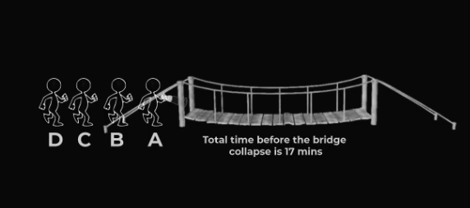

2. The Man in the Elevator Puzzle
A man who lives on the tenth floor of a building takes the elevator every day to go down to the ground floor to go to work or to go shopping. When he returns in the evening, he takes the elevator to the seventh floor and walks up the stairs to the tenth floor to reach his apartment. Why does he do this? Note that if it’s a rainy day, or if there are other people in the elevator, he goes to his floor directly. Also, he hates walking.

3. Heaven or Hell Puzzle
You have two doors in front of you. One door leads to heaven, and the other to hell. There are two guards, one by each door. One guard always tells the truth, and the other always lies, but you don’t know who is who. You can only ask one question to one guard to find the door to heaven. What question would you ask?
PrepInsta.com

4. Three Mislabeled Jars
You have three mislabeled jars. The first jar contains apples, the second contains oranges, and the third contains a mix of apples and oranges. You need to label the jars. You can pick as many fruits as you want from each jar. What is the least number of fruits you have to pick from each jar to label them correctly?
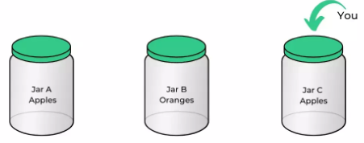
prepinsta.com

5. Gold Bar Cut Puzzle
You have hired someone to work for you for seven days, and you have a gold bar to pay him. You must give him a piece of gold every day. What is the least number of cuts you can make to the gold bar such that you can pay them 1/7th of it each day?
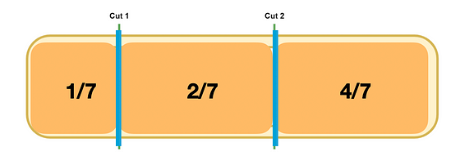
enjoymathematics.com

6. Man Fell in Well Puzzle
A man fell in a well. The well is 30 meters deep. In a day, he can climb 4 meters, but he slips down 3 meters. How many days would he take to come out of the well?
