UNIT-IV

Evaluate the scalability of Entity Resolution techniques in handling large and diverse datasets:
Entity resolution, also called record linkage or deduplication, helps identify and merge duplicate or related records that do not share any unique identifiers within or across datasets. Accurate entity resolution improves data quality, enhances decision-making, and provides valuable insights.
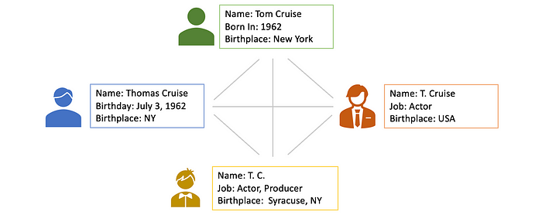
Entity resolution identifies the same real-world entity within or across inconsistent data sources (Image by author)
Entity resolution applies to various industries. For example, CRM systems consolidate customer information, improve service, and enable targeted marketing by resolving duplicate customer records. E-commerce platforms use entity resolution to merge product listings, enhancing search functionality, recommendations, and the customer experience.
In this post, we will explore the technical details of fundamental entity resolution approaches using a benchmark dataset.

Overview of Entity Resolution
The standard entity resolution (ER) framework consists of several steps: blocking, block processing, entity matching, and clustering.
1. Blocking: This is the first step in entity resolution and aims to reduce the search space to identify the same entity by dividing the dataset into smaller, manageable blocks. These blocks contain records that share similar attributes, making the subsequent comparison more efficient.
2. Block Processing: This step refines the blocks to minimize the number of comparisons by discarding two types of unnecessary comparisons: the redundant ones, which are repeated across multiple blocks, and the superfluous ones, which involve records unlikely to match.
3. Entity Matching: This focuses on comparing records within blocks to find matches based on the similarity of the records. Various similarity metrics and matching algorithms can be employed to classify pairs of records as matches or non-matches.
4. Clustering: Clustering involves grouping the matched records into clusters based on their similarity. The created clusters can be used to get a consolidated view of entities.
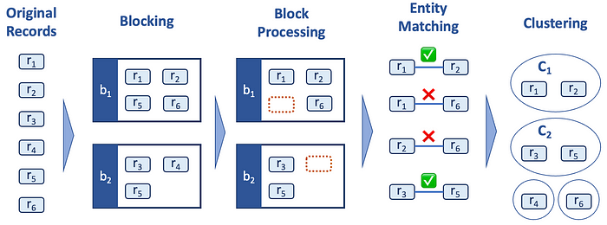
Entity Resolution workflow (Image by author)

Benchmark Dataset
In the following sections, we will dive into more details of each step in the entity resolution process, along with Python implementation using a benchmark dataset.
The dataset, sourced from the database group at the University of Leipzig and licensed with Creative Commons, is derived from actual records concerning songs from the MusicBrainz database but has been deliberately altered using the DAPO data pollution tool. This tool injects both duplicates and errors into the dataset, resulting in a situation where it contains duplicates for 50% of the original records in two to five sources. These duplicates have been generated with a high degree of corruption, serving as a rigorous test to evaluate the effectiveness of ER and clustering approaches.
We can load the data with the following code.
import requests
from io import BytesIO
import pandas as pd
url = "https://raw.githubusercontent.com/tomonori-masui/entity-resolution/main/data/musicbrainz_200k.csv"
res = requests.get(url)
df = pd.read_csv(BytesIO(res.content))
Some example records look like something below.
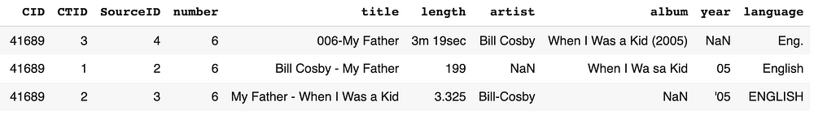
Each record represents a song having attributes such as artist, title, album, year, etc (You can find field descriptions in this link). CID is cluster ID and the records having the same CID are duplicates (in the example above all three records represent the same song). Our goal is to identify those duplicates in this noisy dataset.
To simplify our work, we are focusing only on English songs. The code below identifies records with cluster IDs that have English songs.
english_cids = df[
df.language.str.lower().str.contains("^en|^eg", na=False)
].CID.unique()
df = df[df.CID.isin(english_cids)].reset_index(drop=True)
We are also preprocessing some of the string fields to get standardized values.
for col in ["title", "artist", "album"]:
df[col] = (
df[col]
.str.lower()
.replace("[^a-z0-9]", " ", regex=True) # replacing special characters with a space
.replace(" +", " ", regex=True) # removing consecutive spaces
.str.strip() # removing leading and tailing spaces
)
df.loc[df.number.notna(), "number"] = (
df[df.number.notna()]
.number.replace("[^0-9]", "", regex=True) # removing non-digits
.apply(lambda x: str(int(x)) if len(x) > 0 else None) # removing leading zeros
)
Please note that this benchmark dataset is a single dataset, and if you have multiple data sources for which you want to resolve entities, you need to standardize their data schemas and consolidate these multiple data sources into a unified dataset before proceeding with the subsequent steps.

Blocking
Blocking is the first step in entity resolution that groups similar records together based on certain attributes. By doing so, the process narrows its search to only consider comparisons within each block, rather than examining all possible record pairs in the dataset. This significantly reduces the number of comparisons and accelerates the ER process. As it skips many comparisons, it possibly leads to missed true matches. Therefore, Blocking should achieve a good balance between efficiency and accuracy. In this section, we will explore three different blocking approaches (standard blocking, token blocking, and sorted neighborhood) to find the best balance on that trade-off.

Standard Blocking
The most straightforward blocking technique involves partitioning the dataset into blocks based on a specific attribute. For example, in our dataset, one might create blocks based on Artist or Title field. This approach is intuitive and easy to implement, but its effectiveness is very sensitive to noise, as the slightest difference in the blocking keys of duplicates places them in different blocks.
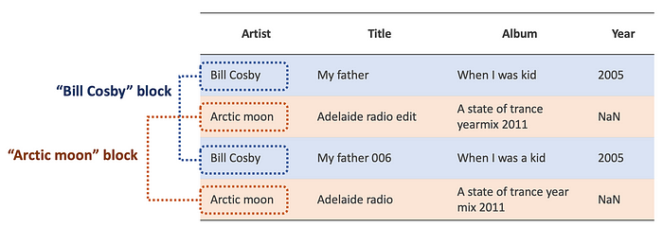
Example of Standard Blocking on Artist field (Image by author)
We can get standard blocks with the function below. The dictionary blockswill store blocking keys (key) and their corresponding indices (idx) of blocked records.
from collections import defaultdict
def standard_blocking(field_values: pd.Series) -> dict[str, list]:
blocks = defaultdict(list)
for idx, key in enumerate(field_values):
if key is not None:
blocks[key].append(idx)
return blocks
In the following code, we are creating three independent standard blocks using the fields of title, artist, and album.
sb_title = standard_blocking(df.title)
sb_artist = standard_blocking(df.artist)
sb_album = standard_blocking(df.album)

Token Blocking
Token blocking focuses on breaking down (i.e. tokenizing) the values of attributes into smaller units, called tokens, and then using these tokens to create blocks for comparison. Tokens are typically single words or small n-grams (substrings of length n) extracted from the text. Token blocking creates a block for every distinct token value, regardless of the associated attributes: two records will be in the same block if they share a token in any of their attributes. This yields high recall, due to redundancy (i.e. a single record can belong to multiple blocks), at the cost of low precision.
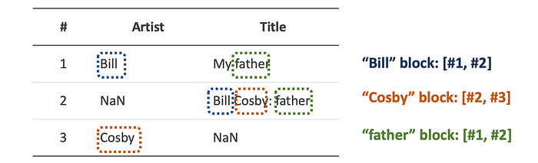
Example of Token Blocking (Image by author)
The function below generates token blocks based on word tokens. Please note we are excluding stop words (e.g. “a”, “the”, “is”, etc) from the tokens.
from nltk.tokenize import word_tokenize
def token_blocking(df: pd.DataFrame, stop_words: set) -> dict[str, list]:
blocks = defaultdict(list)
for i, row in enumerate(df.itertuples()):
# concatenate columns and tokenize
string = " ".join([str(value) for value in row if not pd.isna(value)])
tokens = set(
[word for word in word_tokenize(string) if word not in stop_words]
)
# create blocks
for token in tokens:
blocks[token].append(i)
return blocks
As we know which fields are relevant to create blocks, we only use specific fields (title, artist, and album) to perform token blocking:
import string
from nltk.corpus import stopwords
columns = ['title', 'artist', 'album']
stop_words = set(stopwords.words('english') + list(string.punctuation))
token_blocks = token_blocking(df[columns], stop_words)

Sorted Neighborhood
Sorted Neighborhood sorts records by specific fields’ values in alphabetical order. A fixed-size window slides over the sorted records and all the possible pairs within the window are identified as candidate pairs for comparison. Please note that it directly produces a list of pairs instead of blocks. While this method effectively handles noise in blocking fields, opting for a smaller window sacrifices recall in favor of precision, whereas a larger window has higher recall with lower precision.
Example of Sorted Neighborhood with window size 3 (Image by author)
The code below performs Sorted Neighborhood with window size 3, using the fields of title, artist, and album as the sorting keys.
def sorted_neighborhood(
df: pd.DataFrame, keys: list, window_size: int = 3
) -> np.ndarray:
sorted_indices = (
df[keys].dropna(how="all").sort_values(keys).index.tolist()
)
pairs = []
for window_end in range(1, len(sorted_indices)):
window_start = max(0, window_end - window_size)
for i in range(window_start, window_end):
pairs.append([sorted_indices[i], sorted_indices[window_end]])
return np.array(pairs)
columns = ['title', 'artist', 'album']
sn_pairs = sorted_neighborhood(df, columns)
We will compare the performance of the three approaches discussed in this section after performing block processing and entity matching in the next two sections.

What is Data Analytics?
Data analytics is the process of exploring and analyzing large datasets to make predictions and boost data-driven decision making. Data analytics allows us to collect, clean, and transform data to derive meaningful insights. It helps to answer questions, test hypotheses, or disprove theories.

Applications of Data Analytics
Data analytics is used in most sectors of businesses. Here are some primary areas where data analytics does its magic:
- Data analytics is used in the banking and e-commerce industries to detect fraudulent transactions.
- The healthcare sector uses data analytics to improve patient health by detecting diseases before they happen. It is commonly used for cancer detection.
- Data analytics finds its usage in inventory management to keep track of different items.
- Logistics companies use data analytics to ensure faster delivery of products by optimizing vehicle routes.
- Marketing professionals use analytics to reach out to the right customers and perform targeted marketing to increase ROI.
- Data analytics can be used for city planning, to build smart cities.

Types of Data Analytics
Data analytics can be broadly classified into 3 types:

1. Descriptive Analytics
It tells you what has happened. It can be done using an exploratory data analysis.
Example: Studying the total units of chairs sold and the profit that was made in the past.

2. Predictive Analytics
It tells you what will happen. It can be achieved by building predictive models.
Example: Predicting the total units of chairs that would sell and the profit we can expect in the future.

3. Prescriptive Analytics
It tells you how to make something happen. It can be done by deriving key insights and hidden patterns from the data.
Example: Finding ways to improve sales and profit of chairs.
The graph below represents the difficulty level and values the can be derived from the different types of data analytics.
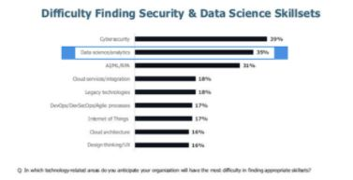

Data Analytics Process Steps
There are primarily five steps involved in the data analytics process, which include:
- Data Collection: The first step in data analytics is to collect or gather relevant data from multiple sources. Data can come from different databases, web servers, log files, social media, excel and CSV files, etc.
- Data Preparation: The next step in the process is to prepare the data. It involves cleaning the data to remove unwanted and redundant values, converting it into the right format, and making it ready for analysis. It also requires data wrangling.
- Data Exploration: After the data is ready, data exploration is done using various data visualization techniques to find unseen trends from the data.
- Data Modeling: The next step is to build your predictive models using machine learning algorithms to make future predictions.
- Result interpretation: The final step in any data analytics process is to derive meaningful results and check if the output is in line with your expected results.

Why Data Analytics Using Python?
There are many programming languages available, but Python is popularly used by statisticians, engineers, and scientists to perform data analytics.
Here are some of the reasons why Data Analytics using Python has become popular:
- Python is easy to learn and understand and has a simple syntax.
- The programming language is scalable and flexible.
- It has a vast collection of libraries for numerical computation and data manipulation.
- Python provides libraries for graphics and data visualization to build plots.
- It has broad community support to help solve many kinds of queries.

Python Libraries for Data Analytics
One of the main reasons why Data Analytics using Python has become the most preferred and popular mode of data analysis is that it provides a range of libraries.
NumPy: NumPy supports n-dimensional arrays and provides numerical computing tools. It is useful for Linear algebra and Fourier transform.
Pandas: Pandas provides functions to handle missing data, perform mathematical operations, and manipulate the data.
Matplotlib: Matplotlib library is commonly used for plotting data points and creating interactive visualizations of the data.
SciPy: SciPy library is used for scientific computing. It contains modules for optimization, linear algebra, integration, interpolation, special functions, signal and image processing.
Scikit-Learn: Scikit-Learn library has features that allow you to build regression, classification, and clustering models.
Analyze the potential challenges and benefits of integrating diverse analytics engines within a single workflow.

Integrating diverse analytics engines within a single workflow can offer several benefits, but it also presents its fair share of challenges. Let's break down both:

Benefits:

1. Specialization: Different analytics engines excel in different areas, such as machine learning, natural language processing, or statistical analysis. By integrating diverse engines, you can leverage the specialized capabilities of each to address specific aspects of your data analysis needs.

2. Comprehensive Insights: Combining multiple analytics engines allows for a more holistic analysis of data. This can lead to deeper insights and a more complete understanding of complex datasets, especially when dealing with heterogeneous data sources.

3. Scalability: Certain analytics engines may be better suited for handling large volumes of data or performing computationally intensive tasks. By integrating multiple engines, you can distribute workloads and improve overall system scalability.

4. Flexibility: Different analytics engines may support different programming languages, frameworks, or data formats. Integrating diverse engines provides flexibility in choosing the most appropriate tools for each stage of the analysis workflow.

Challenges:
1. Integration Complexity: Integrating multiple analytics engines requires careful coordination and management of data inputs, outputs, and dependencies. Ensuring compatibility and seamless communication between different components can be challenging, especially when dealing with proprietary or closed-source software.
2. Data Consistency: Maintaining data consistency and integrity across different analytics engines can be difficult, especially if each engine operates on its own data representation or schema. Inconsistent data formats or interpretations can lead to errors and inaccuracies in the analysis results.
3. Performance Overhead: Running multiple analytics engines simultaneously can introduce additional computational overhead and latency, especially if data needs to be transferred between different components frequently. Optimizing performance and resource utilization across the integrated workflow requires careful tuning and monitoring.
4. Skill and Knowledge Requirements**: Integrating diverse analytics engines may require expertise in multiple programming languages, frameworks, and data processing techniques. Managing a team with diverse skill sets and ensuring effective collaboration between specialists from different domains can be a significant challenge.
5. Maintenance and Support: Managing updates, patches, and compatibility issues for multiple analytics engines can be time-consuming and resource-intensive. Ensuring ongoing maintenance and support for the integrated workflow requires dedicated effort and resources.

Apply the principles of model governance to ensure compliance with regulatory requirements in a machine learning project:

Model governance is a crucial aspect of ensuring compliance with regulatory requirements in a machine learning project. Here's how you can apply the principles of model governance to achieve compliance:

1. Documentation and Transparency: Document all stages of the machine learning project, including data collection, preprocessing, feature engineering, model selection, and evaluation metrics. Maintain clear and transparent documentation regarding the methodology used, assumptions made, and decisions taken throughout the project. This documentation should be easily accessible and understandable by stakeholders, including regulatory authorities.

2. Model Validation and Testing: Implement rigorous validation and testing procedures to ensure that the machine learning model performs as expected and meets regulatory requirements. This includes validating the model's accuracy, reliability, fairness, and robustness across different datasets and scenarios. Perform thorough testing to identify and mitigate any biases or errors in the model predictions.

3. Risk Assessment and Management: Conduct a comprehensive risk assessment to identify potential risks associated with the machine learning model, such as privacy breaches, discriminatory outcomes, or model drift. Develop strategies to mitigate these risks, including data anonymization techniques, fairness-aware algorithms, and model monitoring systems to detect drift and performance degradation over time.

4. Model Monitoring and Maintenance: Establish a robust model monitoring framework to continuously monitor the performance and behavior of the machine learning model in production. Monitor key performance indicators, such as accuracy, precision, recall, and fairness metrics, and set up alerts for any deviations from expected behavior. Implement regular model retraining and maintenance cycles to keep the model up-to-date and compliant with changing regulatory requirements.

5. Compliance Reporting and Auditing: Generate regular compliance reports documenting the model's performance, adherence to regulatory requirements, and any remedial actions taken to address identified issues. Conduct periodic audits to verify compliance with regulatory standards and ensure that all documentation and processes are up-to-date and accurate. Maintain audit trails to track changes made to the model and associated processes over time.

6. Stakeholder Engagement and Communication: Foster open communication and collaboration with stakeholders, including regulatory authorities, compliance officers, data privacy experts, and domain specialists. Seek feedback and input from stakeholders throughout the project lifecycle to ensure alignment with regulatory requirements and address any concerns or questions proactively.

By following these principles of model governance, you can establish robust processes and procedures to ensure compliance with regulatory requirements in a machine learning project. This not only helps mitigate risks and ensure accountability but also builds trust and confidence in the machine learning model and its outcomes.

Given a scenario with multiple software systems, apply the principles of point-to-point integration to connect them.
Point-to-point integration involves establishing direct connections between individual software systems to enable communication and data exchange. Here's how you can apply the principles of point-to-point integration to connect multiple software systems:

1. **Identify Systems**: Begin by identifying the software systems that need to be integrated. This could include applications for customer relationship management (CRM), enterprise resource planning (ERP), human resources management (HRM), and others.

2. **Understand Integration Requirements**: Analyze the specific integration requirements, including the types of data that need to be exchanged, the frequency of data transfer, and any business rules or transformations that need to be applied.

3. **Select Integration Technologies**: Choose the appropriate integration technologies and protocols based on the systems involved and the integration requirements. This could include APIs (Application Programming Interfaces), web services, message queues, file transfer protocols (FTP), or custom integration solutions.

4. **Establish Connections**: Implement point-to-point connections between the software systems using the selected integration technologies. This typically involves configuring endpoints, authentication mechanisms, and data mappings to facilitate communication and data exchange.

5. **Define Data Exchange Patterns**: Determine the data exchange patterns for each integration scenario, such as request-response, publish-subscribe, or batch processing. Ensure that data is transmitted securely and reliably between systems, taking into account error handling and exception management.

6. **Implement Monitoring and Logging**: Set up monitoring and logging mechanisms to track the performance and health of the integration connections. Monitor data throughput, latency, error rates, and other relevant metrics to identify and troubleshoot any issues that may arise.

7. **Handle Versioning and Compatibility**: Account for versioning and compatibility concerns when integrating software systems, especially if they are developed and maintained by different vendors. Ensure that changes to one system do not inadvertently break the integration with other systems.

8. **Document Integration Architecture**: Document the integration architecture, including the connections, protocols, data formats, and business logic involved in each integration scenario. This documentation helps facilitate maintenance, troubleshooting, and future enhancements.

9. **Test and Validate**: Thoroughly test the integration connections to ensure that data is exchanged accurately and efficiently between the software systems. Validate the integration against different use cases, edge cases, and failure scenarios to verify robustness and reliability.

10. **Monitor and Maintain**: Continuously monitor and maintain the integration connections to ensure ongoing performance, scalability, and compliance with changing business requirements. Implement regular updates and optimizations as needed to improve the efficiency and effectiveness of the integrations.

By following these principles of point-to-point integration, you can establish seamless connections between multiple software systems, enabling them to exchange data and communicate effectively to support your organization's business processes and objectives.

Given a scenario, demonstrate how to integrate master data from traditional databases with Big Data sources.

Integrating master data from traditional databases with Big Data sources involves combining structured data from relational databases with semi-structured or unstructured data from Big Data platforms like Hadoop, Spark, or NoSQL databases. Here's how you can approach this integration:

Scenario:
Let's consider a retail company that stores its product catalog, customer information, and sales data in traditional relational databases (e.g., MySQL, PostgreSQL) and wants to integrate this master data with additional data sources stored in a Hadoop Distributed File System (HDFS) for deeper analysis.

Integration Steps:

1. **Data Discovery and Understanding**:
- Identify the master data stored in traditional databases, including product catalog, customer information, and sales data.
- Understand the schema, data formats, and relationships within the relational databases.

2. **Assess Big Data Sources**:
- Explore the Big Data sources stored in HDFS or other Big Data platforms.
- Identify relevant datasets containing additional information that could complement the master data.

3. **Data Ingestion**:
- Select appropriate tools and technologies for data ingestion from both traditional databases and Big Data sources.
- For relational databases, use ETL (Extract, Transform, Load) tools or custom scripts to extract data in structured formats (e.g., CSV, JSON).
- For Big Data sources, leverage tools like Apache Sqoop, Apache Flume, or custom scripts to ingest data into the Hadoop ecosystem.

4. **Data Transformation and Harmonization**:
- Convert the structured data from traditional databases into a format compatible with Big Data platforms (e.g., Parquet, Avro, ORC).
- Perform any necessary data transformations, such as cleaning, filtering, or aggregating the data to ensure consistency and quality.
- Harmonize schemas across different datasets to facilitate seamless integration and analysis.

5. **Integration Strategy**:
- Determine the integration strategy based on the specific use cases and analysis requirements.
- Options include batch processing, real-time streaming, or a combination of both, depending on the timeliness and volume of data needed for analysis.

6. **Data Storage and Management**:
- Store integrated master data and additional datasets in a centralized data lake or data warehouse within the Big Data platform.
- Leverage distributed storage solutions like HDFS, Apache HBase, or Apache Cassandra for scalable and efficient data storage.

7. **Data Analysis and Insights**:
- Use Big Data processing frameworks like Apache Spark, Apache Hive, or Apache Impala to perform advanced analytics and derive insights from the integrated datasets.
- Combine master data with additional data sources to uncover patterns, trends, and correlations that can inform business decisions and strategies.

8. **Data Governance and Security**:
- Implement robust data governance policies to ensure compliance with regulations and industry standards.
- Secure data access and enforce appropriate permissions and encryption mechanisms to protect sensitive information.

9. **Monitoring and Optimization**:
- Set up monitoring and alerting systems to track data ingestion, processing, and storage activities.
- Continuously optimize the integration pipeline for performance, scalability, and cost-effectiveness based on usage patterns and feedback.

By following these steps, the retail company can successfully integrate master data from traditional databases with Big Data sources, enabling comprehensive analysis and driving insights for informed decision-making.

