Network virtualization concepts:
Network virtualization abstracts network resources (routers, switches, firewalls) from physical hardware into software, creating isolated, virtual networks on shared infrastructure. It enables flexible, fast, and, automated network provisioning, allowing multiple virtual networks to coexist, improve resource utilization, and enhance security, essential for cloud computing and data centers.
Key Network Virtualization Concepts
- Abstraction: Decouples network services from underlying physical hardware, treating resources as logical entities.
- Virtual Network Functions (VNFs): Software-based, virtualized network appliances—such as firewalls, routers, and load balancers—that replace traditional, dedicated hardware.
- Network Segmentation (Overlay Networks): The capability to divide a single physical network into multiple, independent virtual networks to enhance security and organization.
- Centralized Management: Tools and software-defined networking (SDN) controllers that manage and configure virtual networks, allowing for automated deployment and agility.
- Virtual Switches/Routers: Software-based traffic management entities that operate within a hypervisor to manage communication between virtual machines (VMs).
Core Types and Uses
- Internal Networking: Connects VMs on a single physical host, separating them from the external network.
- External Networking: Links virtual networks across multiple physical devices, bridging virtualized and non-virtualized environments.
- Logical Segmentation (VLANs/VXLANs): Creates isolated network segments on the same physical infrastructure to manage traffic.
Benefits
- Efficiency: Improves resource utilization by consolidating network traffic.
- Agility & Speed: Reduces provisioning time for network resources from weeks to seconds.
- Scalability: Facilitates scaling network capacity without requiring extensive, manual hardware reconfigurations.
- Security: Enhances security by segmenting sensitive traffic into isolated virtual networks.
Software-Defined Networking (SDN) and Network Functions Virtualization (NFV) are the foundational frameworks for modern network virtualization. While they are distinct, they often work together to transform rigid hardware-based networks into flexible software-based systems.
1. SDN and NFV: Core Concepts
- SDN (Software-Defined Networking): Focuses on centralized control. It separates the "brain" (Control Plane) that makes routing decisions from the "hands" (Data/Forwarding Plane) that move the packets. This allows administrators to manage the entire network via software using a centralized SDN controller.
- NFV (Network Functions Virtualization): Focuses on virtualizing services. It replaces dedicated hardware appliances (like physical firewalls or load balancers) with software-based Virtual Network Functions (VNFs) that run on standard commercial servers.

2. Network Segmentation & Tunnels
- Virtual LANs (VLANs): An early form of network virtualization that logically segments a physical LAN into multiple isolated broadcast domains. While useful for small-scale isolation, VLANs are limited to 4,096 IDs, leading to the rise of more scalable solutions.
- Virtual Private Networks (VPNs): Secure, private communication channels created over public networks (like the Internet). In an NFV context, a Virtual VPN is a software instance of a VPN gateway that can be deployed on-demand on standard hardware.
- Overlay Networks: Virtual logical networks built on top of a physical underlay infrastructure. They use tunneling protocols (like VXLAN, NVGRE, or GENEVE) to encapsulate traffic, allowing thousands of virtual segments to exist independently of the underlying hardware's physical topology.

3. Virtual Switching and Routing
In a virtualized environment, physical cables and hardware boxes are replaced by software-based versions:
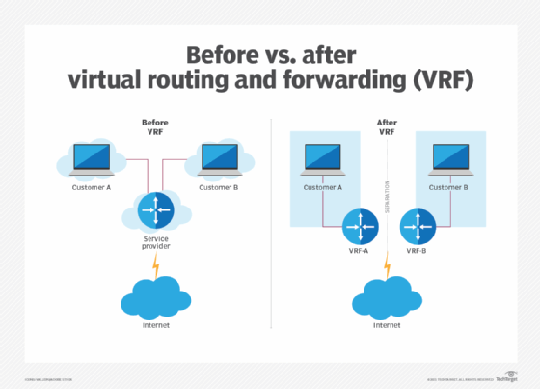
- Virtual Switch (vSwitch): Software that connects Virtual Machines (VMs) to each other and to the physical network. Common examples include Open vSwitch (OVS), which is widely used in SDN environments to manage traffic flows across virtualized hosts.
- Virtual Router: A software-based version of a router that handles IP routing and traffic segregation between different virtual networks or the external world. These are typically deployed as VNFs within an NFV framework to provide flexible, scalable routing without needing more physical hardware.

Feature | SDN | NFV
Primary Goal | Centralize control & programmability | Replace proprietary hardware with software
Layers | OSI Layers 2–3 (Networking/Routing) | OSI Layers 4–7 (Services/Appliances)
Standard | Open Networking Foundation (ONF) | ETSI NFV Industry Specification Group

Containerization Fundamentals
Containerization is a lightweight alternative to traditional virtualization (VMs) that allows developers to package an application with all its required libraries, dependencies, and configuration files into a single image.

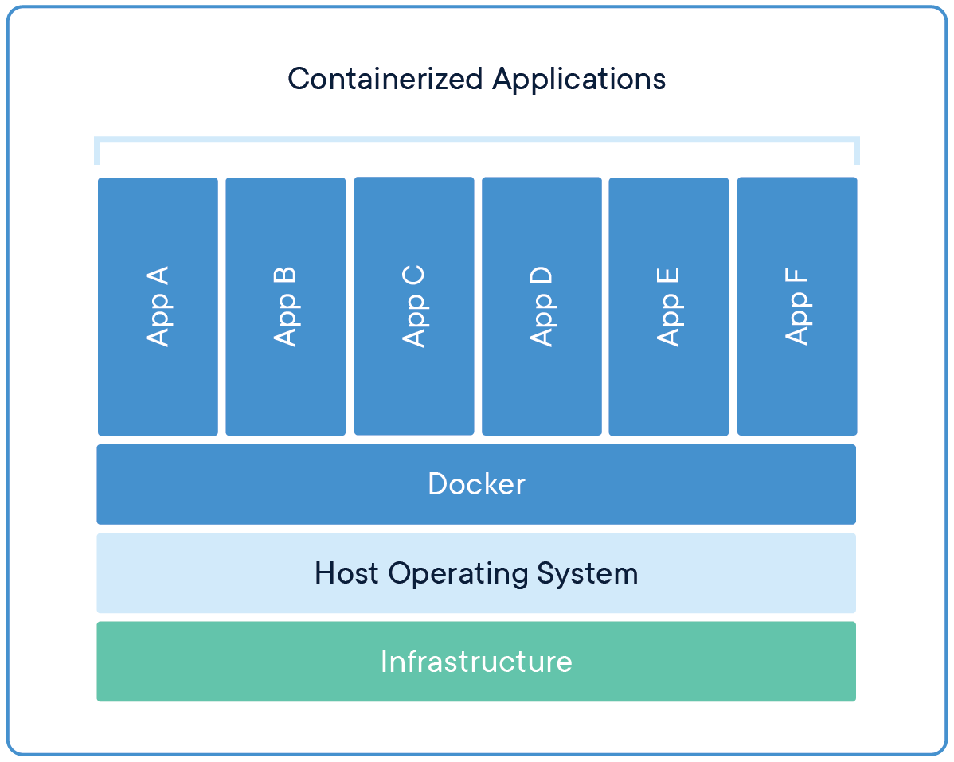

Core Fundamentals
- Isolation at the OS Level: Unlike Virtual Machines, which include a full Guest Operating System, containers share the Host OS Kernel. They use Linux features like namespaces (for isolation) and cgroups (for resource limiting) to stay separate from each other.
- The Container Image: This is a read-only template (a "blueprint") used to create containers. It contains the application code and everything needed to run it.
- Portability: The primary rule of containerization is "Build Once, Run Anywhere." A container running on a developer's laptop will behave exactly the same way in a production cloud environment.
- Efficiency: Because they don't boot an entire OS, containers start in seconds and use significantly less RAM and CPU than VMs.
Key Components
- Container Engine: The software that manages containers. While Docker is the most famous, others like Podman are gaining popularity for their "daemon-less" architecture.
- Container Runtime: The low-level component that actually executes the container. Common examples include containerd and CRI-O.
- Registry: A storage system for sharing images. The Docker Hub is the largest public registry, but many companies use private ones for security.
Containers vs. Virtual Machines
Feature | Containers | Virtual Machines (VMs)
OS | Shares Host OS Kernel | Includes full Guest OS
Size | Megabytes (Lightweight) | Gigabytes (Heavy)
Boot Time | Milliseconds to Seconds | Minutes
Isolation | Process-level (Less secure) | Hardware-level (Highly secure

Docker and container runtimes
In the container ecosystem, Docker and Container Runtimes are often confused, but they serve different roles in the stack.

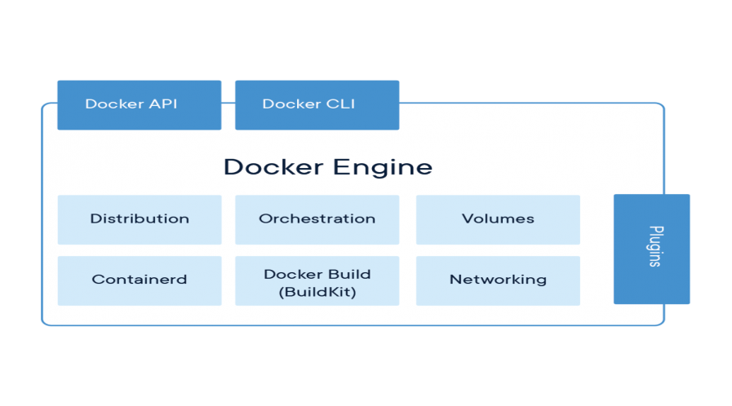

1. What is Docker?
Docker is a complete platform (a suite of tools) that simplifies the entire container lifecycle. It is not just a runtime; it includes:
- Docker CLI: The command-line tool you use to type docker build or docker run.
- Docker Engine: The background service (daemon) that manages images, networks, and storage.
- Docker Desktop: A GUI application for Windows/Mac that bundles these tools for developers.
2. What is a Container Runtime?
A runtime is the specialized software responsible for the "running" part—it takes a container image and tells the OS kernel to start the process. There are two levels:
- Low-Level Runtimes (e.g., runc): These interact directly with the Linux kernel features (namespaces and cgroups) to create the isolated container.
- High-Level Runtimes (e.g., containerd): These manage the "life" of the container. They pull images from a registry, manage networking, and supervise the low-level runtime.
3. The Shift: Docker vs. Kubernetes (CRI)
Originally, Kubernetes used Docker to run containers. However, Docker was "too big" for Kubernetes because it included many features (like a CLI and UI) that a server doesn't need.

- The CRI (Container Runtime Interface): Kubernetes created a standard called CRI so it could talk to runtimes directly.
- Modern Setup: Most modern systems now use containerd or CRI-O directly, bypassing the full Docker Engine to save resources.
4. Comparison Table
Feature | Docker | Container Runtimes (containerd/CRI-O)
Primary Use | Human developers building/testing | Automated systems (like Kubernetes)
Complexity | High (Includes many tools) | Low (Focused only on execution)
Interface | User-friendly CLI | Programmatic API
For technical specifications, you can visit the Open Container Initiative (OCI), which sets the industry standards for how these runtimes must behave

Kubernetes, OpenShift
When you move from running one container to managing thousands across multiple servers, you need Container Orchestration. Think of it as the conductor of an orchestra, ensuring every "instrument" (container) plays its part at the right time.
1. The Heavy Hitters: Kubernetes & OpenShift
- Kubernetes (K8s): The open-source industry standard developed by Google. It automates the deployment, scaling, and management of containerized applications. It’s highly flexible but requires significant expertise to manage.
- Red Hat OpenShift: An enterprise-ready version of Kubernetes. While K8s is the "engine," Red Hat OpenShift is the "luxury SUV"—it comes pre-packaged with extra security, built-in CI/CD pipelines, and a developer-friendly Web Console.
2. Container Networking (The CNI)
Containers need to talk to each other, the host, and the outside world. This is handled by the Container Network Interface (CNI).
- Pod Networking: In K8s, the smallest unit is a Pod. Every Pod gets its own unique IP address, allowing it to communicate as if it were a physical host.
- Services: Since Pods are "ephemeral" (they die and restart with new IPs), a Service provides a single, permanent IP or DNS name to reach them.
- Plugins: Common CNI plugins like Calico or Flannel handle the actual routing and security policies between containers.
3. Container Storage (The CSI)
By nature, containers are "stateless"—if they crash, any data inside them is deleted. For databases or user files, we need Persistent Storage.
- Volumes: A directory accessible to containers in a Pod.
- Persistent Volume (PV) & Claims (PVC): A PV is a piece of storage (like an AWS EBS disk or a local SSD) provided by an admin. A developer "claims" that storage using a PVC, like a voucher.
- Container Storage Interface (CSI): A standard that allows Kubernetes to connect to any storage vendor (NetApp, Pure Storage, Azure Disk) without needing to rebuild the K8s code. You can find the list of supported drivers on the Kubernetes CSI Documentation.

Key Differences Summary
Feature | Kubernetes | OpenShift
Project Type | Community Open Source | Enterprise Product
Security | Basic (Highly configurable) | Strict (Hardened by default)
Installation | Manual / Complex | Automated (Installers

Microservices Architecture in Containers
In a modern ecosystem, container storage and microservices go hand-in-hand to ensure that distributed applications remain both scalable and data-persistent.
. Microservices Architecture in Containers
Microservices involve breaking a large "monolithic" application into small, independent services that communicate over a network. Containers are the perfect vehicle for this because:
- Decoupling: Each service (e.g., payment, login, inventory) can be written in a different language and updated without affecting the others.
- Scalability: If the "payment" service is busy, you can scale just that container rather than the whole app.
- Resilience: If one containerized service crashes, the rest of the application stays online.
- Service Mesh: Tools like Istio are often used to manage the complex communication, security, and observability between these microservices.
Enterprise Storage for Microservices
Since microservices are often "stateless," they rely on external storage for "stateful" data (like databases).
- Dynamic Provisioning: Orchestrators like Kubernetes use the CSI (Container Storage Interface) to automatically create storage disks the moment a microservice requests one.
- Storage Classes: These allow developers to choose the "flavor" of storage, such as "Fast-SSD" for databases or "Standard-HDD" for logs.
3. Case Studies: Network Virtualization in Action
Enterprises use these technologies to solve massive infrastructure bottlenecks:
- Financial Services (e.g., PayPal/Capital One):
  - The Problem: Traditional networking took weeks to provision new security zones for banking apps.
  - The Solution: Using SDN (Software-Defined Networking), they automated firewall rules and network isolation.
  - Result: Reduced deployment time from weeks to minutes while maintaining strict PCI-DSS compliance. Capital One's Cloud Journey is a primary example of this shift.
- Telecommunications (e.g., AT&T/Verizon):
  - The Problem: Buying expensive, proprietary hardware for every new cell tower.
  - The Solution: Implemented NFV (Network Functions Virtualization) to run virtual routers and firewalls on standard servers.
  - Result: AT&T successfully virtualized over 75% of its core network functions, drastically cutting costs and increasing speed. AT&T’s SDN Case Study highlights this transformation.
- Retail (e.g., eBay):
  - The Problem: Managing traffic spikes during "Black Friday" across thousands of servers.
  - The Solution: Migrated to Kubernetes and Overlay Networks (VXLAN) to allow containers to move across physical data centers without losing connectivity.

